Year One Holiday Homework February 2018

Your Holiday Homework is to make a model of a flower.
You could use bits of material, cereal boxes, scraps of ribbons, newspaper,
or anything else that takes your fancy.

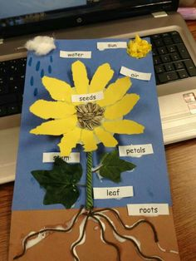
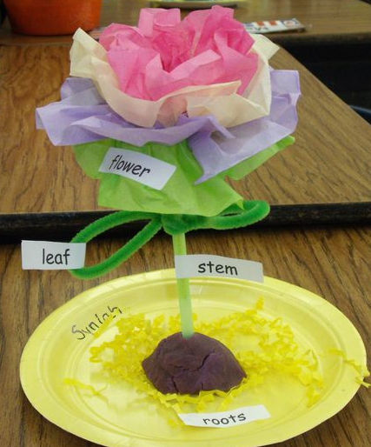

Don’t forget to label
your model!

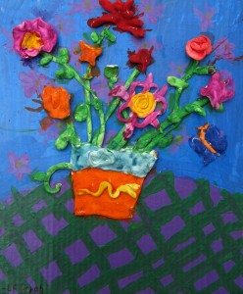
Who will you collaborate with to make your flower?

Use your BLP persevering muscle to keep trying hard until you finish.

Have Fun!

Finish

