Year One Holiday Homework October 2017

Your Holiday Homework is to make your own animal mask.
You could use bits of material, cereal boxes, scraps of ribbons, newspaper,
or anything else that takes your fancy.

Choose an animal you might see in Autumn:

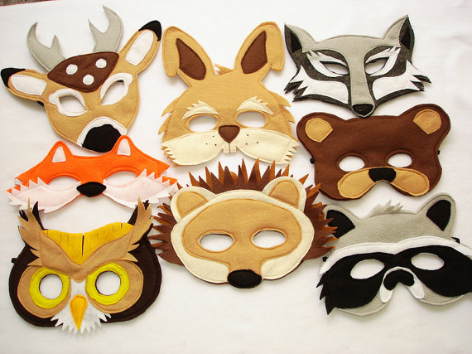

Can you use your BLP noticing muscle to spot the different patterns
in your design?

Have Fun!
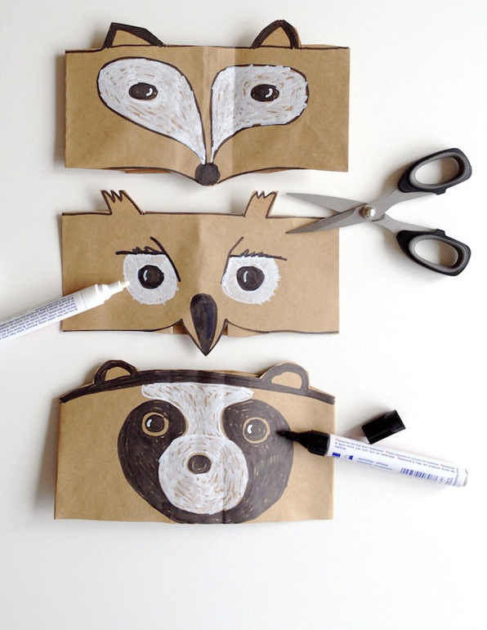
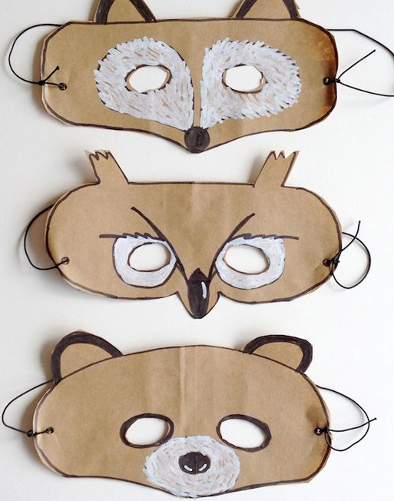

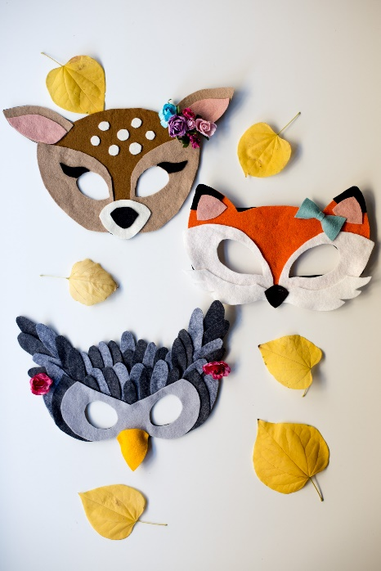
Finish

