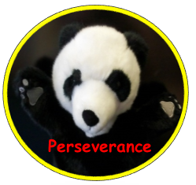
Holiday Homework - December 2017
Our Topic next term is all about Toys.
Your holiday homework is to make your very own puppet for our Toy Shop.
You can make your puppet from any bits and pieces.
You will have so much fun deciding what puppet you want to make. Use your BLP perseverance muscle and keep going!
Remember to bring yourself and your puppet to school on Tuesday, January 2nd, 2018.
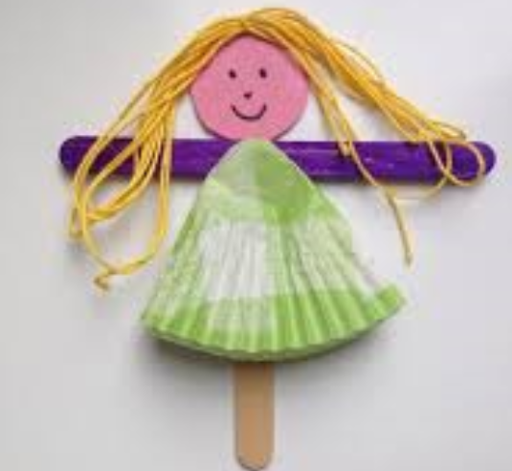
Think about:
- What materials you used to make your pupppet
- How you joined your puppet together
- What games you can play with your puppet
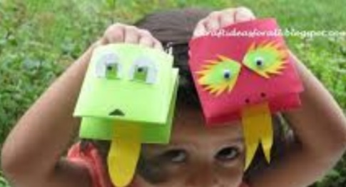
We have some exciting activities planned for you and your puppet to start out new topic.
http://www.activityvillage.co.uk/puppets has lots of ideas to look at.
