8th December 2017
Dear Parent/Carer
Class 5:2 – for information
I write to you concerning class 5:2. Mrs Membe will be leaving us at the end of this term. We thank her for all the work she has done with Class 5:2. Mr Dunderdale, Assistant Head teacher and previous Y5 teacher, will take over class 5:2 for the rest of the academic year.
I am sure you will join with me in wishing Mrs Membe all the best, and I know Mr Dunderdale is looking forward to working with you.
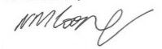
Yours sincerely

Mr N. M. Cooper
Headteacher

