8th December 2017
Dear Parent/Carer
Class 5:3 – for information
I write to you concerning class 5:3. After the Christmas holidays Mrs Atherton will commence her maternity leave. Class 5:3 will be taught by Mrs O’Connor for the rest of the academic year.
I am sure you will join with me in wishing Mrs Atherton all the very best at this exciting time.
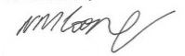
Yours sincerely

Mr N. M. Cooper
Headteacher

