****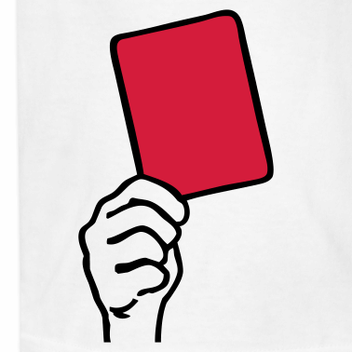**GIVE LITTERING A RED CARD**

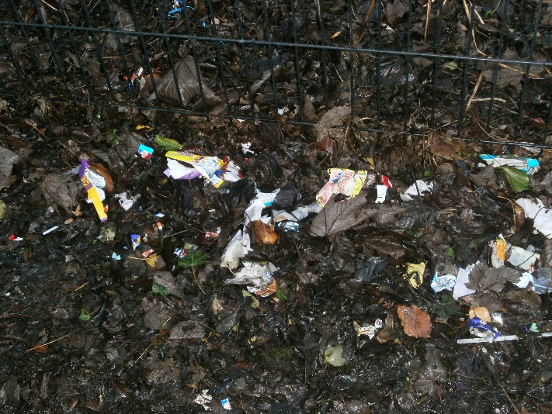

**Littering is when you throw your rubbish on the floor or in unacceptable places instead of putting them in the bin.**

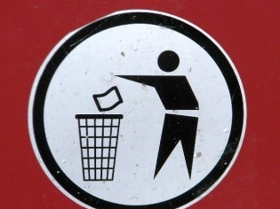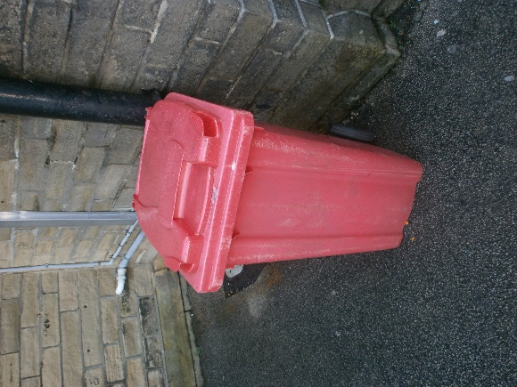

**It is not the site staffs’ job to clean up our mess when we could just go and put the rubbish in the bin. As the school council, we want this to stop completely and have a clean environment. We will be going outside again in around two weeks’ time to hopefully see an improvement in the way our play-ground looks.**

**We have at least 3 bins in the play-ground so there is no excuse!!!!🙁**