

**Policy for The Learning Environment and Display**

**Appendix 1: Mathematics Working Walls**

**Key Stage 1**

Key vocabulary, signs and symbols are displayed. These are age appropriate to the year group curriculum.

Year 1

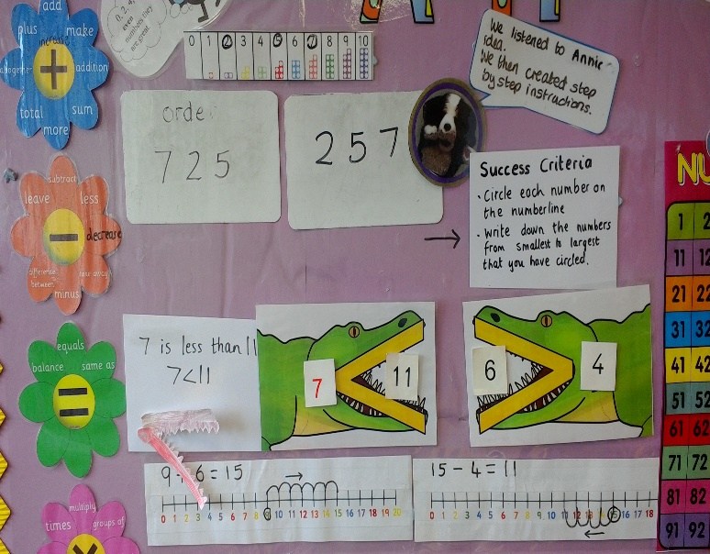

Modelled exemplars of calculation processes provide a reference point for children.

Clear success criteria supports independent learning and provides a reference point for ‘stuck’ pupils.

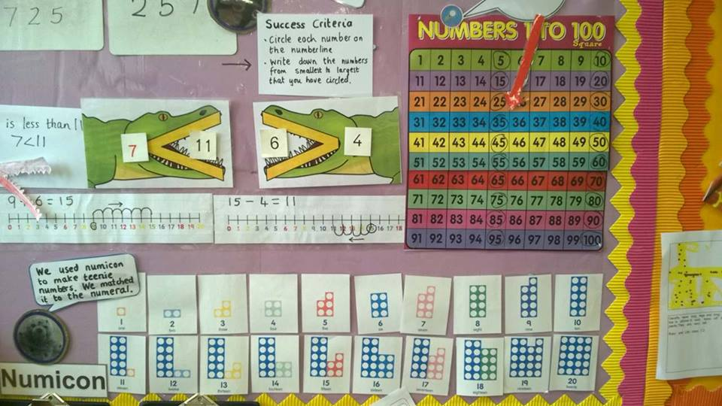

Resources specific to the year group provide a reference point for children. In Year 1 the 100 square ensure a challenge for the more-able whilst modelled teen numbers support learning.

Links are made between learning – using number bonds to 10 to solve the problem.

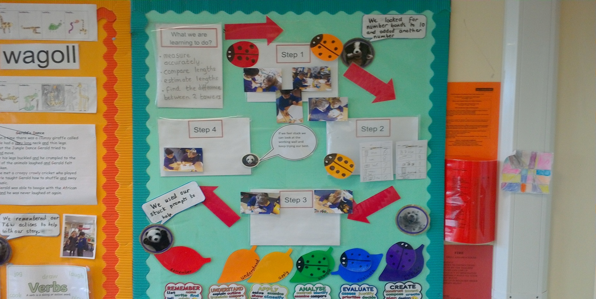

Problem solving with a clear focus on learning.

Modelled steps with photographic prompts support pupils as they solve the problem.

WAGOLLs support stuck pupils and celebrate success.

Blooms enables deepening for pupils.

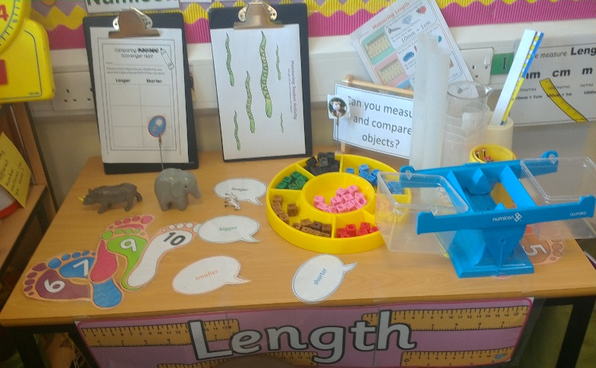

Resources are readily accessible for independent use by pupils. Clipboards encourage independent recording.

**Lower Key Stage 2**

Year 3

Resources are readily accessible for independent use by pupils; with the progression to Year 3 resources are selected to support progress within the Year 3 mathematics curriculum.

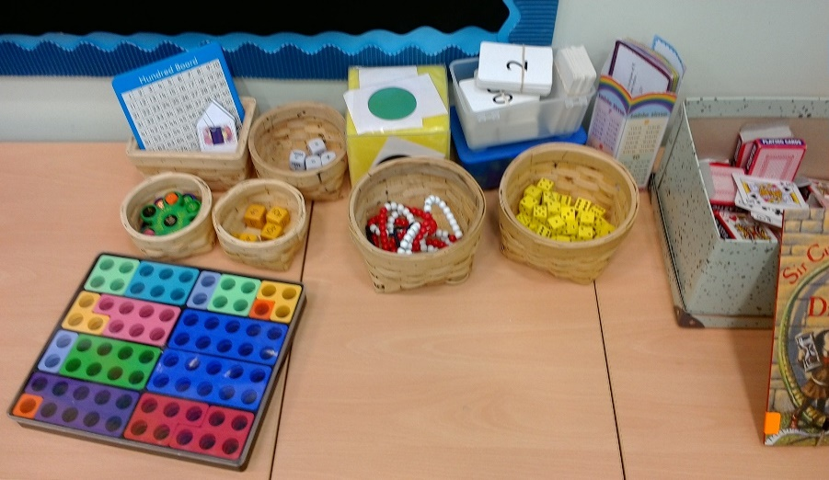

Year 4

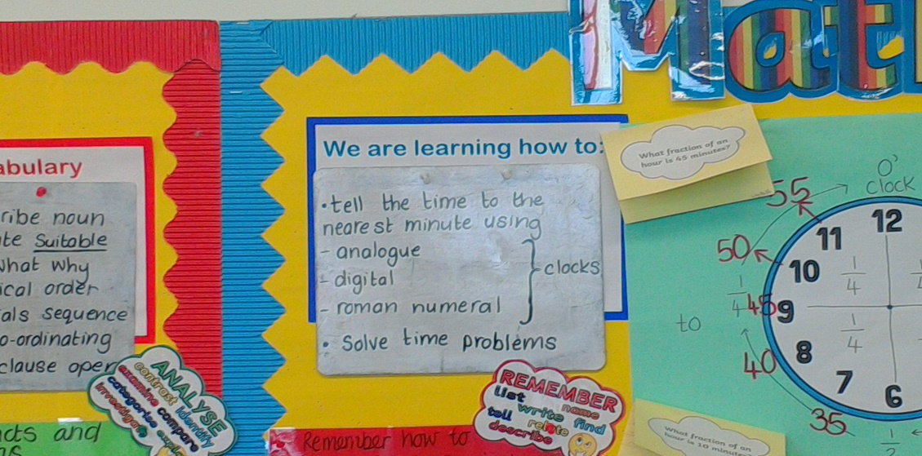

Clear learning objectives reflect the current learning and are skills based.

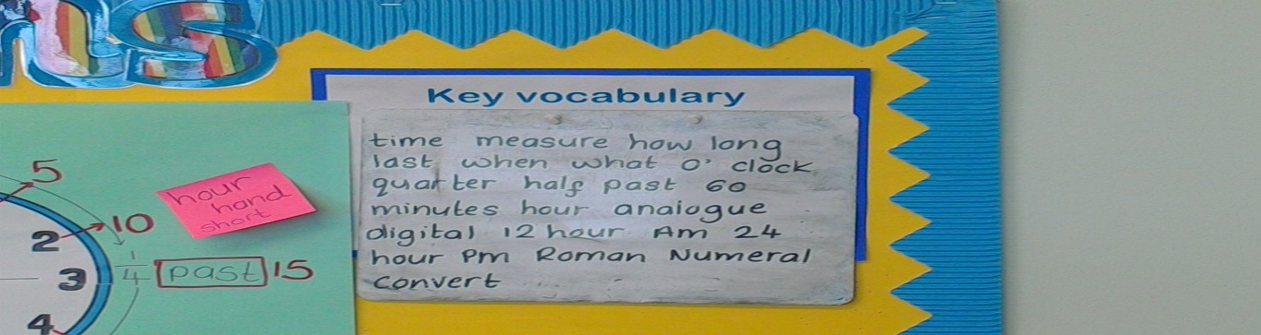

Key vocabulary to be used consolidates vocabulary from the previous key stage and introduces the new, age appropriate, vocabulary.

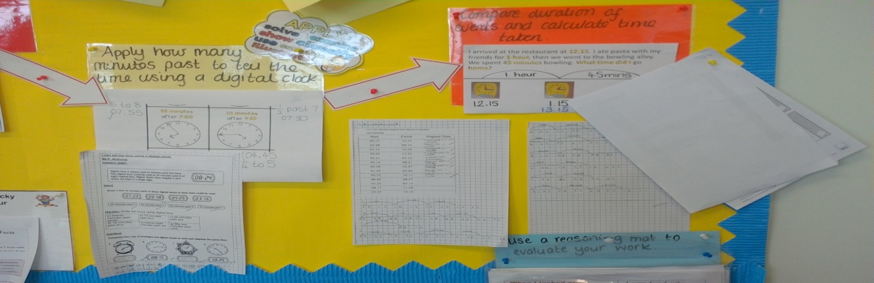

Next steps within the learning journey are modelled for pupils. The modelled process reflects the calculation policy and provides a prompt for pupils during the lesson. Process is placed within the context of application to a problem which provides a challenge and opportunity to apply.

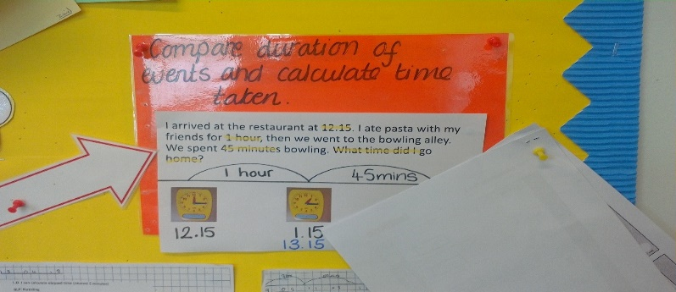

Prior learning consolidated through a modelled example ensures the working wall is inclusive for all pupils.

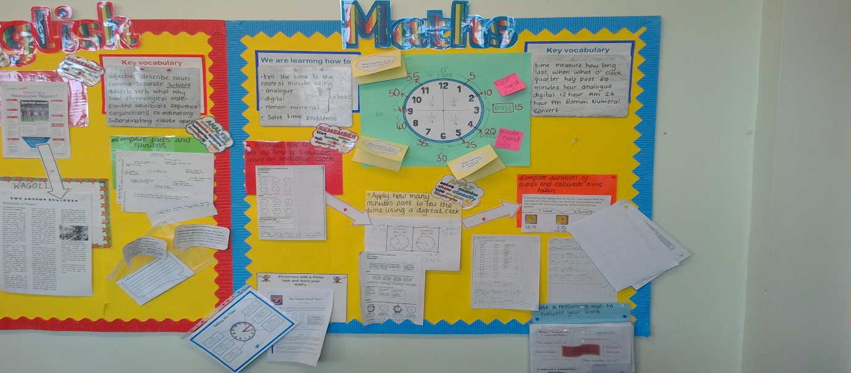

WAGOLL – provide modelled examples form pupils’ work which also celebrate progression in learning.

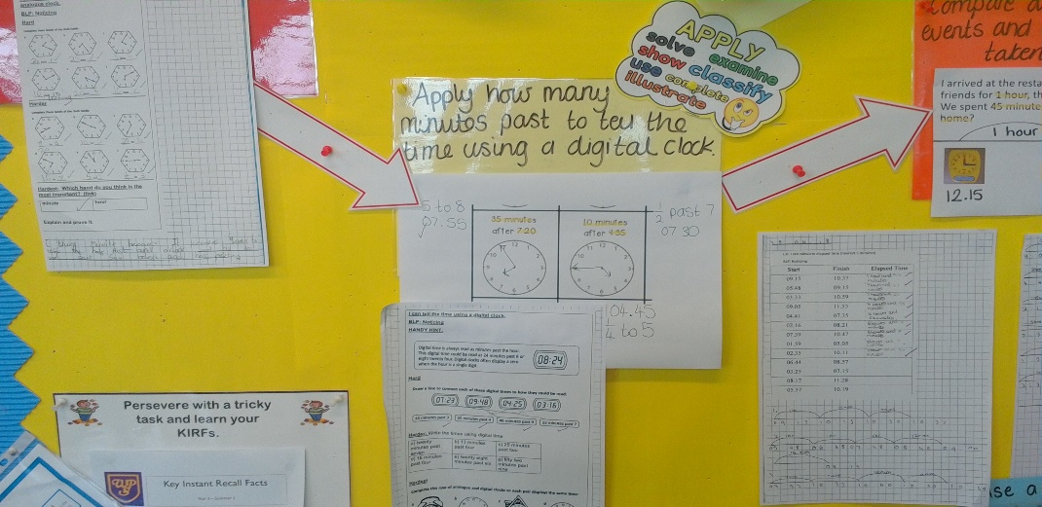

KRFS – link to learning homework which aids fluency – making links in learning and developing independence.

**Upper Key Stage 2**

Year 5

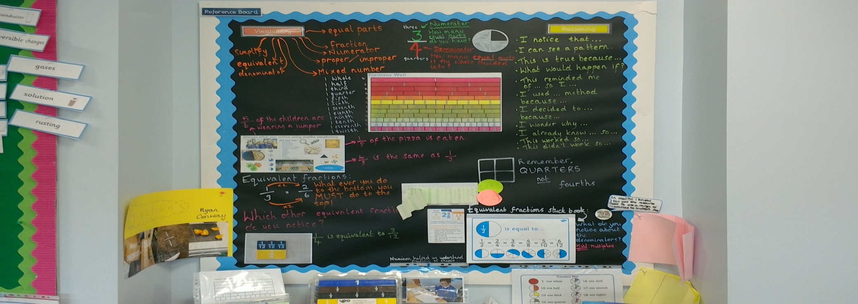

The reference board contains the key vocabulary associated with the learning and is modelled alongside a fraction wall.

The learning journey from writing fractions to equivalent fractions is clear – with the small steps modelled.

Modelled process of calculating equivalent fractions supports progress and provides a reference point for pupils during learning time. Questions permeate the board; these encourage pupils to apply their knowledge.

Link to feedback - misconceptions addressed.

Key vocabulary associated with reasoning is modelled. This moves children into greater depth - making links and explaining their thinking.

The working wall alongside the reference board celebrates and uses pupils’ work to model and show the small steps of learning across the journey from the pre-skills.

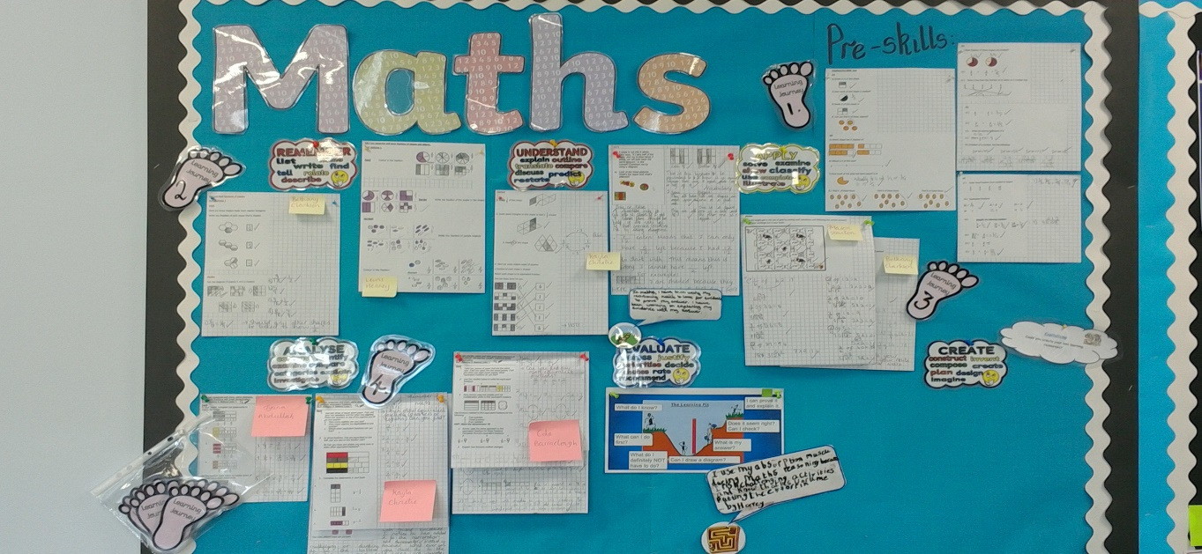

The process of deepening through Blooms is modelled using WAGOLLs.

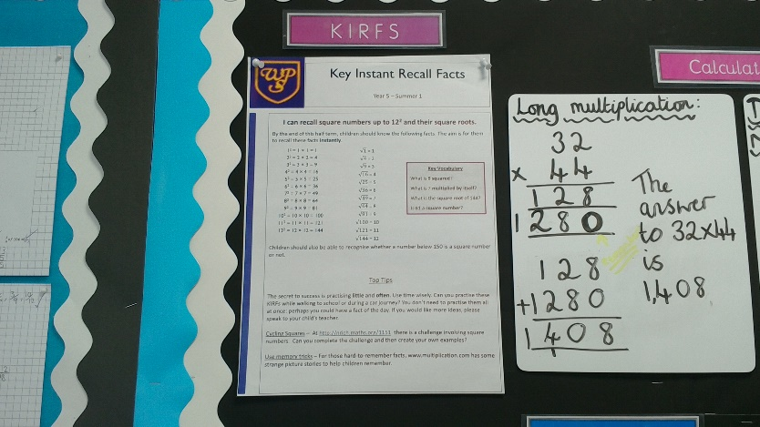

Addressing misconceptions from weekly arithmetic sessions and modelling correct process.

KIRFS: Homework link to aid fluency and accuracy.

Resources appropriate to the learning journey are accessible for pupils to select from.

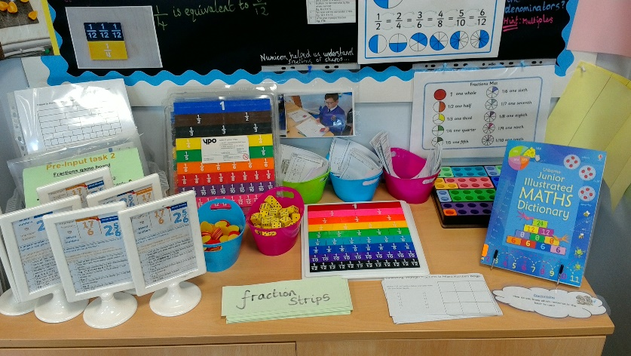

Year 6

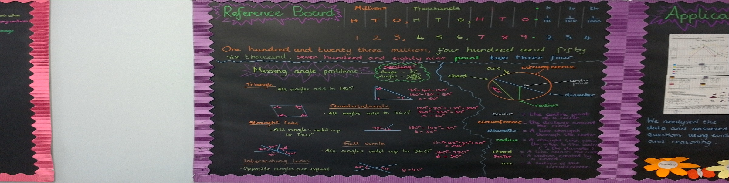

The reference board models place value to millions, and includes decimal notation. This is appropriate for this top set.

Key and new vocabulary is modelled using diagrams and alongside key facts. Key vocabulary is defined.

This reference board consolidates learning and provides a reference point for pupils to confirm key facts, clarify the meaning of vocabulary and provides support for pupils who are stuck. Independence in learning is promoted. The link between key facts and application to problem solving is clear and makes links between learning clear for pupils.

The application board uses WAGOLLs and pupils’ work to model application of learning to real life problems. This provides challenge for the top set an models the deepening learning journey.

The learning has a real life context and WAGOLLs model responses to the problem using evidence and providing reasoning.

