

**Policy for The Learning Environment and Display**

**Appendix 2: English Working Walls**

**Key Stage 1**

Year 1

The Literacy wall has an area that addresses the Writing Process.

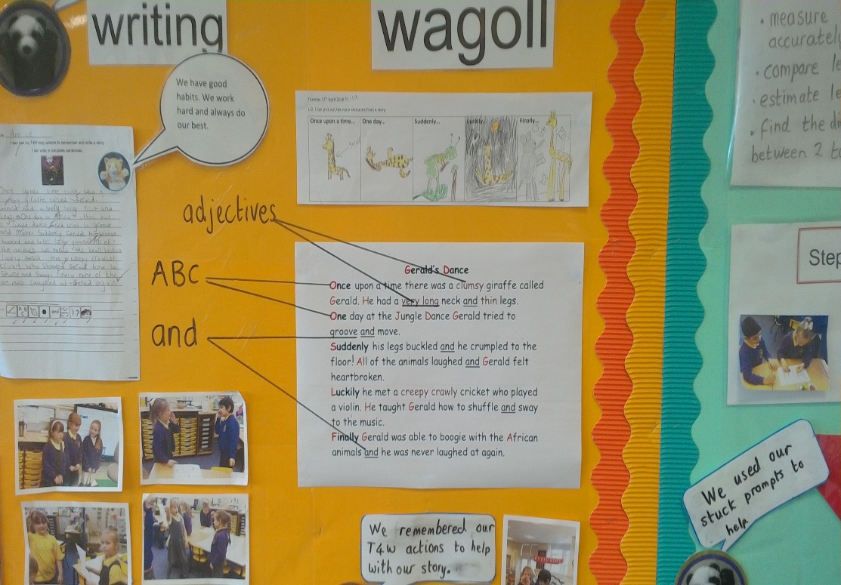

Talk for Writing supports pupils in writing their stories. Photographs support pupils in recalling Talk for Writing.

WAGOLL with pictorial success criteria provides a modelled example.

A modelled WAGOLL is highlighted with key punctuation and grammar points: capital letters, use of ‘and’ and adjectives.

The text of the term is evident with pupils having ordered the story. WAGOLLs are used to model the ordering and celebrate success.

Learning is clear for pupils with a clear learning objective with skills taken from the punctuation and grammar programme of study. The writing is given an audience.

The text of the term is evident with key vocabulary identified.

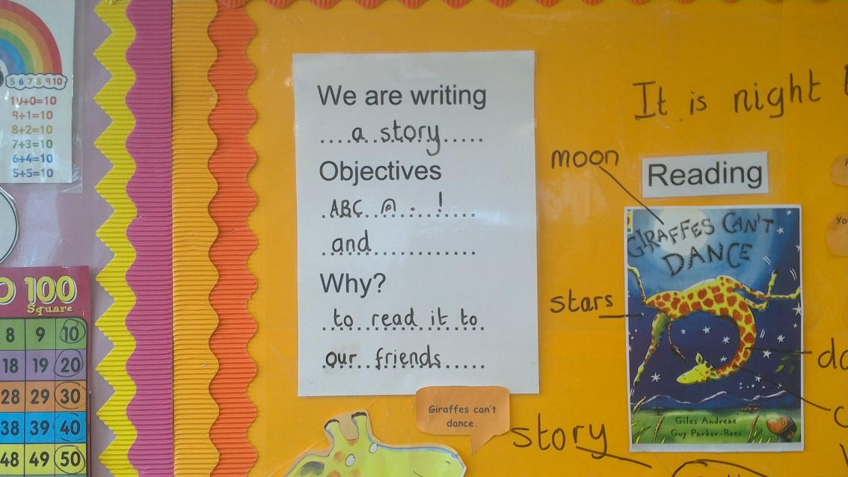

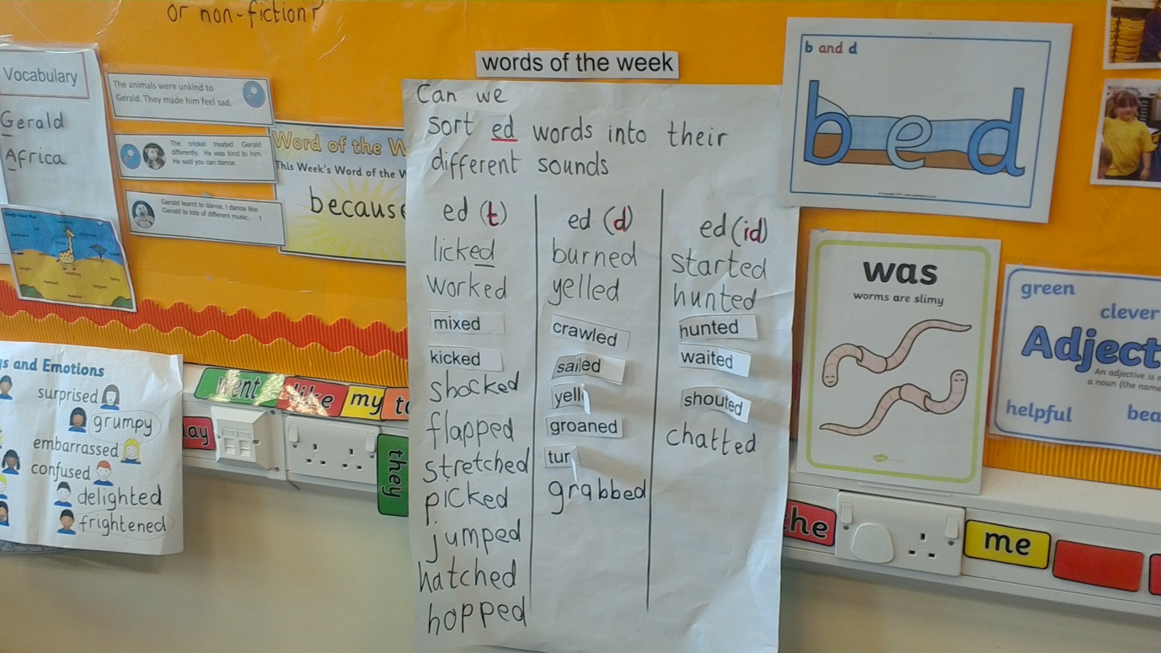

Current learning in phonics is displayed to reinforce learning. Display is used interactively in class with pupils sorting words according to their sound.

**Lower Key Stage 2**

Year 3

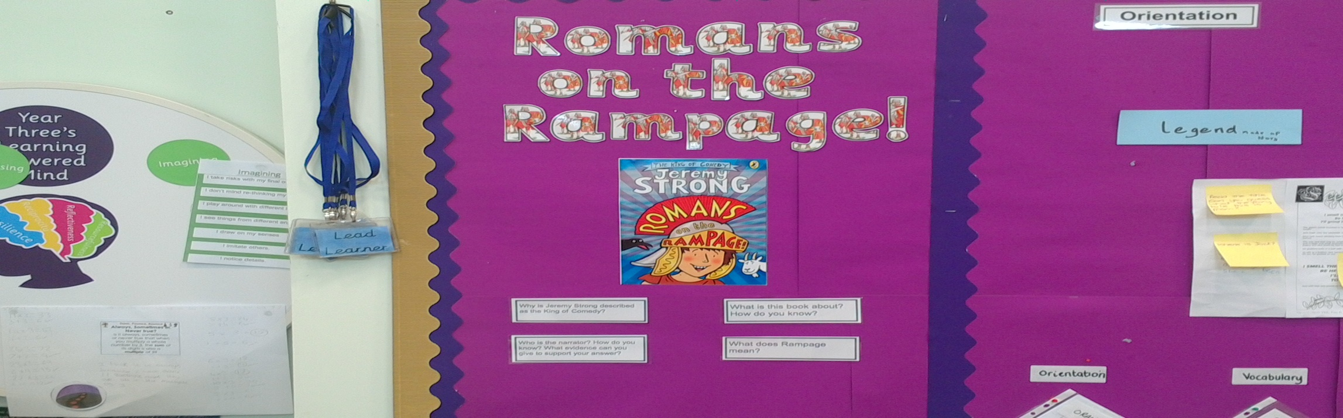

The ‘Text of the Term’ is evident with key questions that encourage pupil response.

Text of the term is used to identify the ‘Who’, ‘What’, ‘Where’ and ‘When’ for the start of a newspaper report.

Shared writing is used as a WAGOLL for this.

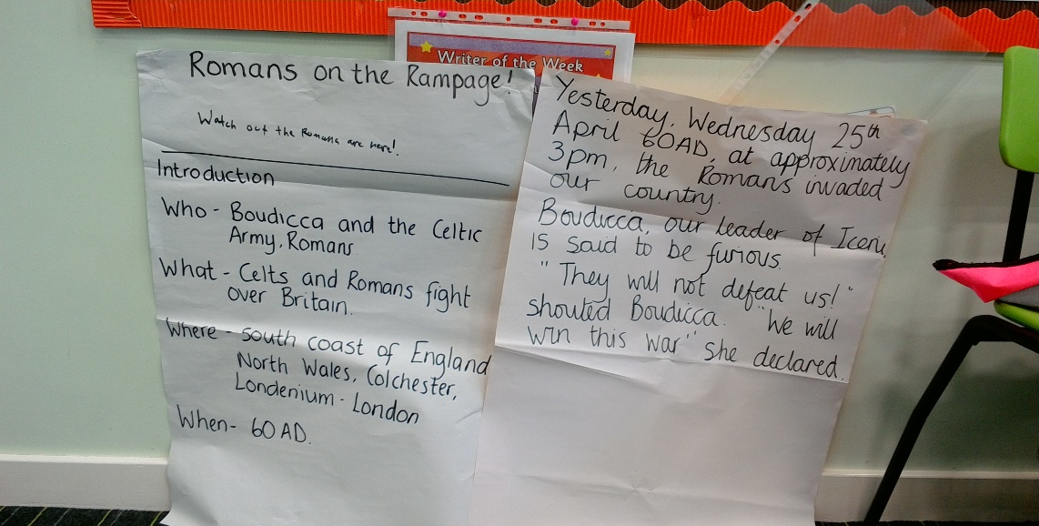

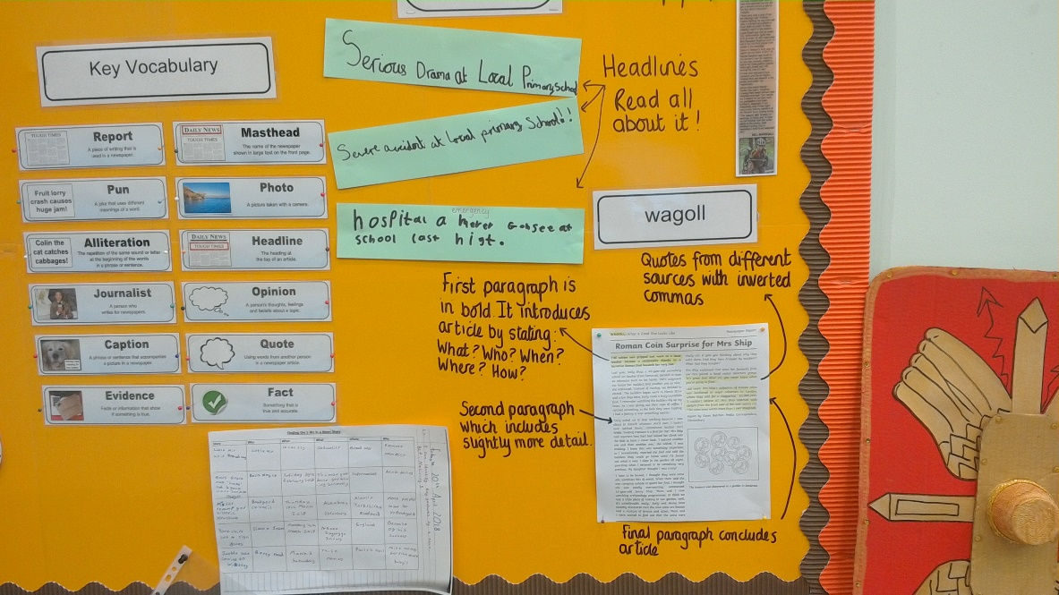

A teacher modelled WAGOLL breaks down the structure of the newspaper report into paragraphs. This is modelling new learning at the ‘Age Related Expectation’ for pupils and provides a reference point for when pupils are writing their own newspaper report.

Key vocabulary is defined which provides a reference point for pupils.

Small steps in learning are modelled using WAGOLLs that celebrate success. Pupils write their own headlines.

Pupils find the 5 ‘Ws’ independently across different stories. This is the next step and provides progression from the shared writing in which the ‘5 W’s’ were found in the ‘Text of the Term’.

The WAGOLL celebrates success in identifying the ‘5 W’s’.

Year 4

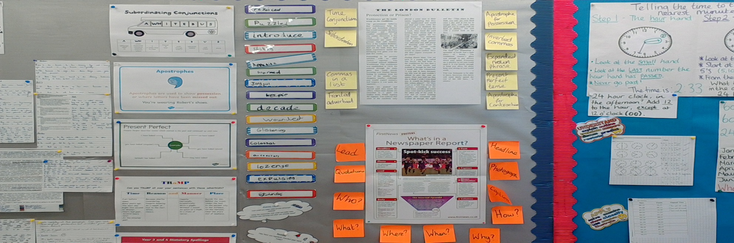

The learning journey is clearly evident with a focus on newspaper reports. Punctuation and grammar is interwoven with definitions e.g. present perfect tense, given to provide a reference point to support pupils in their new learning. The modelled WAGOLL displays the grammar and punctuation that is being taught whilst a second modelled WAGOLL displays the genre features. This provides progression from Year 3, with consolidation of Year 3 learning but it also moves learning along. Pupils’ WAGOLLs are also displayed.

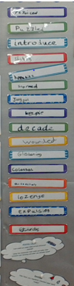

Interactive development of new vocabulary which comes from the ‘Text of the Term’ and pupils’ own reading. It provides a reference point for pupils.

The focus on new vocabulary is evident across the classroom with the reading area displaying key vocabulary from the ‘Text of the Term’ alongside definitions.

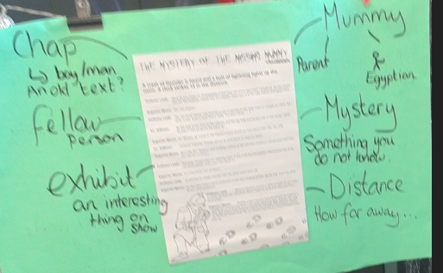

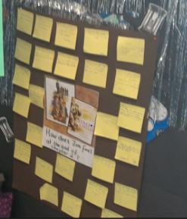

Pupil response to the ‘Text of the Term’ is encouraged through this interactive wall. Pupils have read chapter 2 as a class and their comprehension skills are evident as they respond to a key question.

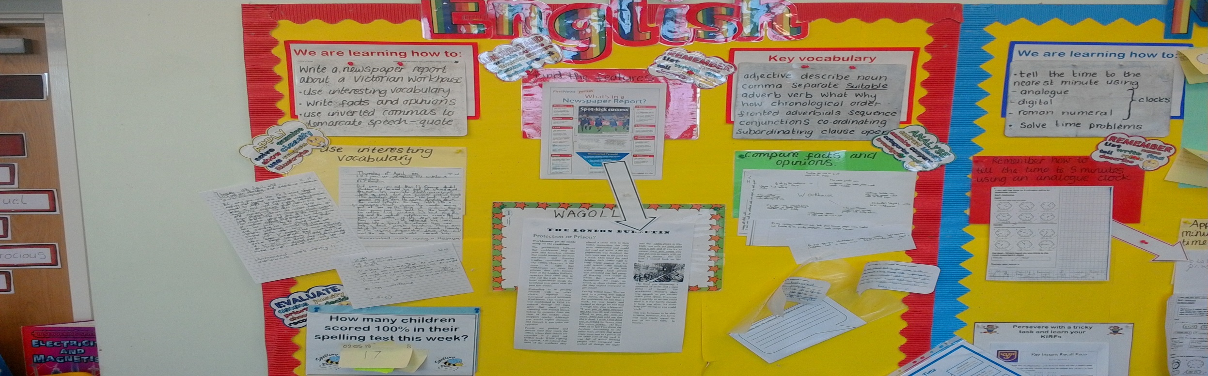

The learning objective identifies the current learning journey with the success criteria embedding the skills, knowledge and understanding that are being covered. The key grammar and punctuation for the learning journey is evident, as is the application within the genre. The topic theme is used as a vehicle for learning. Key vocabulary is displayed.

The working wall defines the skills, knowledge and understanding and provides a reference for pupils during their learning time.

Understanding of fact /opinion is new learning and moves the understanding of newspaper genre on from Year 3. Modelled examples relating to the theme are provided.

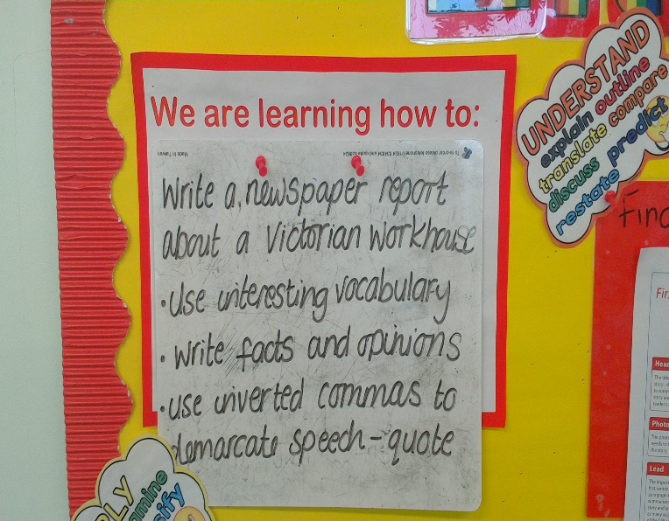 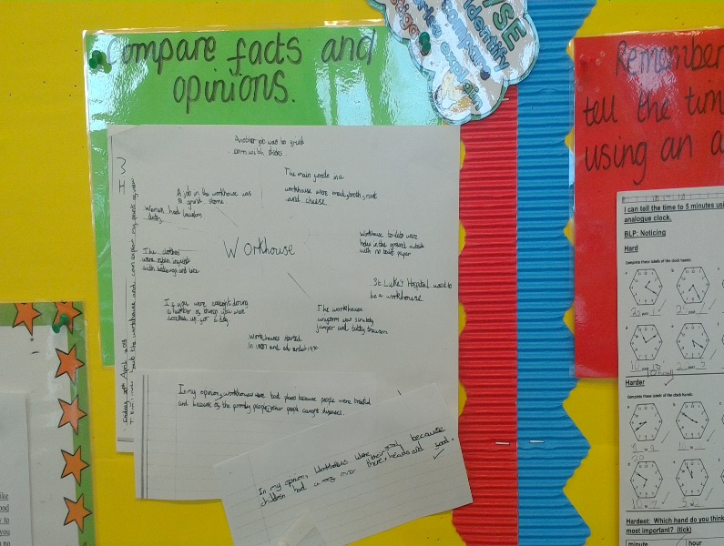 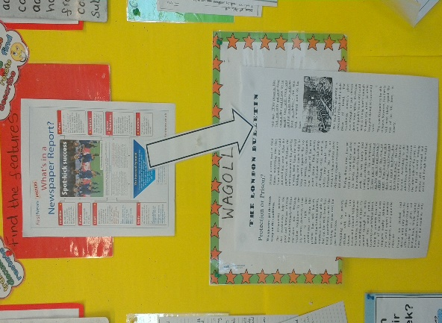

The small steps in the learning journey are modelled and serve as a reference point to support pupils in becoming independent in their learning.

Text of the Term is evident and the text is used as a vehicle for writing.

The link between reading and writing is evident for learner.

**Upper Key Stage 2**

Year 5

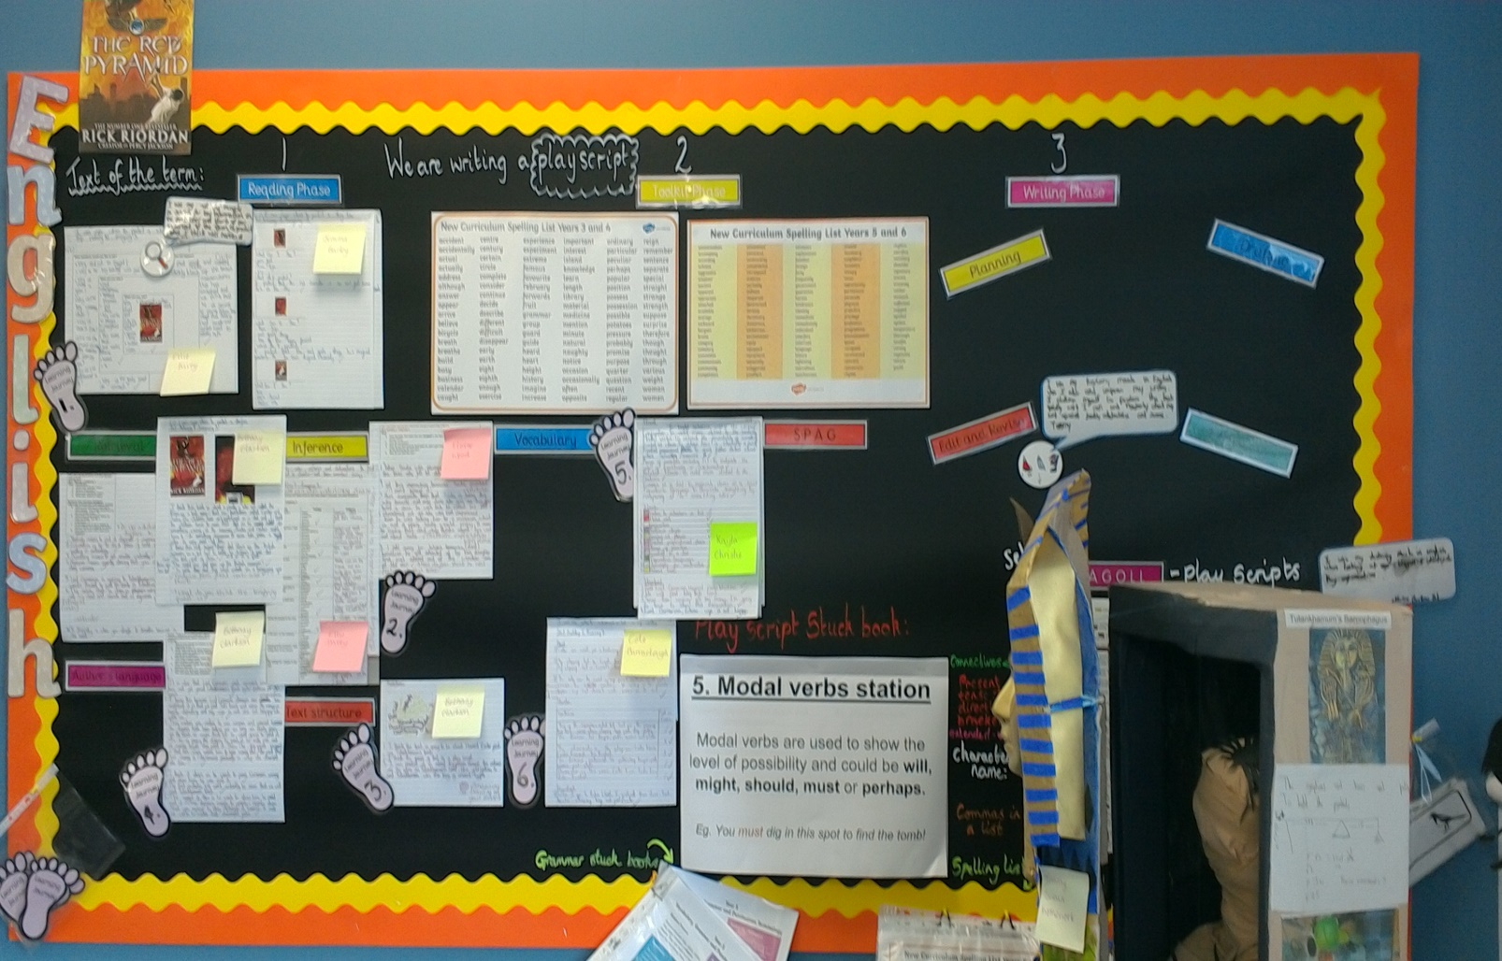

Development of inference skills through the ‘Text of the Term’ with WAGOLLs that celebrate pupil success.

The writing process is clear with the small steps evident from reading, to using the toolkit to identify the next steps on the journey to the final written piece. A tool kit is available on the wall to support learners and promote independence. The toolkit contains: key vocabulary, spellings from the KS2 POS, punctuation and grammar, through the use of a modal verbs station (which is new learning).

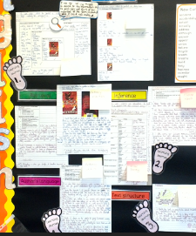

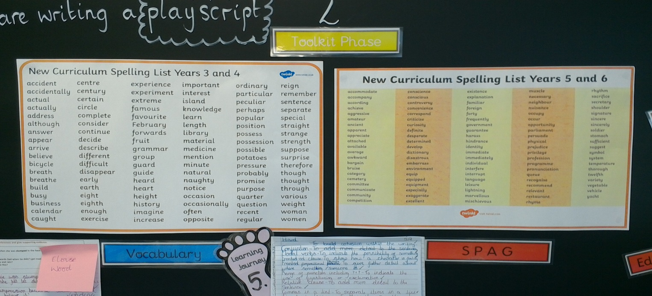

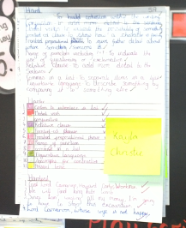

As the learning journey progresses children’s work provides the WAGOLL – here self-assessment against the success criteria provides guidance for pupils and supports independence.

The ‘grammar stuck books’ covers the grammar that is to be taught and provides a reference guide for pupils should they be stuck.

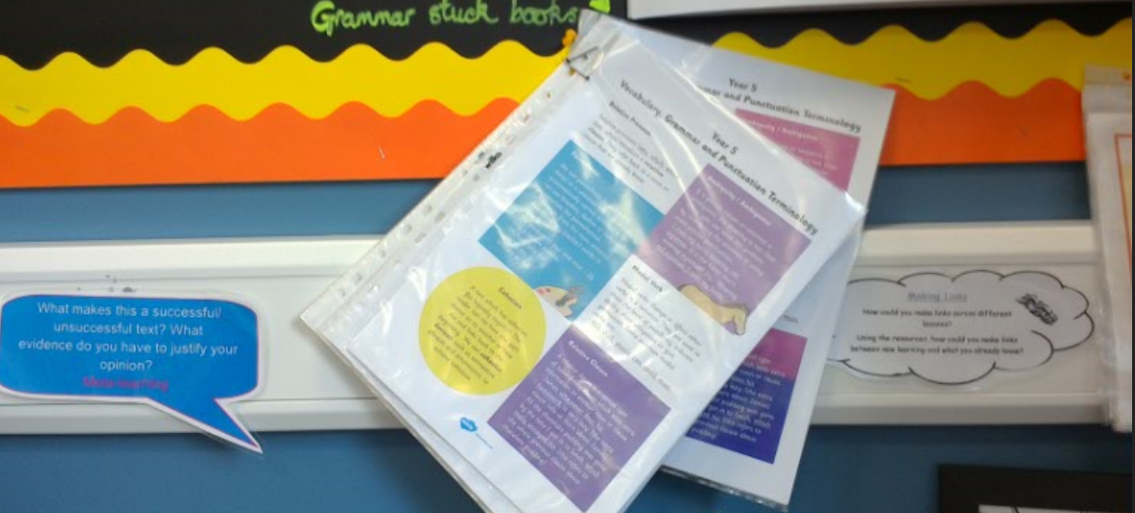

Pupils are encouraged to evaluate the text in the light of their knowledge and understanding of the genre. Using the evidence to justify their opinion deepens their learning.

Year 6

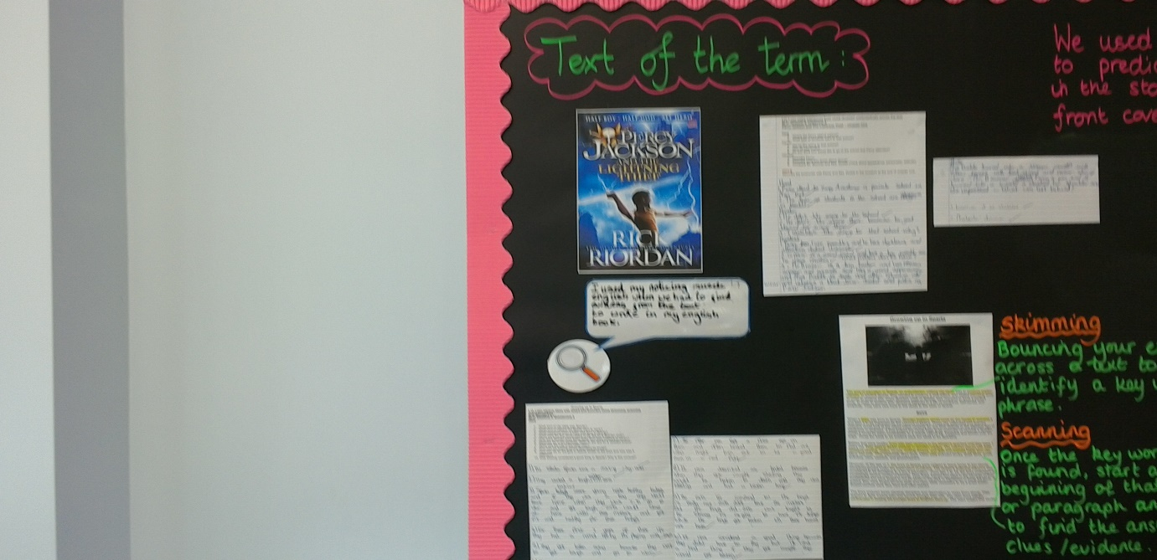

The English Working Wall has separate sections for the Reading Process and the Writing Process.

The Reading Wall strongly reflects the ‘Text of the Term’. There is pupils’ work used as a WAGOLL, which is taken from the ‘Reading Continuum’ and which modes the development of comprehension skills.

Key reading skills, skimming and scanning, are clear with a text highlighted as a model. These are defined so pupils are clear on the difference between them.

The WAGOLL identifies the key genre features and the grammatical skills that need to be evident. This acts as success criteria for finished pieces and a reference point for pupils whilst undertaking the writing process.

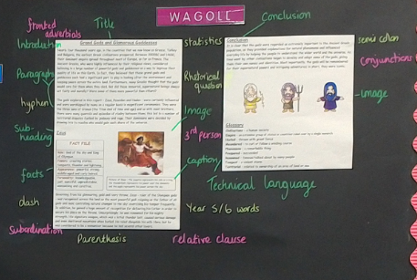

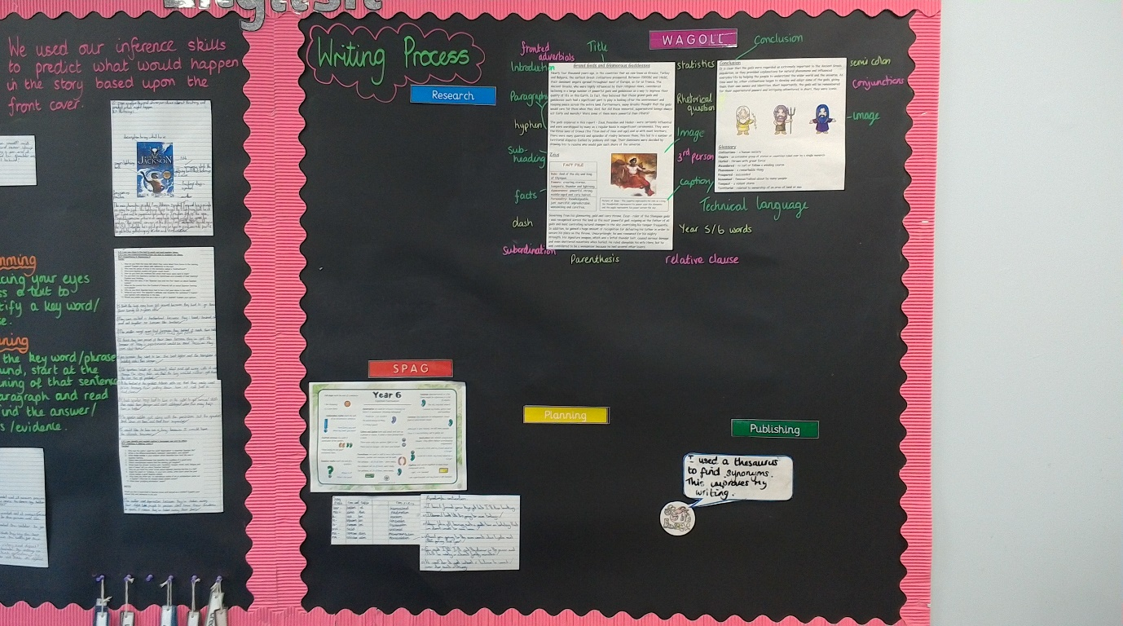

The Writing Process across the learning journey is built up as the pupils go through the learning journey from planning to the final published piece.

]