Year One Holiday Homework July 2018

Your homework challenge over the summer holiday is to stick or draw your own skeleton. You can use white paper or white art straws to make your own skeleton picture.
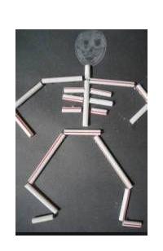
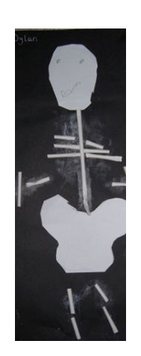

You may want to label it too.
Funnybones introduces a family of skeletons – a big skeleton, a little skeleton and a dog skeleton.
Find the story here: https://www.youtube.com/watch?v=Cfpk8QEhK1c

Have fun, and we look forward to seeing your skeletons in September!
Have a lovely, safe summer holiday,

From Mrs Moody, Mrs Kershaw, Mrs Hunter-Smith and Miss Oldcorn.

