Year 6 SATs revision books
Please order and pay for the books that you would like to buy via ParentPay. These will then be sent home with your child as soon as they arrive in school.
1) | E6FR22  £2.50 | 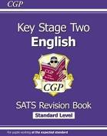 | New KS2 English Targeted SATs Revision Book – Standard Level
2) | E6HR22  £2.50 | 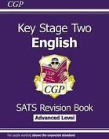 | New KS2 English Targeted SATs Revision Book – Advanced Level
3) | EGR23  £2.25 | 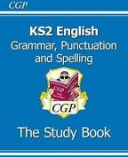 | KS2 English: Grammar Punctuation and Spelling Study Book
4) | E6S23 | 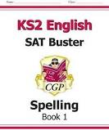 | KS2 English SAT Buster: Spelling Book 1
1) | MLBR22 | 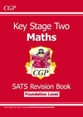 | New KS2 Maths Targeted SATs Revision Book – Foundation Level
2) | MLFR22 | 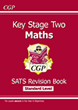 | New KS2 Maths Targeted SATs Revision Book - Standard Level
3) | MLHR22  £2.50 | 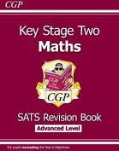 | New KS2 Maths Targeted SATs Revision Book – Advanced Level

Please complete your order and payment on ParentPay by Friday 7th December.
Thank you.
Year 6 Teaching Team

