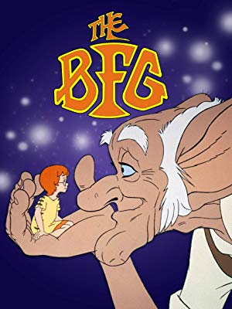
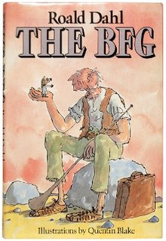
Year 2 Holiday Homework!
BFG

Are you ready for an enormous challenge?
For your holiday homework we would like you to make a chair that is suitable for the BFG.

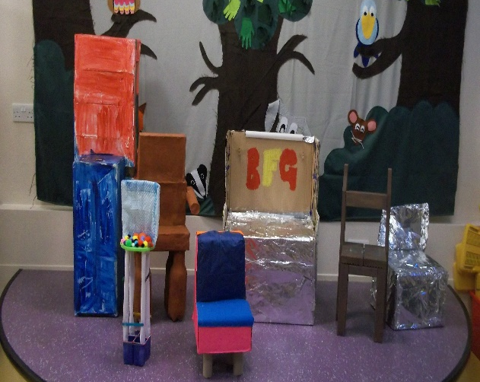
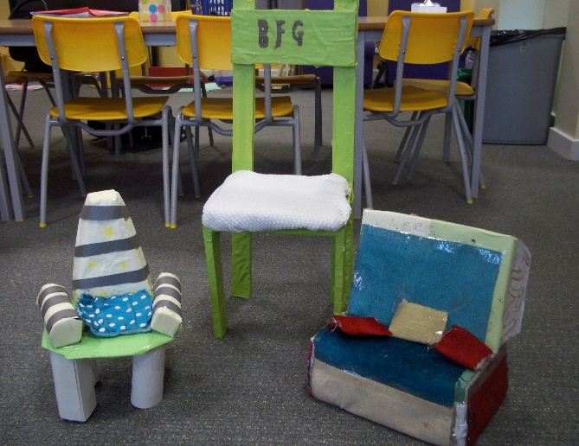

Please remember to use recyclable, child friendly materials such as empty plastic pop bottles/milk cartons, cereal boxes, newspaper, cardboard boxes and cardboard tubes.

Super Challenge:

Can you make your chair as strong as a house?

We wish you a happy and safe Easter.

The BFG is looking forward to testing your chairs.

