Year Two Holiday Homework July 2019
Our topic in September is all about Super Heroes

Your Holiday Homework is to make your own superhero mask.
You could use bits of material, cereal boxes, scraps of ribbons, newspaper, or anything else that takes your fancy.

Choose any Superhero you might like to be.

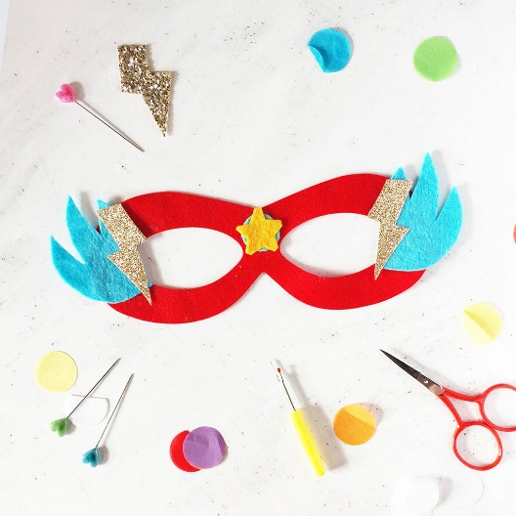
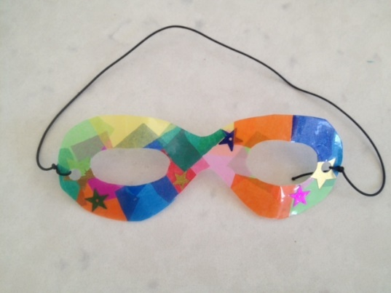

Can you use your BLP noticing muscle to spot the different patterns
in your design?
Have Fun!

