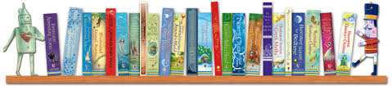

BOOK SHOP

Following on from the success over the last few years, we will be continuing with the Book Shop. Most books will be £1 however some of the newer releases may be £2. We try to source our books so that the cost is down to a minimum for our families.
To launch, the book shop will be available at Parents’ Evening in the middle hall. Please stop by and have a look at the different books we have. The Book shop will then be available each week on a rotation of mornings (weather permitting) and afternoons. We are always looking for volunteers to help run the book club. If you could share some time, please come and see us.

Books will be on sale at Parents’ Evening on 16th October in the middle hall.

MAIN SCHOOL CONSERVATORY:

The Book Shop will then be open as follows up to Christmas:-

Wed 6th November – 3.45pm
Wed 13th November – 8.15am
Wed 20th November – 3.45 pm
Wed 27th November – 8.15am
Wed 4th December - a stall will be available at the Christmas Fair
Wed 11th December – 3.45pm

