Connect 4  This film tells the story of someone new and different joining a group. Can you think of four situations where someone new and different might join a group? | Watch and Understand  Copy and complete this table in your book to help you compare the different characters  small birds big birds  lots of them only one  no neck long neck | Create Something Great  Imagine you were one of the little birds in the middle and you had to explain to your mummy bird why you were coming home without your feathers. How would you explain it to her?
Reflect and Respond  Think about how the small birds behave when they are on the wire at the start.  - what do they actually do?  - what does that tell you about how they are feeling?  - how do you think that affects the story? | Task map 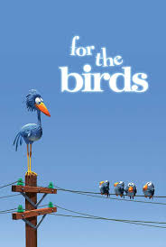 | Reflect and Respond  Why do you think the birds in the middle peck at the big birds’ feet? What do they hope to achieve? What do you think they do achieve? Was it a good idea?
Watch and Understand  answer in sentences in your book  1.What do the little birds do when they first sit on the wire?  2. What happens when the big bird first sits on the wire?  3. What do the little birds do to the big bird?  4. What happens at the end of the film? | Infer What’s Not There  answer in sentences in your book  The whole film is without words. What do you think the birds might be saying in the film?  Fill in the speech bubbles | Create Something Great  Imagine you have to storyboard a similar story set in a school playground. Create your “small bird” and “big bird” characters. Write three sentences about each underneath.

