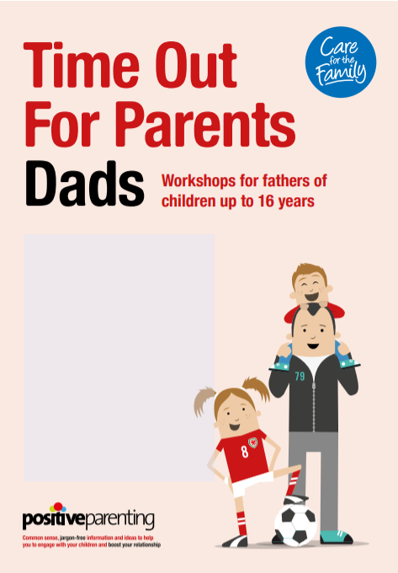

**FREE!**

**When?**

Every Friday, 9.15am – 11.15am

15th November – 13th December 2019

**Where?**

Holybrook Primary School

Rillington Mead

BD10 0EF

For more information or

to book your place

call 01274 437523 and ask to speak with Amanda Finn