Friday 20th December 2019
Our topic this term is
‘Around the world in 80 days’ .
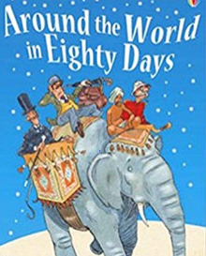
We will be reading about Phileas Fogg and his journey around the world.

Our learning journey will be about Christopher Columbus and why he is an important person.

For your homework we would like you to choose a country to explore. Choose a continent below then choose a country within the continent.
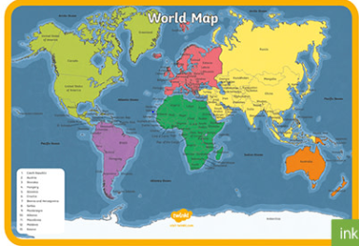
You can present your work as a poster, letter, postcard or mind map.
You might want to explore the countries;
- Landmarks
- Food
- Weather
- Animals
We look forward to seeing your creations!

