Year 3 Holiday Homework
Topic Project
How brave a warrior are you?
Carry out some research about the Celts (be as creative as you can!). You can do this however you wish. You could:
- Design a poster
- Create a model
- Design your own Celtic knot
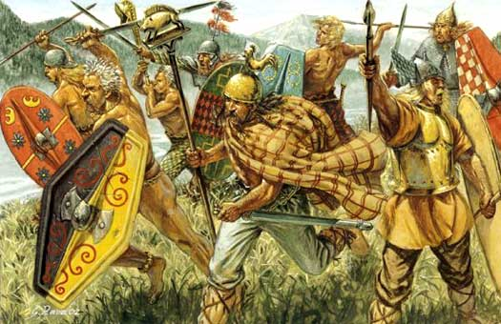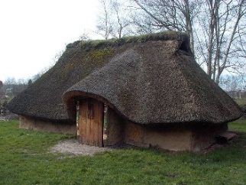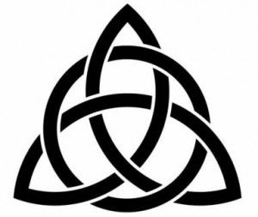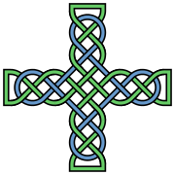
Maths
Key Instant Recall Facts (Year 3 – Spring 2).
Please practise multiplication and division facts for the 4 times table.
Spellings – Write a sentence for each of these words:
interest | island | knowledge | learn | length
library | material | medicine | mention | minute

Mathletics – Don’t forget to keep going on it! You can still achieve certificates over the holidays!
Reading journals –
Please try to complete at least one task during the holidays!

