Wibsey Primary School
North Road, Bradford, BD6 1RL
Headteacher: Mr N M Cooper

Dear Parent/Carer,
Thank you for your responses and application for a place at the childcare provision at school. We have had a very high number of requested places. Due to this and to ensure the safety of our staff and pupils, we need to gather further information from you to ensure that it is just for those families that fit the criteria outlined by the government.
Vulnerable children
If your child has an EHCP, is on a Child Protection or Child In Need plan or is a Child Looked After, we ask you to keep your children at home if possible. School will keep in contact with you during this time by phone calls to check on the welfare of the children and give support where needed. If you still require a place, could you please get your social worker to contact Mrs Smith to discuss this further.
Critical/Key Worker’s children.
Critical worker list: https://www.gov.uk/government/publications/coronavirus-covid-19-maintaining-educational-provision/guidance-for-schools-colleges-and-local-authorities-on-maintaining-educational-provision
The government guidance states that if workers think they fall within the critical worker categories they should confirm with their employer that based on their business continuity arrangements, their specific role is necessary for the contribution of this essential public service. Therefore, please provide school with either a letter or email from your employer outlining your specific role and why it is essential to the response to Covid-19 and the hours that you are working or give your employer’s details (name of manager and contact information) for us to contact them to verify your status. In trust and goodwill, if you are a doctor, police officer, nurse or teaching staff we accept that you are a critical worker and you do not need to provide evidence but please let us know of your working hours.
If there is a member of your family that is an adult and does not fall into the critical worker category then they must take responsibility of the child at home, this includes adults that are now working from home. If you are unsure please follow the flow chart provided below. SMLT members will be available tomorrow to discuss any concerns and to share information with.
We thank you for your patience and understanding at this time. Please do not hesitate to contact us via the app and we will attempt to respond as soon as we can.
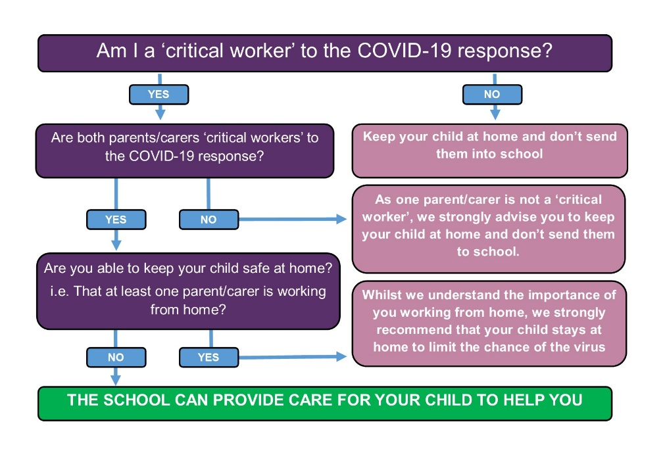
The Wibsey Team

