Year 4 Holiday Homework
Next half term, we will be beginning a local study of Saltaire. Over the holiday, we would like to research our main question for the term:
Why is Saltaire such a special place?

Think carefully about where Saltaire is, what makes it different, what you might have heard about the village itself already and what it looks like. It may be useful for you to do some research online or talk to someone at home who may know more about Saltaire.
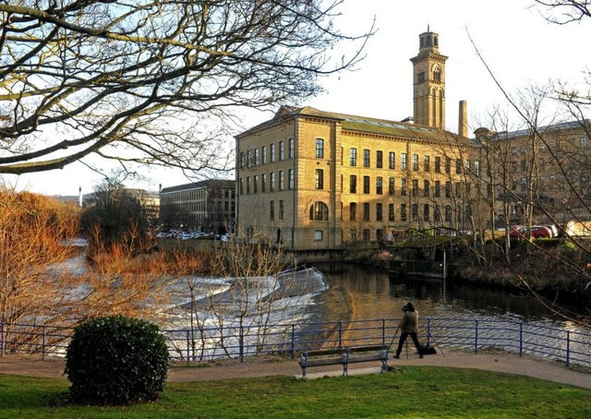
You could produce:
- Drawings
- A PowerPoint presentation
- Collages
- Poems
- Stories
- A newspaper report

Your homework will be presented to the rest of the class during the first week back.
We would also like you to:
- Go on TTRS
- Learn your KIRFs – shared on the school website
- Read your reading book
- Complete one of the reading tasks that can be found in your white reading journal.
- Learn the following spellings.
hear | there | wear | brake | sun
here | their | where | break | son

We hope that you have a super, safe and enjoyable break!
Mr Hudson, Mrs Bilevych and Miss Knowles

