Year One Reading Challenge!
Over the holidays, try to complete as many of these reading challenges as possible. Tick and date the ones you have completed, and return to your class teacher after half term.
Ebooks can be found on https://www.oxfordowl.co.uk/please-log-in
You will need to create a login but access to ebooks is free.
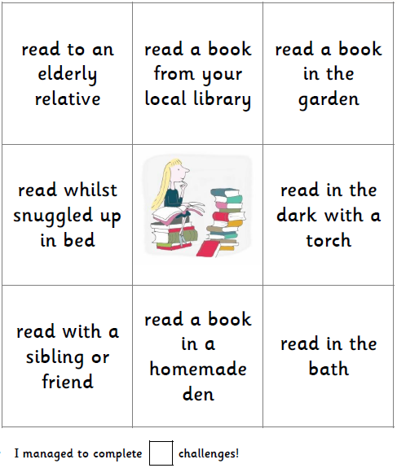
Choose a book from your local library.
Read a book in a homemade den.
Listen to a story snuggled up in bed.
Read your favourite book to your teddies.
Read your favourite book to a family member, using the pictures.
Read a book to yourself.
Ask a relative who doesn’t live in your house to read a story on a video call.
Ask an adult to read an ebook with you.

Here is a photograph of me completing one of the Reading Challenge tasks:

In this photo, I am reading ______________________________________________________________ by _______________________________________.
I enjoyed this task because _______________________________________________________________________________.

Make sure you get whoever you read with to comment in your reading journal about which task you have completed and how excellent your reading is!

