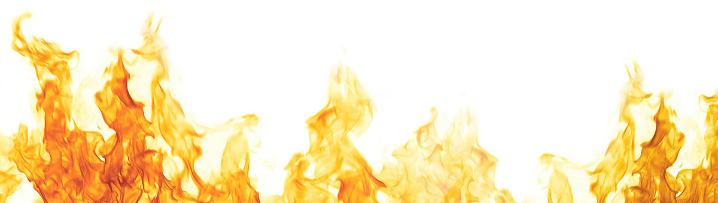

Holiday Homework.

Next half term, we will be learning about fire and we would like you to become researchers during the holidays!
For your homework we would like you to research and create a magnificent poster about fire. You might want to focus your poster on;
- The Great Fire of London
- Fire safety
- Bonfire night
- Diwali
We look forward to seeing your creations!

