Google Classroom | Getting started

What is Google Classroom?
Google Classroom is a free Google App that aims to simply creating, distributing and assessing learning in a paperless way. Teachers can use Google Classroom to send announcements to entire classes, share resources, lesson notes, PowerPoints, diagrams and home learning. Pupils can use it to access work covered in class in school, at home or on the go and complete home learning. Parents can use some of the features to engage with and support pupils in their home learning. It is a free resource that can be accessed from any device connected to the internet-laptops, desktop computers, tablets or mobile phones.

What is G Suite for Education?
GSuite for Education is a set of Google Apps: Docs, Sheets, Slides, Drive, Classroom, Calendar and more, designed with intelligent features that make work easier to complete. It is a suite of tools that can help increase opportunity for critical thinking, communication, collaboration and creativity, all while supporting the learning. Gmail will not be enabled for children at this time.

Accessing Google Classroom
- On your chosen internet browser, go to: www.classroom.google.com

- Enter your child’s unique Google Classroom username and password. These can be found in your child’s reading journal.
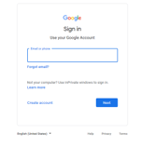

- Once pupils have logged in, they will see the class overview page. From here they can see all of the classes they are registered with. Clicking on a class will open that classroom.
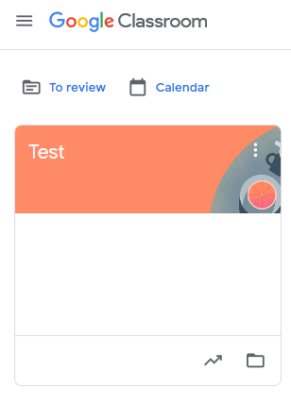
- ‘Stream’- New work that teachers have posted will appear in the stream here.
Click on the ‘Classwork’ tab to view learning that has been set.
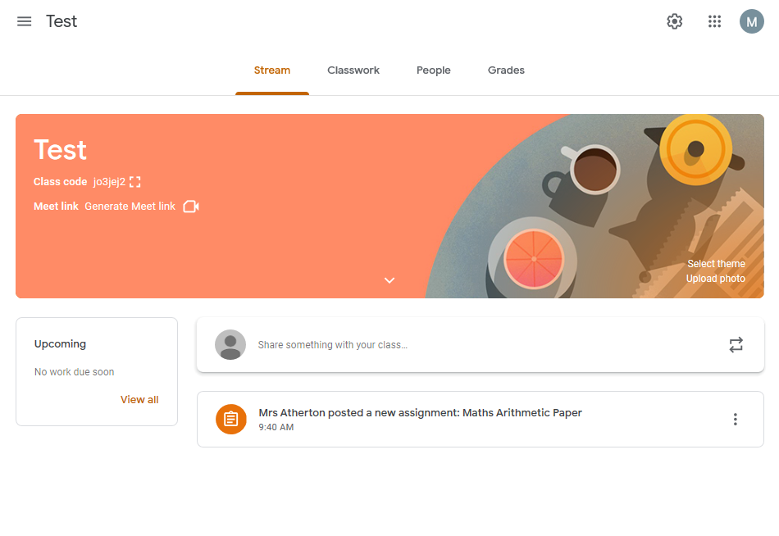
- ‘Classwork’- This is where you can view all of your current or ongoing learning tasks and deadlines. Learning tasks can be viewed by clicking individual assignments.
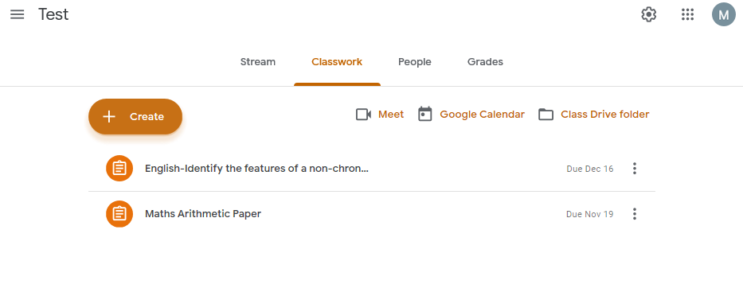
- ‘Assignment’- Click on the assignment to view the learning task.

Submitting learning
Learning can be completed and submitted in two ways. Pupils can complete their learning task on a variety of Google apps, such as Docs, Drawings, Forms and Slides. If a pupil is unable to do this, they can take a photo, video or audio of their learning and submit it as a file attachment instead.

- To complete a Google app document, click on the file under the section ‘Your work’.
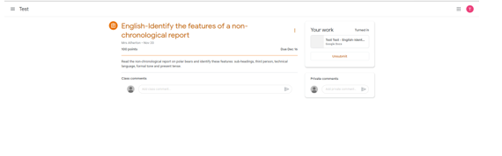
- Pupils can type straight onto the document and when they have finished they can close the tab in their web browser. There is no need to press save if you are connected to the internet as Google files are saved automatically.
- If you would prefer to submit a different file (photo, video or audio) containing the learning, click on ‘Add or create’.
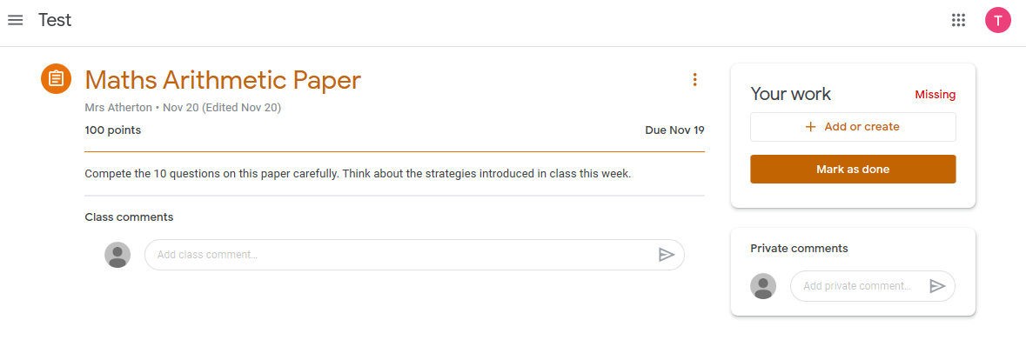
- There are several options to choose from. If you want to upload a file from your device, click ‘File’.
- Select the upload tab and then click on ‘Select files from your device’.
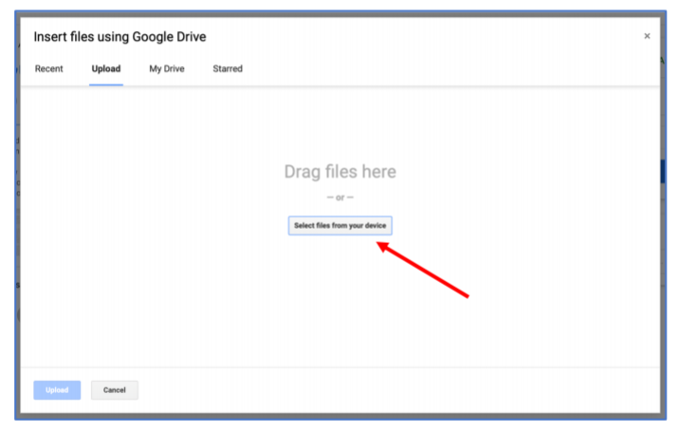
- Select the file (containing the learning) that you want to submit. Then click ‘Upload’.
- The file should now appear under ‘Your work’. Click ‘Turn in’ to submit learning.
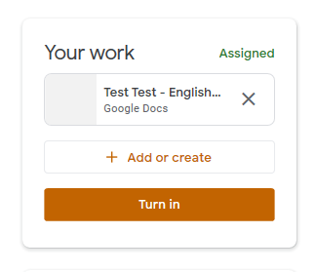
- If at any time you want to make any changes to your learning, you can click ‘Unsubmit’.

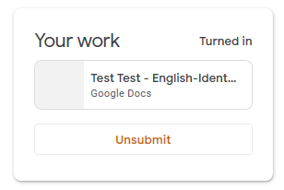
Although many safety features have been enabled by our administrators, it is still the responsibility of parents to monitor what children are accessing online at home. We will continue to teach children the importance of being responsible digital citizens and accessing age appropriate material and we appreciate parents supporting this at home with their children.

If you have any questions or comments, please send a MyEd App message to your child’s class teacher.

