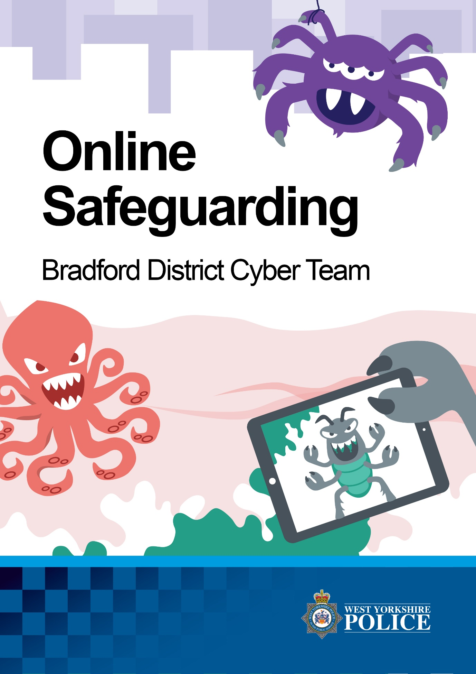
bd.cyberproblemsolvers@westyorkshire.pnn.police.uk
Social Media and CSE
Child sexual exploitation (CSE) is where someone takes advantage of a child, sexually, for their own benefit.
Some people use technology to make contact with children and young people with the intention of “grooming” them. To “groom” someone is to prepare them to do something for the benefit of the groomer.
Those who seek to groom children or young people might try to gain their trust by using a fake profile picture and fake personal details, as well as pretending to have similar interests in order to befriend them.
People who try to groom children and young people want them to believe these lies in order to get information such as:
- Their age
- Where they live
- Where they play
- Who else might use the computer, phone or technology that they use

Advice for parents/carers
Could you recognise some signs of online grooming?
Some sights may be:
- Increased/secretive use of mobile/internet – Changing password frequently, covering phones whilst using them in your company
- New ‘friends’ online – Number of online friends increased and some appear a lot older
- Receiving unexplained gifts online – On games or in app purchases, credit on phone
- Involvement in offending – Leaving mean messages (bullying) or displaying extreme views

Child sexual exploitation can take place online – On smart phones, tablets, computers and game consoles. Do you know who your children are talking to online? See our information about keeping young people safe online at http://www.westyorkshire.police.uk/cse

- Taking time to research and talking to your children about what they are doing online is one of the best ways to keep them safe

- Social Media might seem confusing if you don’t use it yourself, our simple guides can help with advice on privacy settings – http://www.westyorkshire.police.uk/cse/onlineguides

- Ensure privacy settings are in place on Social Media sites such as: Facebook, Twitter, Snapchat etc. It is extremely important that you have the correct privacy settings in place on your Social Media platforms. If these are not in place you run the risk of anyone accessing your personal information, some of which can be used to commit crime or even steal your identity.

- Keep the computer in a central location. It’s much easier to keep tabs on any online activity when the computer is located in an open location rather than, if your child is using a computer in the privacy of their own room.

- Make sure online games are age-appropriate. Some parents that would never let their children watch an over 18-rated film might think its ok to play with an over-18 game. The violence is just as graphic and have just as strong effect on children. Parents should be familiar with PEGI-the rating system for games that you can buy.

- Talk to your child. If you are concerned about your child’s internet use/behaviour then you should talk to them. If you think your child won’t talk to you, then ask a family friend, older sibling or cousin to have a chat. Communication is key, and you cannot keep your child safe unless you know what might be troubling them.

- Set up Parental Control. The four main internet service providers – Sky, BT, TalkTalk and Virgin Media – have parental controls that you can switch on by using their website, logging in and managing your account/security settings. You can also log on to www.opendns.com and setup controls/filters.

- Remember once status update or a picture is sent you lose control and may be out there forever. You cannot control where or who may see your pictures or posts. These can then sometimes be used against you.

Useful Sites
www.bradford-scb.org.uk
www.ceop.police.uk
www.thinkuknow.co.uk

www.nspcc.org.uk

www.barnados.org.uk
www.childline.org.uk

www.childrenssociety.org.uk

www.internetmatters.org
www.mesmac.co.uk/project/blast
www.childnet.com

www.iwf.org.uk
www.getsafeonline.org
www.commonsensemedia.com

www.net-aware.org.uk
www.safenetwork.org.uk
www.parentinfo.org
www.parentsprotect.co.uk

Useful Apps
Here are a few examples of parental control apps that parents/carers can use to monitor and manage their child’s phones, tablets, computers etc.
Mobicip My Mobile Watchdog Norton Family
Selfiecop FamilyTime WebSafety

There are many apps that can be used to help protect and manage devices, these can be found by completing an internet search.
Please note: West Yorkshire Police do not endorse any product, company or website. Those listed above are merely examples of different apps that are available and can be used for parental controls.

