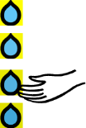  Distilling | Revising
1.What is this BLP muscle? | 1.What is this BLP muscle?
2.How will this BLP muscle help me with my learning? | 2.How will this BLP muscle help me with my learning?
3.What targets will I set myself for this half term? | 3.What targets will I set myself for this half term?
Interdependence
1.What is this BLP muscle?

2.How will this BLP muscle help me with my learning?

3.What targets will I set myself for this half term?
Imagining
1.What is this BLP muscle?

2.How will this BLP muscle help me with my learning?

3.What targets will I set myself for this half term?

