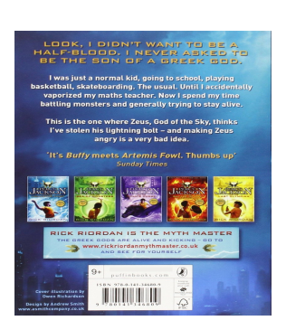
Thursday 7th January 2021
Blurb Picture

