Equivalent Fractions
LO: To use common multiples to find equivalent fractions and common factors to simplify fractions.
A fraction can be changed to an equivalent fraction by:
- Cancelling using common factors for example - 18/30 = divide both numbers by 6(HCF) = 3/5
- Multiplying using common multiples for example – 2/3 = multiply both number by 5 = 10/15
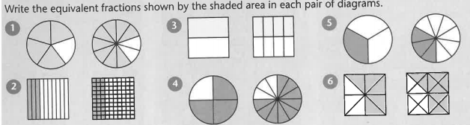
Task 1:

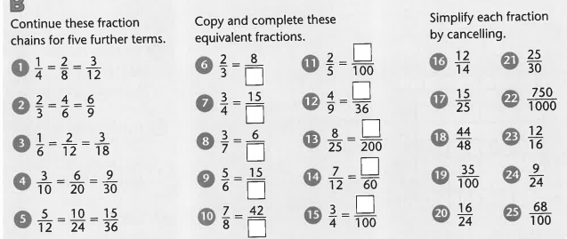
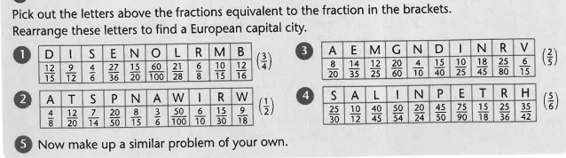
Task 3:

Task 2:

Have a go at the question starting with Task 1 and see if you can challenge yourself and get onto Task 3.

