Monday 25th January 2021
Maths
TTRS: Soundcheck
My Mini Maths: Complete the following questions
I can use a formal written method to solve - calculations (without exchanging).
Success Criteria
- Subtract the ones
- Subtract the tens
- Subtract the hundreds
- Subtract the thousands.

Fluency: Solve the subtraction calculations. Work it out on paper at home and write the answer in the table provided underneath the questions. You can send a photograph of your working out to the year 4 email address as additional evidence to show that you are secure with this method of calculation.

1. | 2. | 3. | 4.
5. | 6. | 7. | 8.

Problem-solving: Identify the missing digits. Work it out on paper at home and write the completed calculation in the table provided underneath the questions. You can send a photograph of your working out to the year 4 email address as additional evidence.

1 | 2 | 3 | 4

Use reasoning to explain how you solved calculation number 4.

English
Spelling: Fix the spelling mistakes
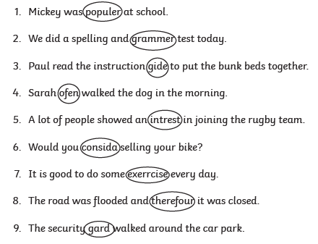
1.
2.
3.
4.
5.
6.
7.
8.
I can use expanded noun phrases and use commas to separate
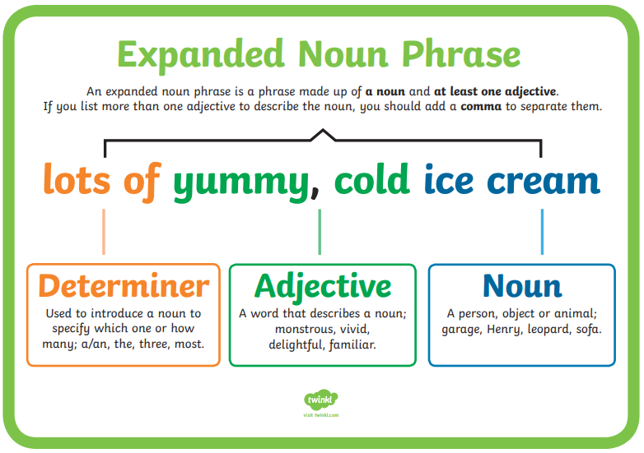
Hard: Read the sentences and underline the expanded noun phrases.
- The suspicious, dark figure slipped into the night.
- The loud, brass bell began to chime in the tower.
- A lonely, old woman was visited by her children.
- In the middle of the desert, the scorching, golden sand fell untouched.
- It was late at night, the cold, icy wind blew against the window.
- All of a sudden, the ferocious, hungry lion opened its gigantic, wide jaw.
- Under the ground, the sly, fluffy fox curled up into a tight, comfy ball and went to sleep.
Harder: Rewrite the sentences and include the correct punctuation.
- The hungry tired children ate their delicious fresh sandwiches.
- The crunchy white snow fell onto the creaky wooden houses.
- The forgetful helpless man forgot his old rusty keys.
- An eager skinny boy ran to class trying not to be late.
- As the large admiring audience went silent the elegant nervous woman began to sing.
- As they entered the gigantic park the obedient, tiny dog jumped for joy.

Hardest: Write a sentence about the following character including your own expanded noun phrase.
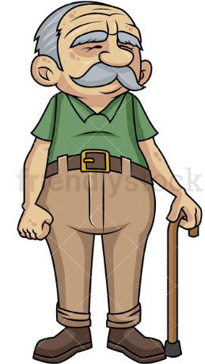 |  | 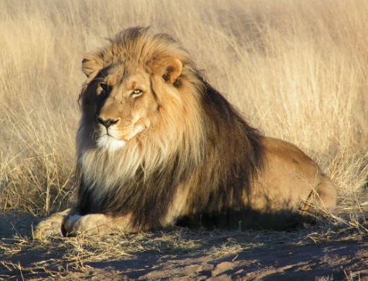 |  | 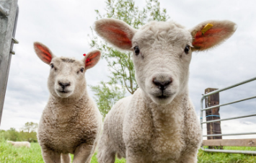
man | doctor | lion | baby | sheep | children

Use the adjective list below to help you.
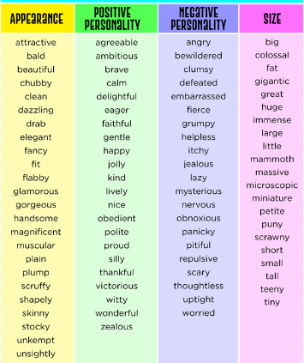

Music
Log on to Charanga: Username: 6233 Password: Bradford

Go to Freestyle
Visit the Listening centre.
Find the listening calendar and select January
Listen to: Eine Kleine Nachtmusic by Wolfgang Amadeus Mozart
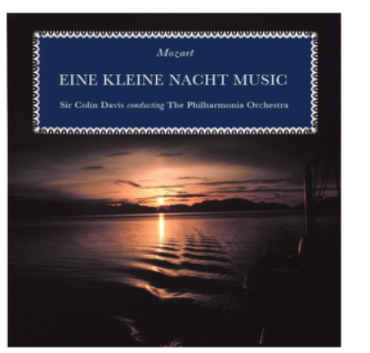
Use the key questions to discuss the music. Try to use musical vocabulary related to the tempo of the music.
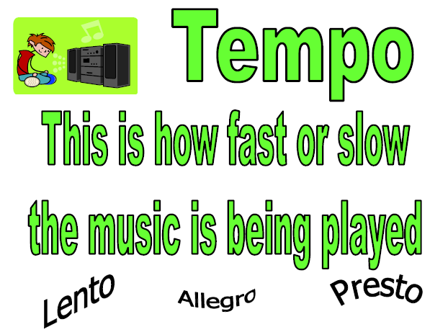

Say sentences to answer the questions.
- What can you hear?
- How would you describe the song?
- Do you like the song?
- How does it make you feel?

WSFL : I can take care of my mental health.
Look at following actions that help to take care of mental health.
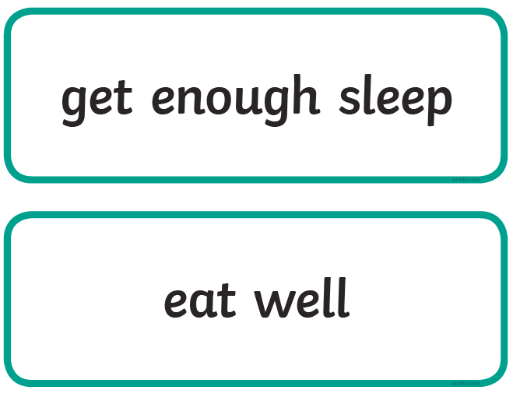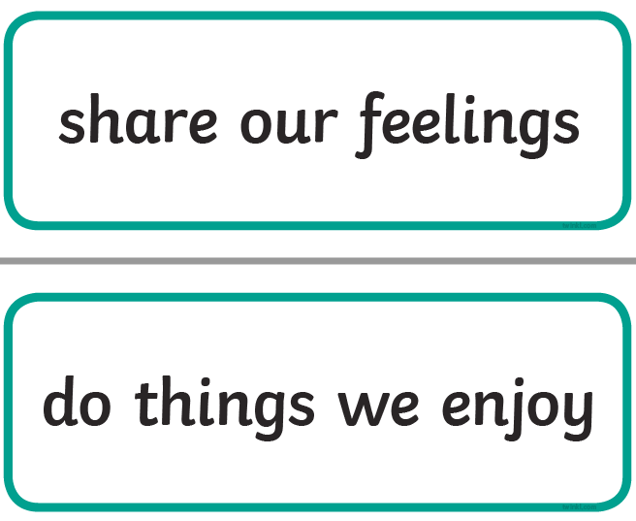
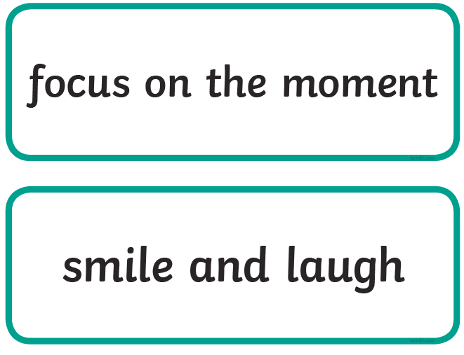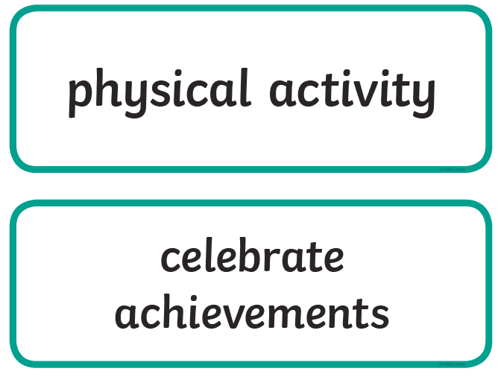
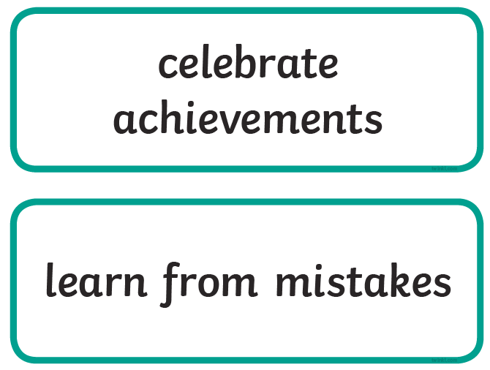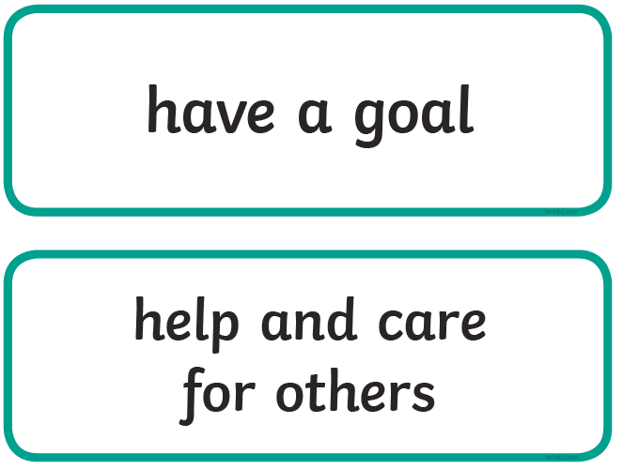
Discuss and make a list of 3 things that you already do and explain how they help to take care of your mental health.
3 things that I do to help take care of my mental health:
1.
2.
3.
Make a list of 3 new things that you are going to try and do this week in order to take care of your mental health.

3 different things that I am going to try and do in order to help take care of my mental health:
1.
2.
3.

Tuesday 26th January 2021
Maths
TTRS: Soundcheck
My Mini Maths: Complete the following questions
I can use a formal written method to solve subtraction calculations (with exchanging).
Success Criteria
Fluency: Solve the addition calculations. Work it out on paper at home and write the answer in the table provided underneath the questions. You can send a photograph of your working out to the year 4 email address as additional evidence to show that you are secure with this method of calculation.

1 | 2 | 3 | 4

5 | 6 | 7 | 8

Problem-solving: Identify the missing digits. Work it out on paper at home and write the completed calculation in the table provided underneath the questions. You can send a photograph of your working out to the year 4 email address as additional evidence.
1 | 2 | 3 | 4

Use reasoning to explain how you solved calculation number 4.

English
Spelling: Find and fix the spelling mistakes
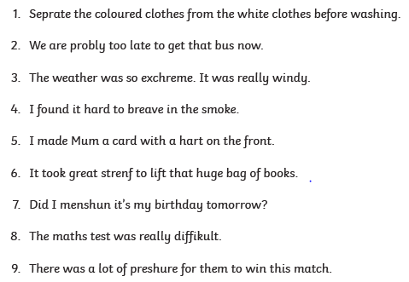

1.
2.
3.
4.
5.
6.
7.
8.
26.01.21 I can use expanded noun phrases in my writing
Watch the following clip – ‘Mega City’
https://www.literacyshed.com/megacity.html

Hard: Looking at the different examples, which would be best to use to describe the setting, characters and objects in this story?
1. | The scruffy, lonely boy | or | the happy, clean boy
2. | The empty, calm streets | or | The lively, crowded streets
3. | the soft, light rain | or | the heavy, cold rain
4. | the mysterious, quiet people | or | the friendly, talkative people
5. | his new, shiny bike | or | his rusty, fragile bike

Harder – Use your chosen expanded noun phrases from Hard to create your own full sentences.
WAGOLL: As the crowd cleared, the scruffy, lonely boy strummed joyfully on his guitar.

Hardest
- Use some different adjectives to create some new expanded noun phrases
- the ________________ , _______________ boy
- his ________________ , _______________ dog
- the ________________ , _______________ people
- the ________________ , _______________ rain
- the _________________ , _________________ streets
- Use your new expanded noun phrases to create your own full sentences.
(Remember: don’t forget your punctuation)

- .
- .
- .
- .
- .

Geography
I can identify the different plants that live in the rainforest and explain how they are used.
Read the information.
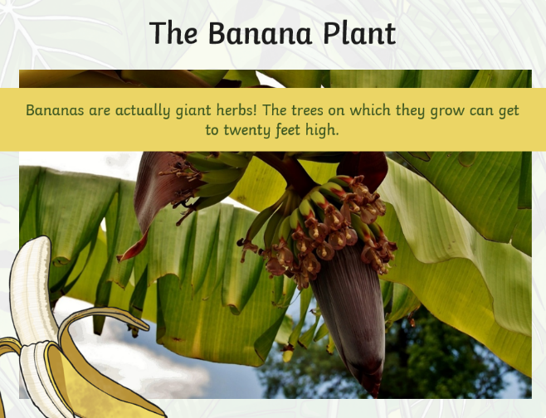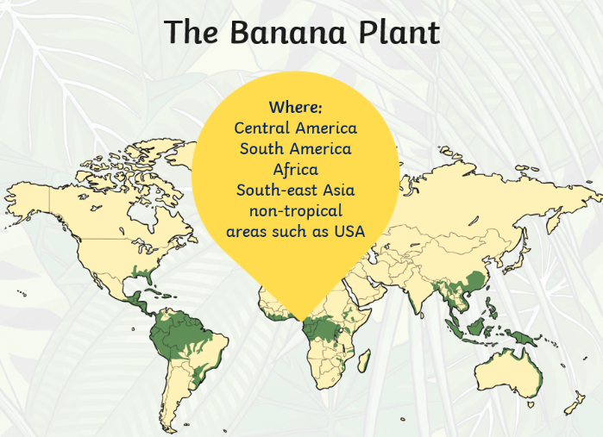

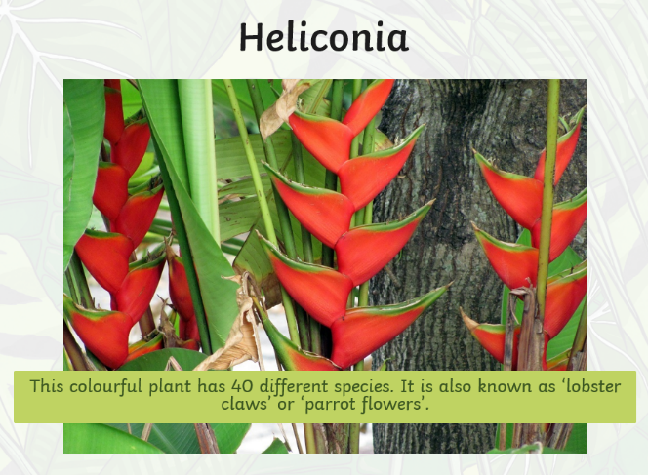
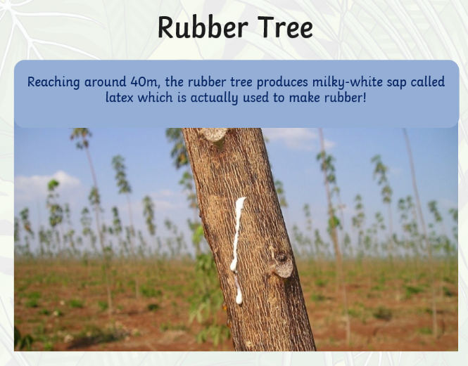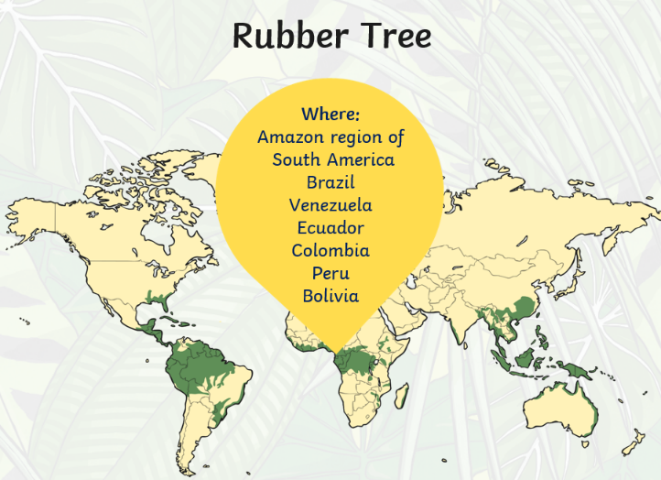
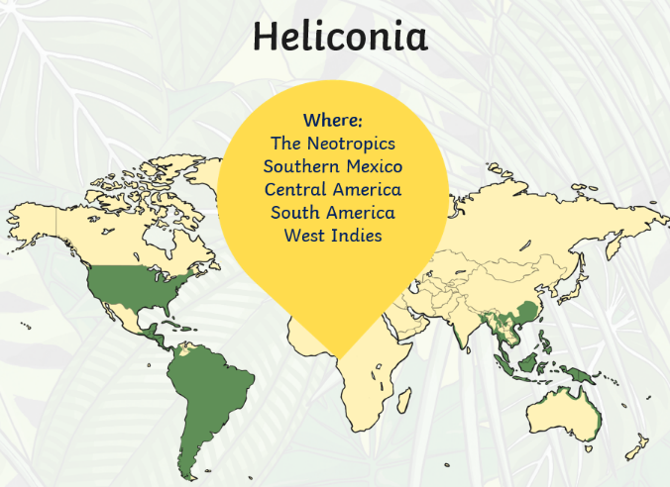

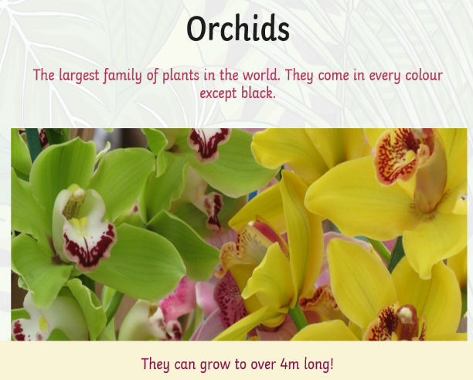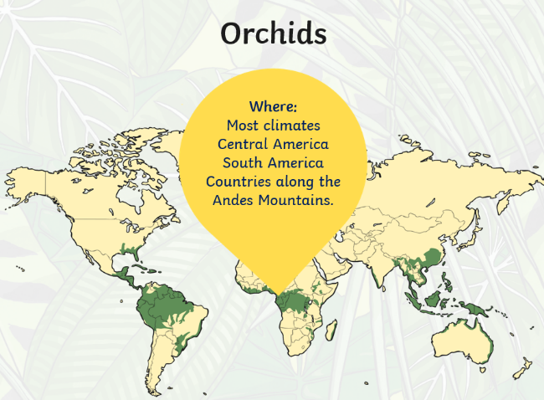
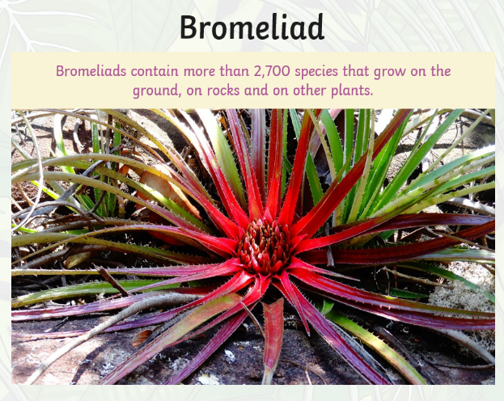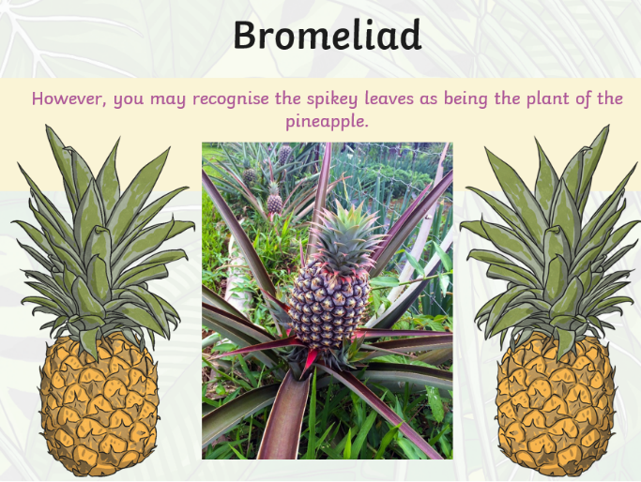
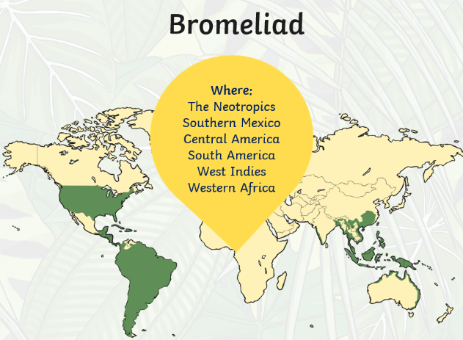
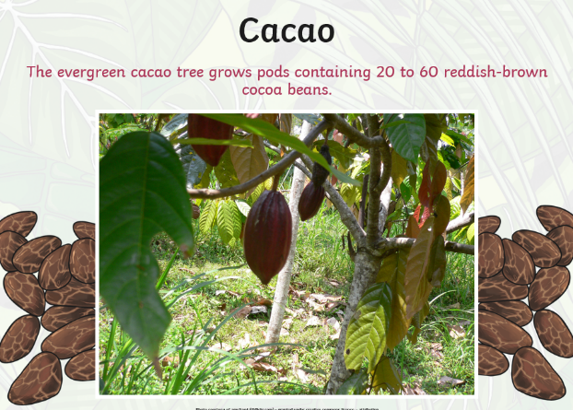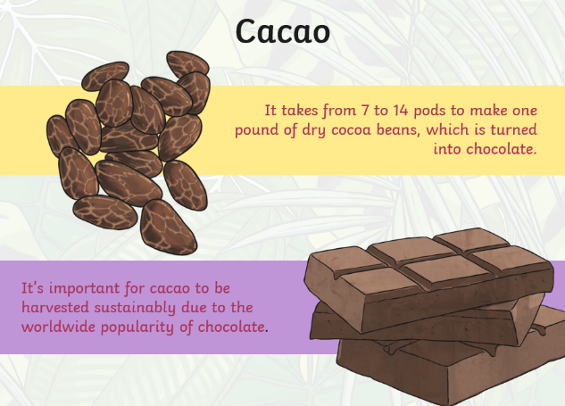

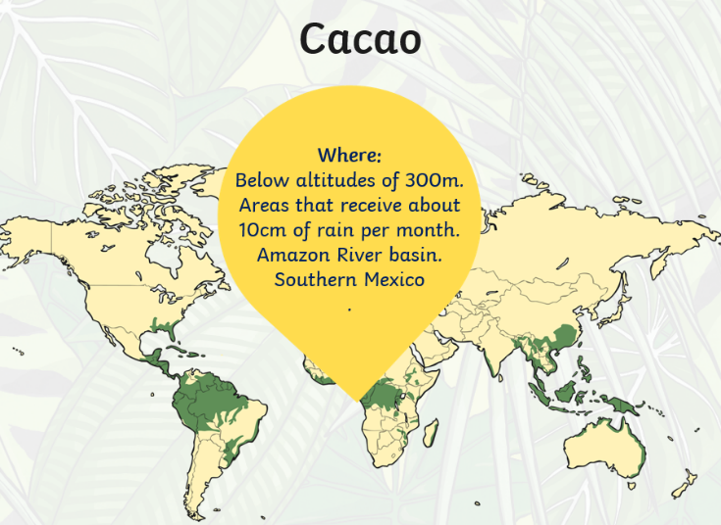
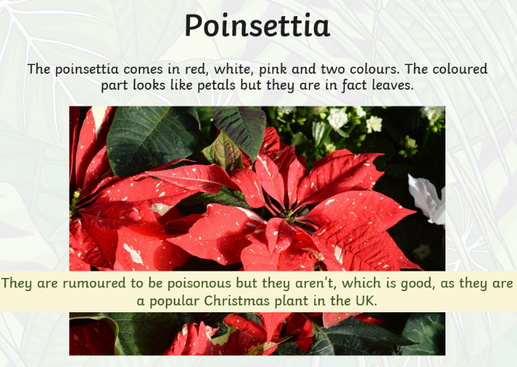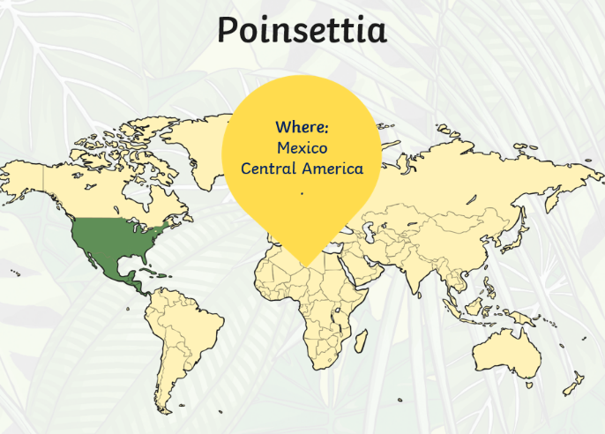
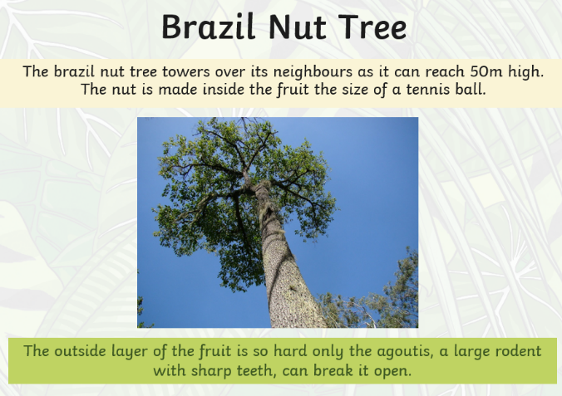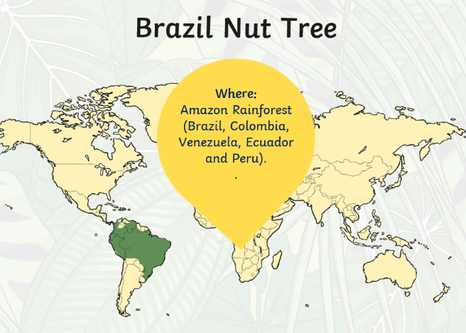
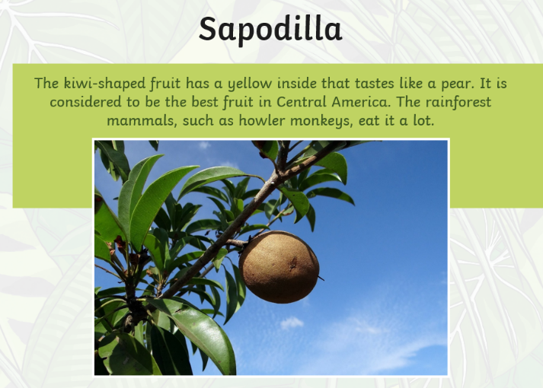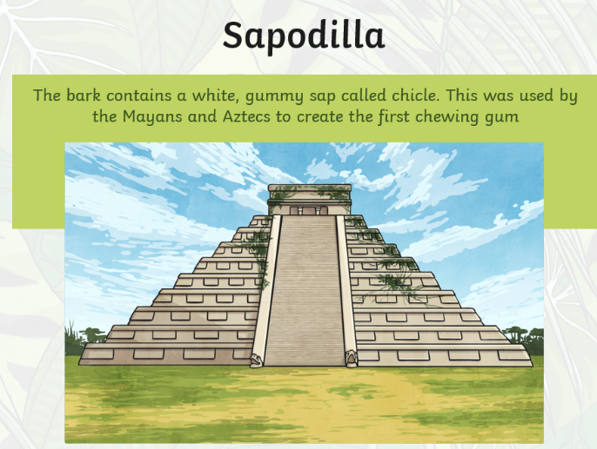
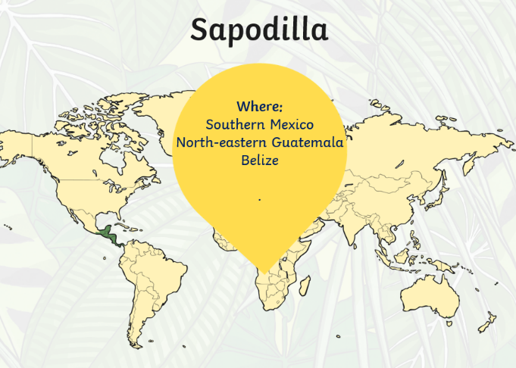
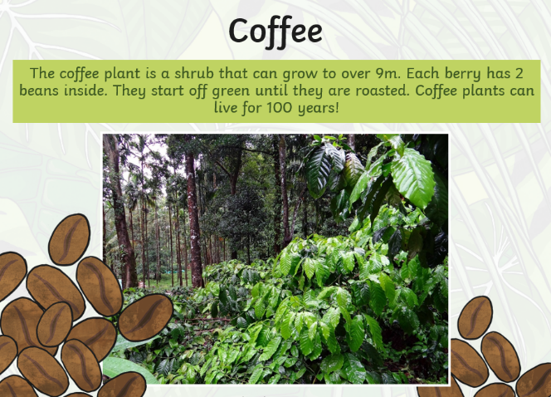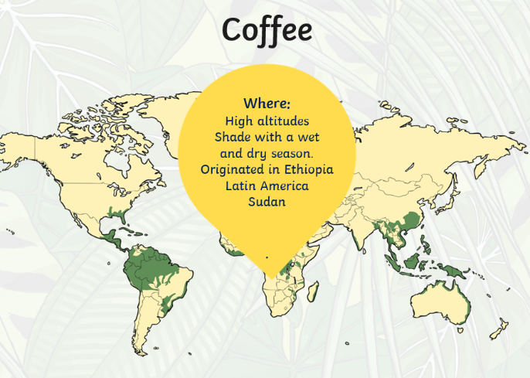
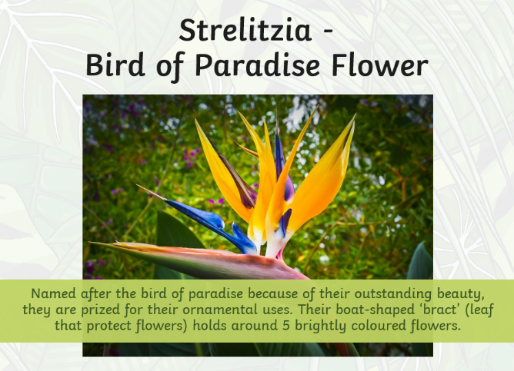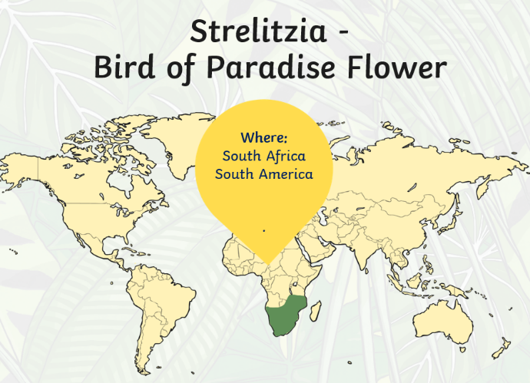
Hard: Know it. Complete the table and make a list of the different plants that grow. Identify where they grow and explain how they are used. The first one has been done for you.
Plant | Where does it grow? | How is it used?
Banana Plant | Central America, South America, Africa, South East Asia and USA | They are used to grow bananas.

Harder: Use what you know. Think about what you have found out. Use it to decide which three plants you consider to be the most important and explain your ideas. Think about what life would be like without the plant to help you to justify your ideas.

The 3 plants which grow in the rainforest that I consider to be the most important:
1.
2.
3.

Hardest: Evaluate what you know. Think about one of the plants and find out more about it. Use the additional information that you have found out to make an informative poster about the plant.

Here are some useful websites:
https://wiki.kidzsearch.com/wiki/Rainforest

http://www.primaryhomeworkhelp.co.uk/rainforest.html

Wednesday 27th January 2021
Maths
TTRS: Soundcheck
My Mini Maths: Complete the following questions
I can use a formal written method to subtract decimal numbers (with exchanging)
Steps to success
- Line up your digits in the correct columns.
- Write your decimal point in the answer line.
- Subtract as normal – beginning at the hundredths column and moving left from there until completed.

Fluency
Complete your working out with a paper and pencil and then write your answers in the grid below.
a | b | c
d | e | f
g | h | i
j | k | l

Problem-solving: Work out on paper and then answer in the box below
1.
2.
3.

Spelling task:
Log on to Purple Mash and complete the spelling task that has been set as a 2do for you.
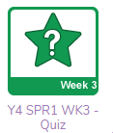
I can retrieve information from a text.
We are currently reading a story called ‘Around the world in 80 minutes’ on purple mash.
Read Chapter three – this has been set as a 2do for you.
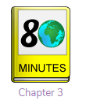
When you read the story, you can click on the underlined words and the definitions of the words will be explained to you.

When you have finished reading the chapter, answer the questions in the purple mash quiz. This has also been set as a 2do for you.

Thursday 28th January 2021
Maths
TTRS: Soundcheck
My Mini Maths: Complete the following questions
I can use column methods for addition and subtraction to solve problems
Problem-solving: Use your addition and subtraction skills to find the missing numbers in the pyramid.

Challenge – Can you create your own pyramid problem for someone else to solve?

English
Spelling task: Fix the spelling mistakes.
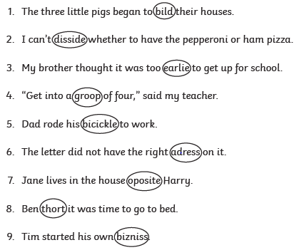
1.
2.
3.
4.
5.
6.
7.
8.

I can use expanded noun phrases to write a story opening
Go to https://www.literacyshed.com/megacity.html and watch the clip called ‘Mega city’.
You are going to write a story opening at the end of this document about what happens at the beginning of the video. You may wish to break your story into three paragraphs like this. Spend 5 minutes making some quick notes about the video now.
Paragraph | What is it about? | Notes
Paragraph 1 | Describing the setting  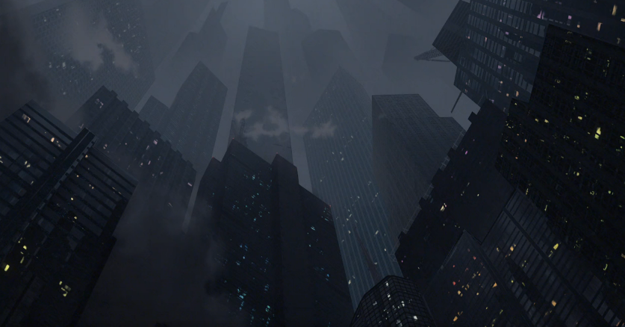  Where does this story take place?  5 senses? | - busy, crowded street
Paragraph 2 | Who are the main characters?  - appearance?  - personality?  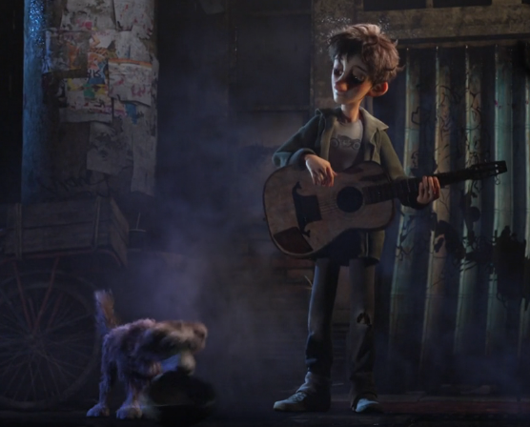 | - scruffy, playful puppy.
Paragraph 3 | What are they doing and what is it like on the streets?  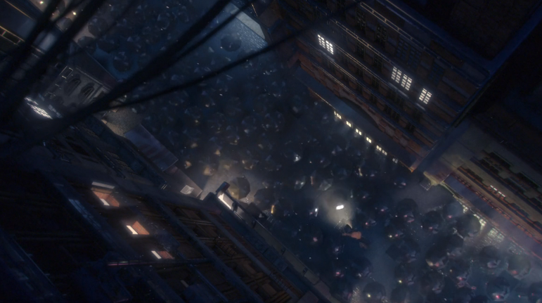 | - blistering, howling wind

In your story opening, try to use some of the features we have learnt about this week, as well as what we have looked at in previous weeks.
TIP: Use your expanded noun phrases to describe the characters and what it’s like on the streets.
Skill | Examples
Contractions | didn’t, hadn’t, shouldn’t, wouldn’t
Verbs | barged sang sniffed climbed  stroked snuggled charged leapt  threw kicked flew collaborated
Present perfect | “He has dropped his money!” shouted the boy.  “We have been here too long,” sighed Jack.
Expanded noun phrases | The beaming, glowing street lamps  the exhausted, young man
Conjunctions | if, since, as, when, after, while, although, because, until, before, and, but, yet, so, or
My Story Opening

Science
LO – I can name and group a variety of living things based on feeding patterns and compare habitats found in other places
BLP – Making Links

https://www.bbc.co.uk/bitesize/topics/zbnnb9q/articles/zwbtxsg

Follow the link above, watch the video, read the information and then have a go at the quiz. What score did you get for the quiz?
I got ___ out of 5 in the quiz.

Now that you know a little bit about food chains and why they are important to understand, you are going to be having a go at three ‘Food Chain Challenges’ below. For each activity, you need to find the different food chains that would be seen in that biome. Spend ten minutes having a go at each one, before moving on to the final task of the lesson.

The Savannah: https://www.bbc.co.uk/bitesize/topics/zbnnb9q/articles/z93vdxs

The Tundra: https://www.bbc.co.uk/bitesize/topics/zbnnb9q/articles/zcgbjty

Woodland: https://www.bbc.co.uk/bitesize/topics/zbnnb9q/articles/zsphrwx

Challenge
You should now have a growing awareness of the different food chains that are seen around the world. Your final challenge is to:
- Choose a biome that you looked at for the Food Chain Challenges. You could choose The Savannah, The Tundra or Woodland.
- Create a poster all about the different food chains found within that biome. Try to make your poster both attractive and packed-full of information.
- Take photos and send to your teachers.

Friday 29th January
Maths
TTRS: Soundcheck
My Mini Maths: Complete the following questions
I can complete Arithmetic Test 3
Complete this using the ‘Google Forms’ file.

English 29.01.21
Spelling: Find and fix the spelling mistakes.
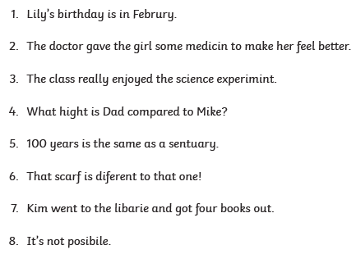
1.
2.
3.
4.
5.
6.
7.
8.

I can use my best handwriting to publish my written piece
You should now have typed up your story opening based on the short film about a young boy and his dog called ‘Mega City’.
For today’s task, you need to use a pen and paper to write your story opening up in your best handwriting. Try to read over your work carefully to check for any ways that you can improve it.

Make sure that you take a photo of your hand-written work when you are done and email it to year4@wibsey.bradford.sch.uk .

Your teachers cannot wait to see your beautiful handwriting!

Art
Starter:
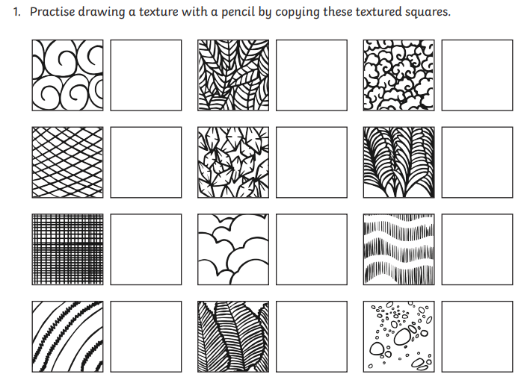

Your task is to experiment with different textures to create a 3D look.
Look at the different drawing techniques and copy the 3D effects. Have a go yourself.
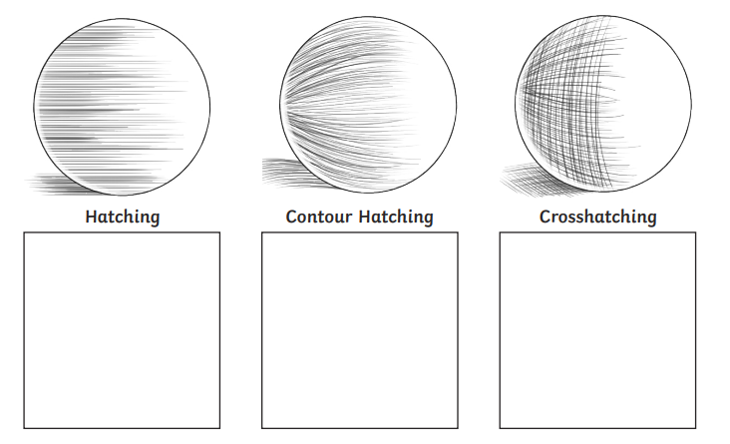
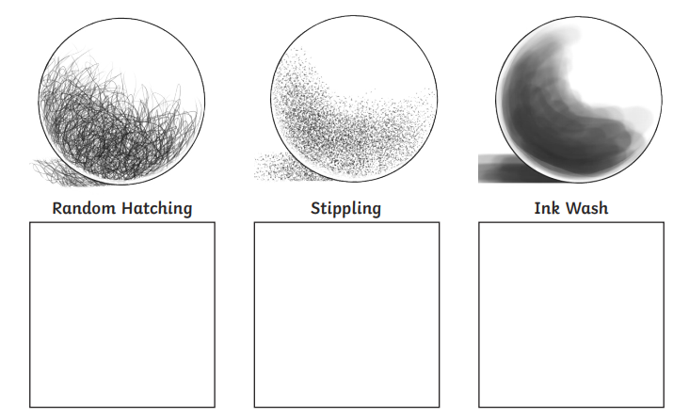
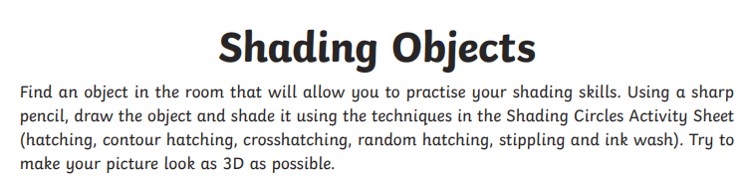

Computing:
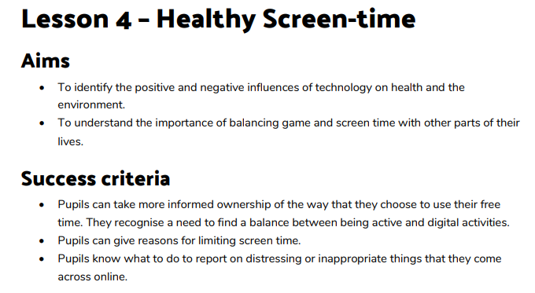
For this lesson we are going to learn all about Healthy Screen. How much time should you spend on a device and what classes as healthy?

Look at the record sheet underneath

This is Joe Black’s screen time record card from last week.
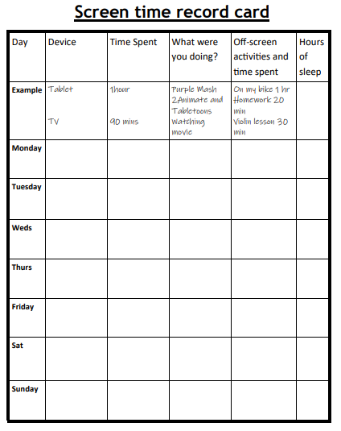
Laptop 2 hours work for school 1 hour bike ride 6

Tablet 3 hours watching videos 30 mins played in 7
garden
Laptop 2 and half hours work for school

Laptop 2 hours work for school 7
Phone 1 hour playing games 3 hours arts and
crafts
Phone 1 and half hours playing games 30 mins playing
With brother 8
Laptop 2 hours work for school

Tablet 30 mins watching videos 7
Play station 1 hour playing games
Laptop 1 hour work for school

Phone 1 hour playing games 2 hour walk 5
Playstation 2 hours playing games
TV 5 hours watching films

TV 3 hours watching Peppa 3 hours plaing in
Garden 7
Tablet 3 hours watching videos 30 mins walk

Answer the following questions by looking at the score card above.
Do you think Joe has a good balance between screen time and other activities throughout the week?
Please explain your answer.

This week we would like you to fill out your Screen time record card for how much screen time you use ready for next week’s lesson.

Day | Device | Time spent | What were you doing? | Off-screen activities and time spent | Hours slept.
Monday
Tuesday
Wednesday
Thursday
Friday
Saturday
Sunday

