Important things to do each day

Get yourself dressed. Only ask an adult for help if you really get stuck and can’t put something on by yourself. Can you get quicker each day?
Brush your teeth twice a day; after your breakfast and before you go to bed.
Count the number of steps in your house; when you come downstairs for breakfast each morning and when you go back upstairs to bed at night.
Read a bedtime story with an adult or older brother/sister.
Practise drawing lines and circles, or writing your name (You could use pens, pencils, chalk or water & a paintbrush on the doorstep).

- See how many sounds can you recognise on the Listening Game – Phase 1 Phonics (Listening & Attention Skills). Copy the link below into your search bar https://youtu.be/h0Kp_J9kvNM

Make Goldilocks & the 3 Bears puppets

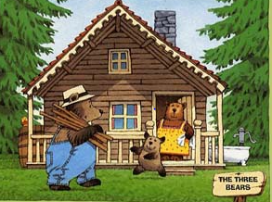

- Print out the story characters below, or draw your own Goldilocks & the 3 Bears. Now carefully cut around them; ask an adult for help if you get stuck. Sellotape them on to lolly sticks, spoons or something similar.

- Print out the ‘Winter Pencil Control’ pages in the home learning and carefully draw along the dotted lines. If you aren’t able to print them out, draw circles to make a snowman and lines to make snowflakes.

