Important things to do each day

Get yourself dressed. Only ask an adult for help if you really get stuck and can’t put something on by yourself. Can you get quicker each day?
Brush your teeth twice a day; after your breakfast and before you go to bed.
Count the number of steps in your house; when you come downstairs for breakfast each morning and when you go back upstairs to bed at night.
Read a bedtime story with an adult or older brother/sister.
Practise drawing lines and circles, or writing your name (You could use pens, pencils, chalk or water & a paintbrush on the doorstep).

- Watch the video in today’s home learning ‘What’s in the bag: things beginning with m’.

Once upon a time there was a little girl called Goldilocks…

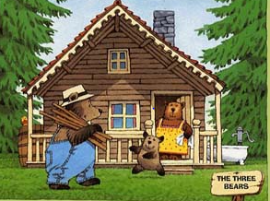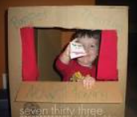

Use your Goldilocks & the 3 Bears puppets to tell the story. You could ask someone else to help. If you have an old cardboard box, cut out one side and turn it into a puppet theatre. If not, crouch down behind the sofa so no one can see you. Hold up your puppets so that they look as though they’re walking along the back of the sofa. Remember to start your story by saying: ‘Once upon a time…’

Walk 10 big Daddy Bear sized steps.

Walk 10 medium Mummy Bear sized steps.

Walk 10 small Baby Bear sized steps.

