Important things to do each day

Get yourself dressed. Only ask an adult for help if you really get stuck and can’t put something on by yourself. Can you get quicker each day?
Brush your teeth twice a day; after your breakfast and before you go to bed.
Count the number of steps in your house; when you come downstairs for breakfast each morning and when you go back upstairs to bed at night.
Read a bedtime story with an adult or older brother/sister.
Practise drawing lines and circles, or writing your name (You could use pens, pencils, chalk or water & a paintbrush on the doorstep).

- Watch the letter ‘a’ video in today’s home learning.

- Help set the table for dinner. Count how many people are in your family, now get the correct number of knives, forks, spoons and anything else that you think you’ll need. Talk about the food that you’re eating. Can you remember what everything is called? Is it hot, cold, sweet or spicy? I hope it tastes yummy.

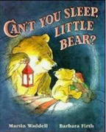

Listen to the story: ‘Can’t You Sleep, Little Bear’ by Martin Waddell
- https://youtu.be/u1aJimzuzbg

