Important things to do each day

Get yourself dressed. Only ask an adult for help if you really get stuck and can’t put something on by yourself. Can you get quicker each day?
Brush your teeth twice a day; after your breakfast and before you go to bed.
Count the number of steps in your house; when you come downstairs for breakfast each morning and when you go back upstairs to bed at night.
Read a bedtime story with an adult or older brother/sister.
Practise drawing lines and circles, or writing your name (You could use pens, pencils, chalk or water & a paintbrush on the doorstep).

Sorting m and s things

- Put 2 trays or mats on the floor. Write ‘m’ on one piece of paper and ‘s’ on another piece (or print the letters ‘m’ and ‘s’ below). Put one letter on each tray.
- Look around your house for things beginning with ‘m’ and ‘s’, then match each item to the correct letter sound.
- Which group contains the most objects?
- Which group contains the fewest objects?

Where’s the troll? Where’s he gone?

- Build another bridge and find a little person or toy to pretend to be the troll. Now ask your adult to hide the troll in different positions around the bridge (under, behind, in front, on top). Tell them where the troll is hiding using the correct positional word, don’t just point.

Listen to Mrs Larvin reading the story ‘Shark in the Park on a Windy Day’

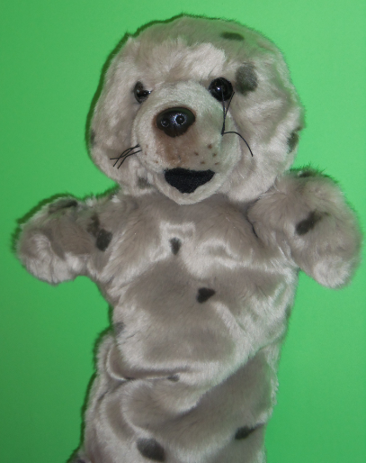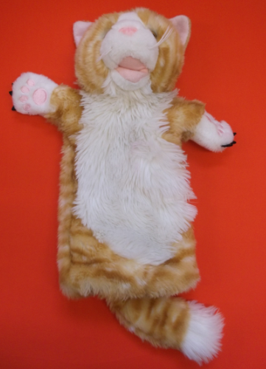
- Watch Miss Rankin’s video with Collaborative Clarice and her new friend Copy Cat.

m

s

