Important things to do each day

Get yourself dressed. Only ask an adult for help if you really get stuck and can’t put something on by yourself. Can you get quicker each day?
Brush your teeth twice a day; after your breakfast and before you go to bed.
Count the number of steps in your house; when you come downstairs for breakfast each morning and when you go back upstairs to bed at night.
Read a bedtime story with an adult or older brother/sister.
Practise drawing lines and circles, or writing your name (You could use pens, pencils, chalk or water & a paintbrush on the doorstep).

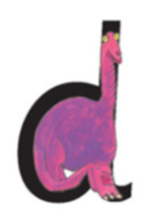
- Find 5 things from around your house that start with the sound ‘d’.
- Put your teeth together and say each word – listen carefully as you say the ‘d’ sound at the start.
- Put the items on the floor and cover them up with a cloth. Close your eyes and ask an adult or brother/sister to take one item away and hide it behind their back.
- Remove the cloth. Can you work out what’s missing? Now repeat with other items.

Are you ready to do some dinosaur counting?

- Pretend you’re a dinosaur and do 10 big dinosaur stomps.
- Pretend you’re a dinosaur and do 10 tiny dinosaur steps.
- Pretend you’re a dinosaur and do 10 huge dinosaur strides.
- Count the spots on each of the spotty dinosaur pictures in today’s home learning.

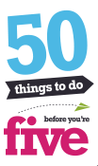
#42 –The Rough and The Smooth

Get your playdough ready for a DOUGH DISCO

Remember that everyone who takes part, has their name put into the ’50 things’ prize draw.

