Monday 11th January 2021
English 11.01.21

Spelling task: Fix the spelling mistakes.
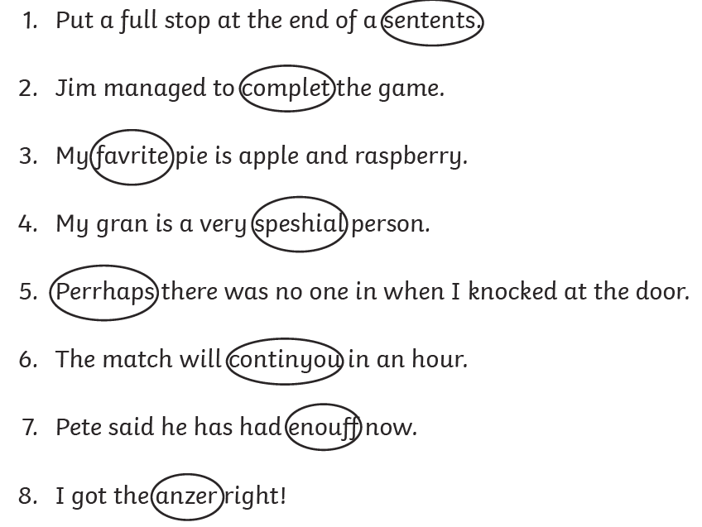
1.
2,
3.
4.
5.
6.
7.
8.

I can identify and use verbs in my writing.
A verb is an action word.
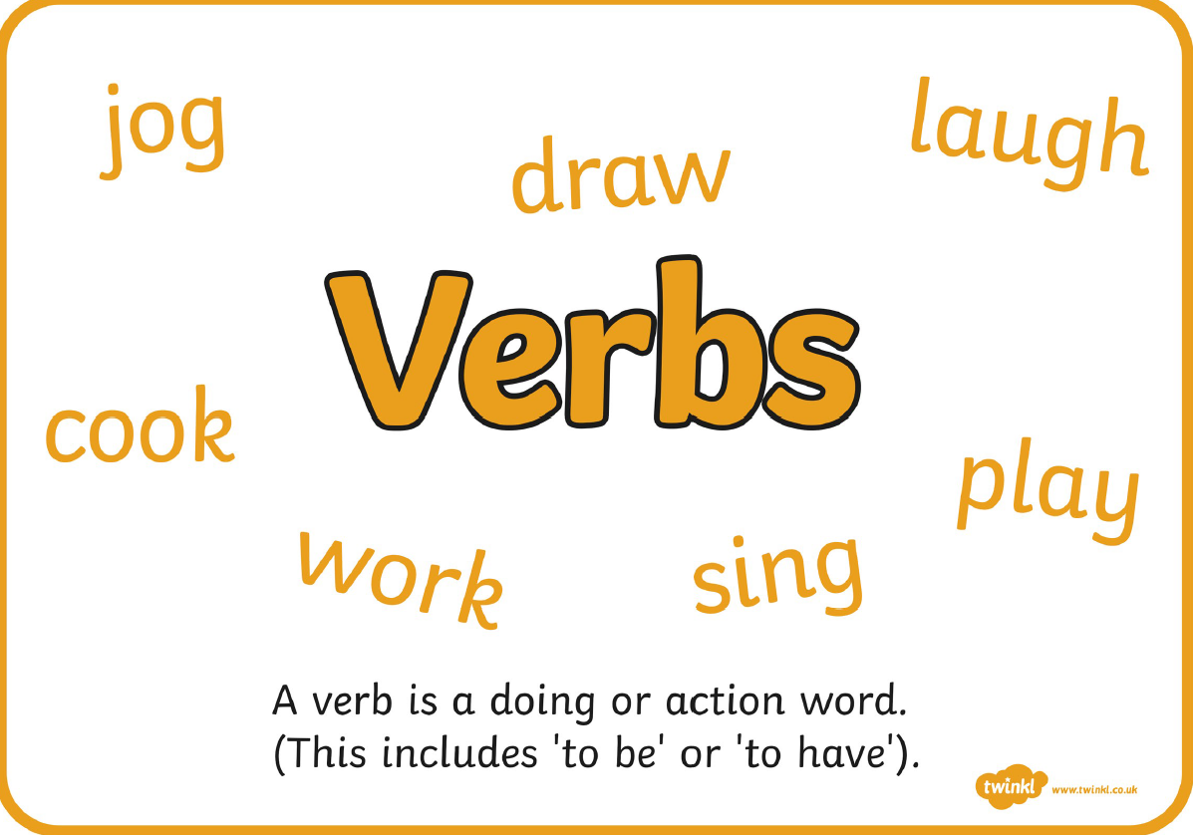
Hard: Role play and pretend to do 5 different actions at home for an adult to guess.
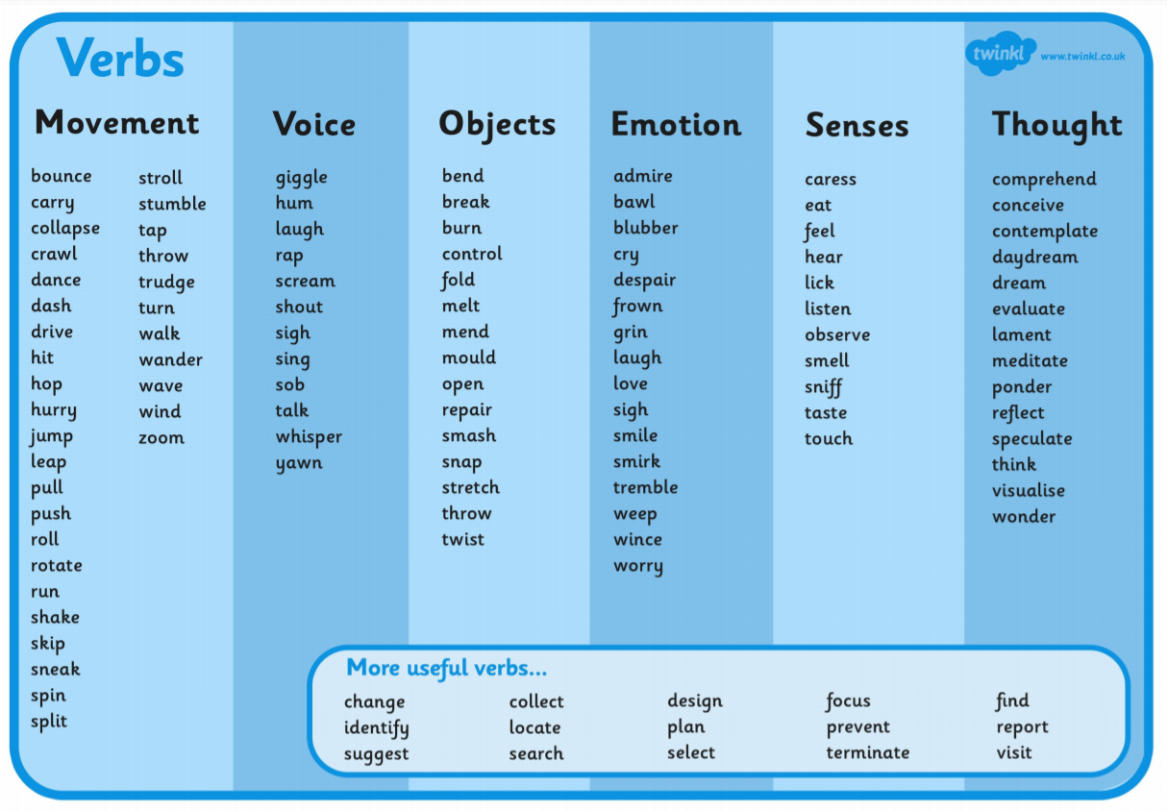

Harder: Read the sentences. Find and write the verbs used. There is more than one verb used in each sentence!

She yawned as she climbed the steps upstairs to bed.

The dog stretched and jumped over the wall.

He wondered where to go next.

They hurried down the road because they didn’t want to be late.

We designed our model and collected the materials needed to create it.

Hardest: Use the verbs that you found to write your own ideas for sentences.

Maths
TTRS: Soundcheck
My Mini Maths: Complete the following questions
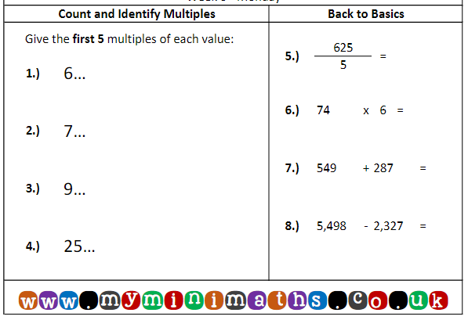
Order these numbers from largest to smallest.  - 7236  - 3762  - 1823  - 9432  - 6729  - 2734 | Order these numbers from largest to smallest.  - 6304  - 6743  - 6225  - 6874  - 6912  - 6821 | Order these numbers from largest to smallest.  - 1400  - 1432  - 1472  - 1443  - 1465  - 1411
I can order 4 digit numbers.
Choose your level of challenge!

Problem-solving
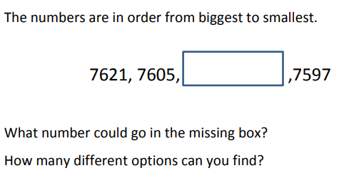

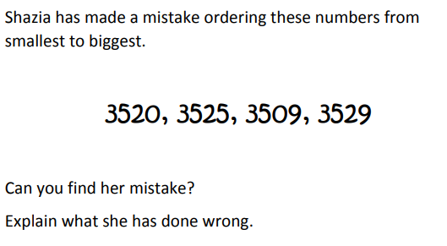

Music
Log on to Charanga: Username: 6233 Password: Bradford

Go to Freestyle
Visit the Listening centre.
Find the listening calendar and select January
Listen to Elvis Presley – Suspicious minds
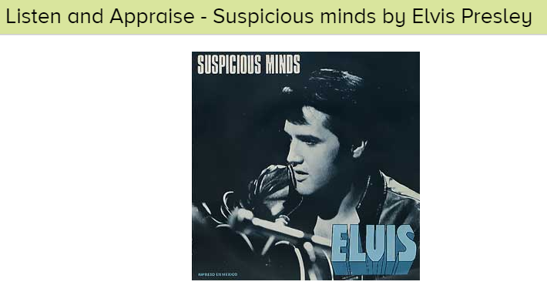
Use the key questions to discuss the song. Say sentences to answer the questions.
- What can you hear?
- How would you describe the song?
- Do you like the song?
- How does it make you feel?

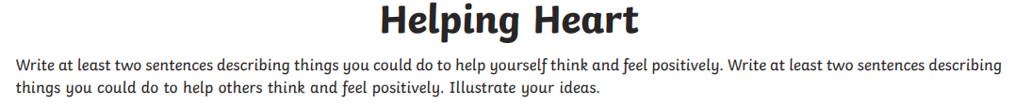
WSFL

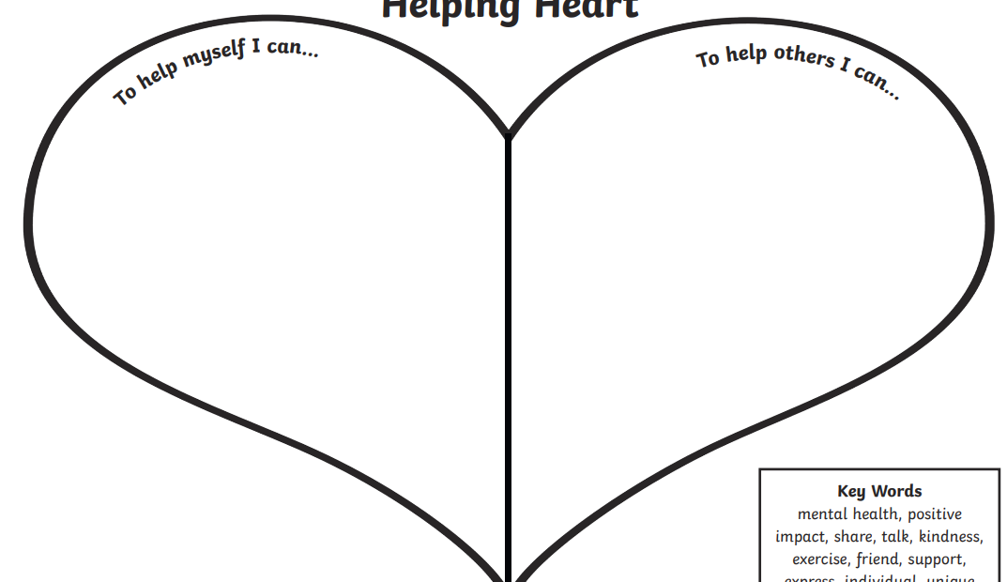

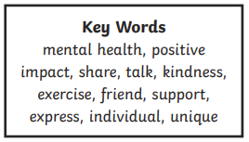

Tuesday 12th January 2021

Spelling: Find and fix the spelling mistakes.
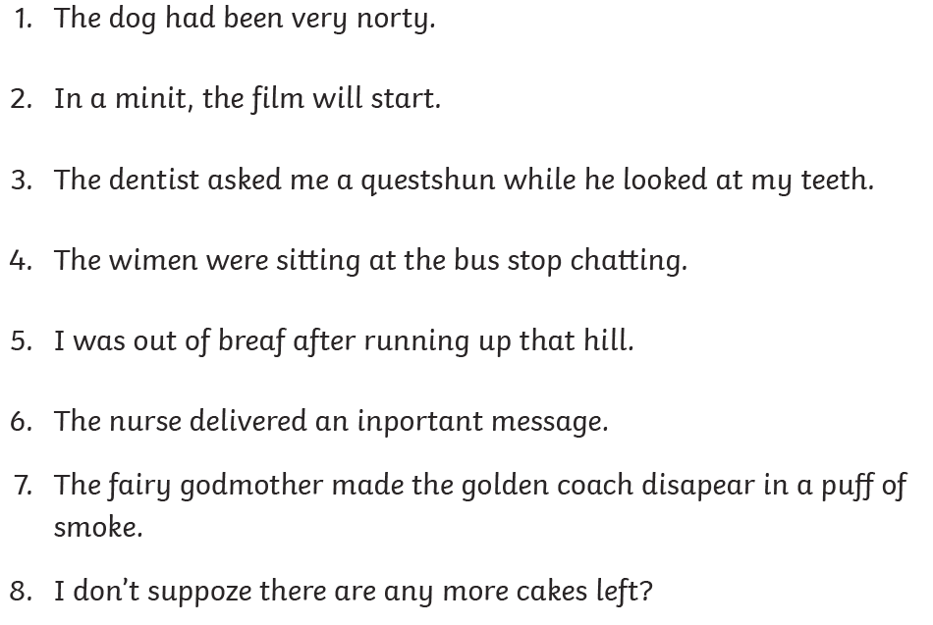

1.
2.
3.
4.
5.
6.
7.
8.

I can identify and use adverbs in my writing.
An adverb describes a verb.

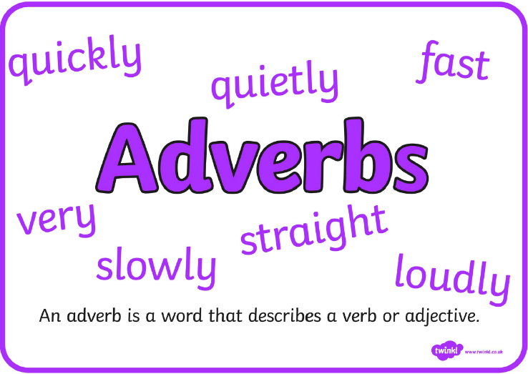
Hard: Read through the bank of interesting adverbs and discuss any unknown vocabulary with an adult at home.
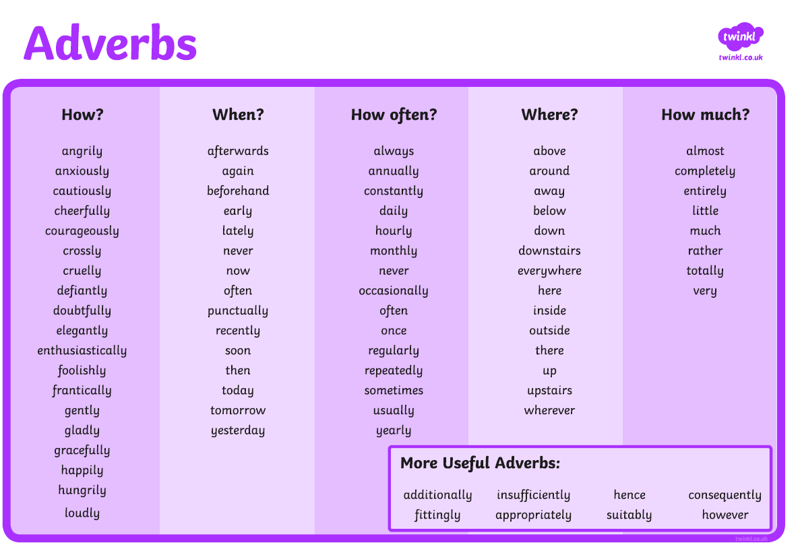
Harder: Read through the sentences. Find the adverbs and write them down.

He gracefully danced his way across the stage when he performed his ballet routine.

We usually shop at Morrisons but today we are shopping at Aldi.

I quietly ate some sweets in class whenever the teacher was distracted.

The laptop repeatedly shut down despite being fully charged.

She unfortunately forgot what time the bus was due and was late for her appointment.

Hardest: Use the adverbs that you found to write your own ideas for sentences.

Maths
TTRS: Soundcheck
My Mini Maths: Complete the following questions
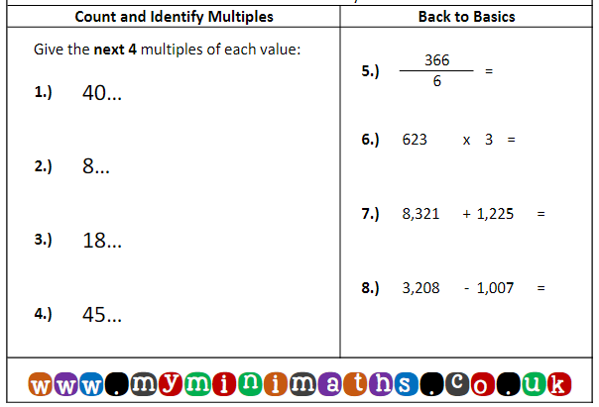
Compare these numbers using ˃ = ˂  1900 2400  3500 6200  2300 2300  9600 3700  3000 2000 9000  7000 4000 4000 | Compare these numbers using ˃ = ˂  2304 2403  3078 3708  2039 2309  9807 9708  3070 4532 1722  9283 2532 6251 | Compare these numbers using ˃ = ˂  2365 2367  5744 5733  2711 2911  9843 9843  3098 9083 983  790 7290 7092
I can compare 4 digit numbers.
Choose your level of challenge!

Problem-solving
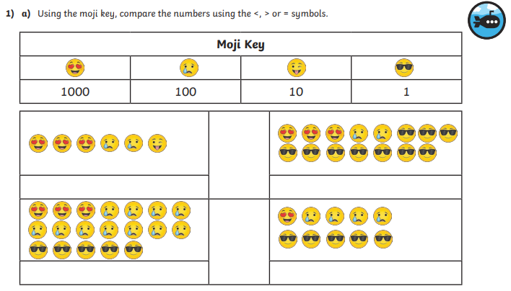
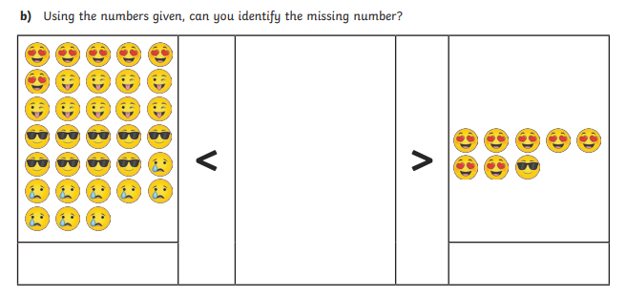

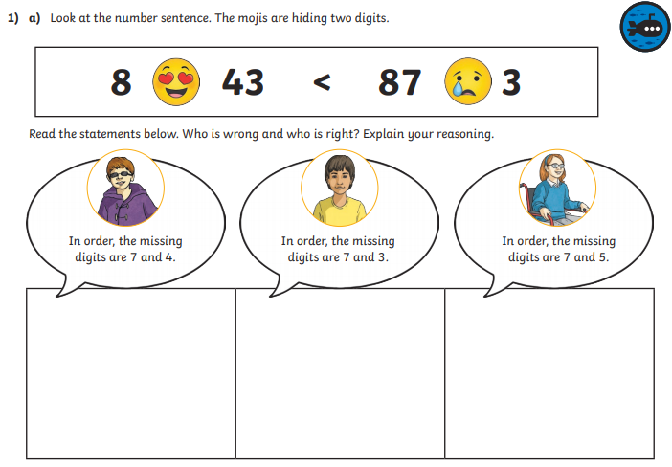

Geography
LO: I can use geographical vocabulary to locate countries within South America.
Hard:

Harder:
Go onto google and search Google Earth.
Launch Google and search South America
Fill in the missing countries on the blank map.
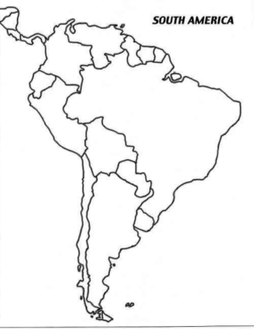

Hardest:
- What is north of Argentina?
- What is south of Columbia?
- What is east of Peru?
- What is west of Uruguay?

- What is north-west of Bolivia?
- What is south-east of Venezuela?
- What is north-east of Chile?
- What is south-west of Suriname?

HOTS:
Describe where the following countries are using the correct vocabulary?
Word Bank
North East South West
North-East North-West
South-East South-West

- Bolivia
- Ecuador
- Paraguay
- Brazil

Wednesday 13th January 2021
Spelling task:

Log on to Purple Mash and complete the spelling task that has been set as a 2do for you.

I can retrieve information from a text.
We are going to be reading a story called ‘Around the world in 80 minutes’.
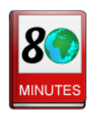
The story can be found on purple mash. If you use purple mash to read the story you can click on the underlined words and the definitions of the words will be explained to you.

Read the text and use your reading retrieval skills to answer the questions.

Does Phil want to get a Saturday job?

Why?

What does Phil make?

When did he start?

What did he use to build his first skateboard?

How old is Phil?

What did he use to build some electric stilts?

Why did he set off for the high street?

What did ‘The Sun Forest Garden Center’ need someone to do?

Maths
TTRS: Soundcheck
My Mini Maths: Complete the following questions
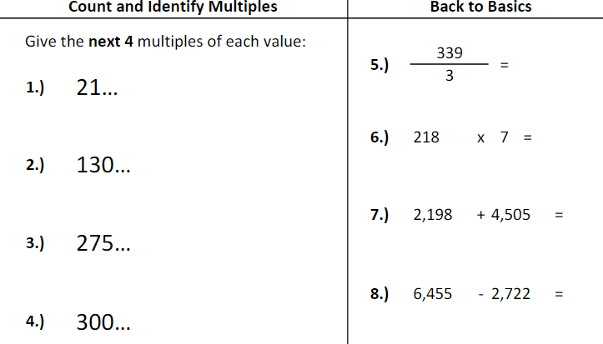

I can order decimal numbers.
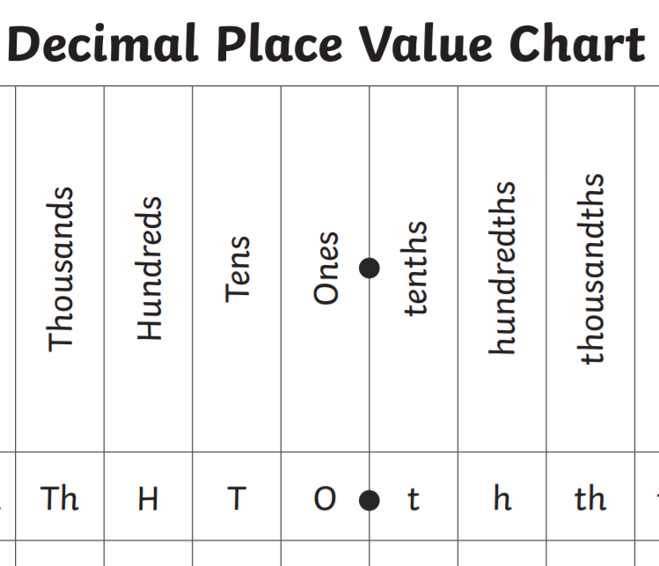

Write in ascending order.  33.3  36.3  30.3  35.3  32.3  39.3 | Write in ascending order.  33.4  33.9  33.2  33.6  33.1  33.8 | Write in ascending order.  57.29  57.92  92.75  92.57  79.25  79.52
Write in descending order.  53.2  57.2  50.2  54.2  55.2  59.2 | Write in descending order.  66.5  66.6  66.3  66.0  66.9  66.2 | Write in descending order.  88.88  68.88  88.68  86.88  72.58  72.85
Fluency
Choose your level of challenge!

Problem Solving.
Look at the digits. Use them to create as many decimal numbers as possible and write them in ascending order. You can only use each digit once per number.
5 0 9 2

Thursday 14th January 2021
English

Spelling task: Fix the spelling mistakes.
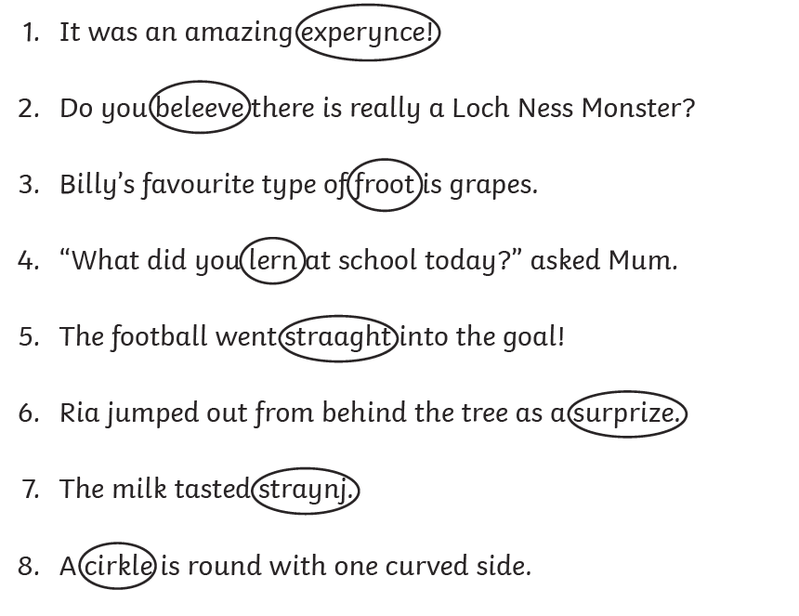

1.
2,
3.
4.
5.
6.
7.
8.

I can use adverbs to write sentences.

Go to https://www.literacyshed.com/the-other-cultures-shed.html and watch the story called ‘The Catch’.

Watch it again and think about adverbs that you would use to describe when the boy:
- sat fishing
- put the little fish in the bowl
- saw the trapped fox
- crawled through the dark tunnel
- chased the fox
- climbed the mountain
- reached the top of the mountain
- gave the fox a fish

Hard: Use adverbs to write sentences about the different actions above. (8 sentences).

Harder: Use adverbs to write sentences that include various conjunctions about the different actions above. (8 sentences).

Hardest: Use adverbs to write sentences that include expanded noun phrases and various conjunctions about the different actions above. (8 sentences).

Maths
TTRS: Soundcheck
My Mini Maths: Complete the following questions.
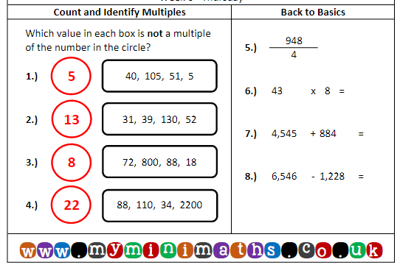
I can compare decimal numbers using < and >.
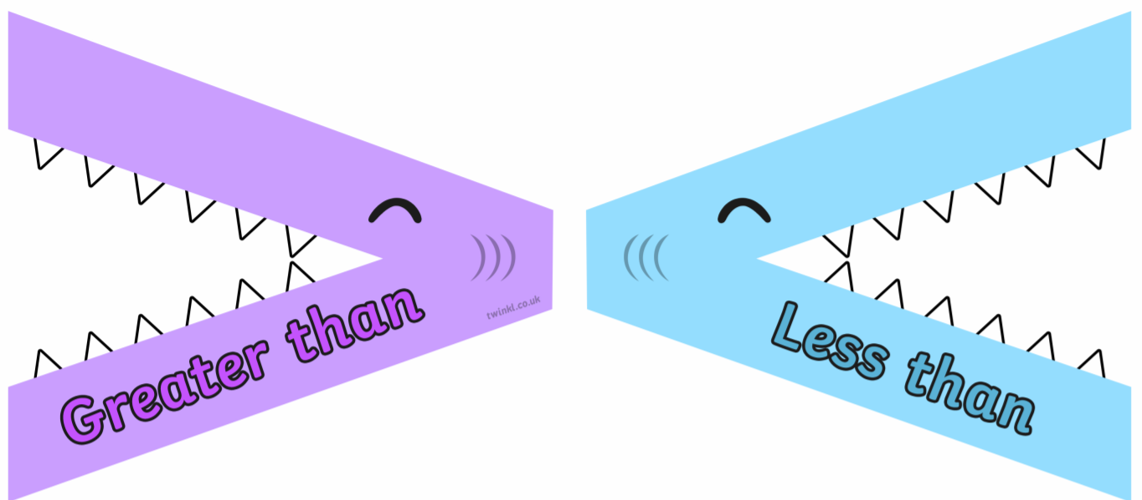
Fluency. Use the correct symbols to compare the decimal numbers.
3.5 ____ 4.5  8.1 ____ 6.1  7.8 ____ 5.8  6.6 ____ 7.6  5.8 ____ 8.8  7.6 ____ 6.6  3.7 ____7.7  4.8 ____ 8.8 | 16.7 ____ 16.2  21.8 ____ 21.6  35.1 ____ 35.9  42.7 ____ 42.4  55.6 ____ 55.3  44.4 ____ 44.2  65.8 ____ 65.2  72.3 ____ 72.7 | 254.46 ____ 254.64  301.72 ____ 301.27  432.90 ____ 432.09  650.82 ____ 650.28  506.34 ____ 506.43  782.10 ____ 782.01  647.35 ____ 674.53  772.87 ____ 772.78

Problem Solving

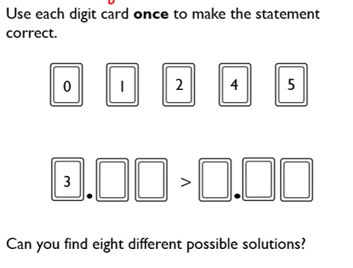

Art
Starter:
Using your pencil try and copy the designs in each square.
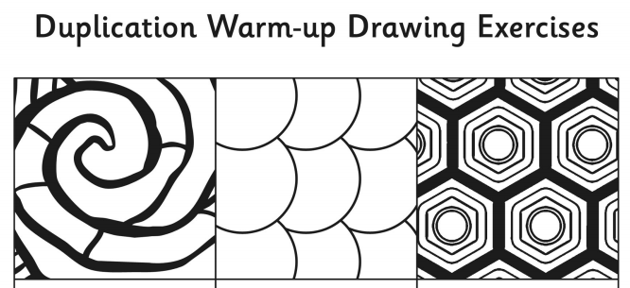
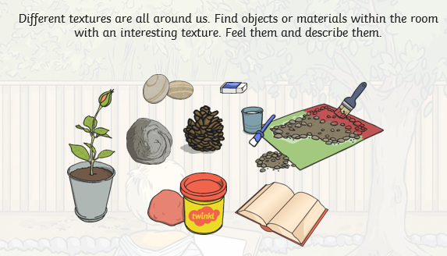
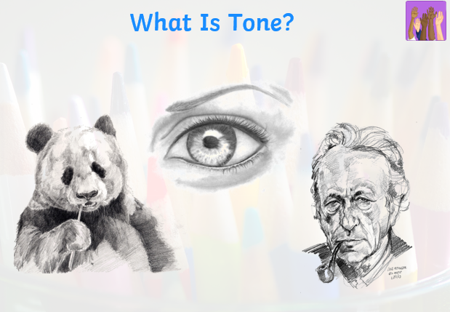
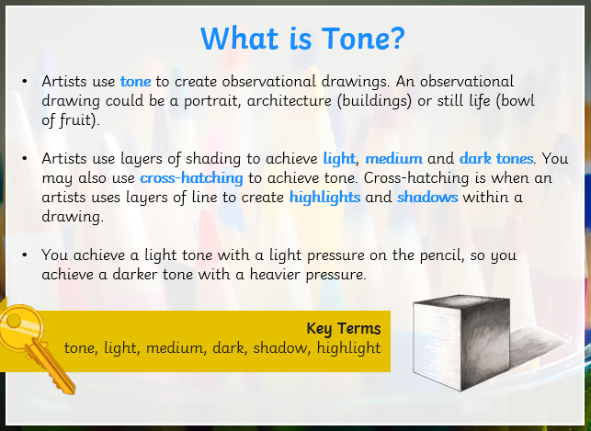

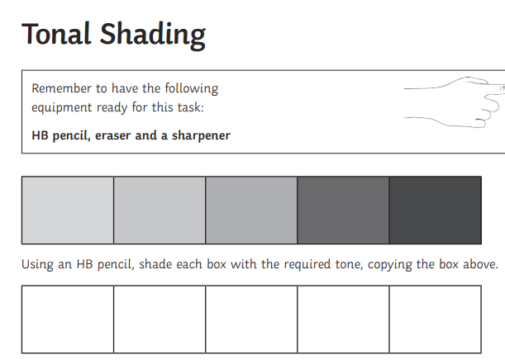

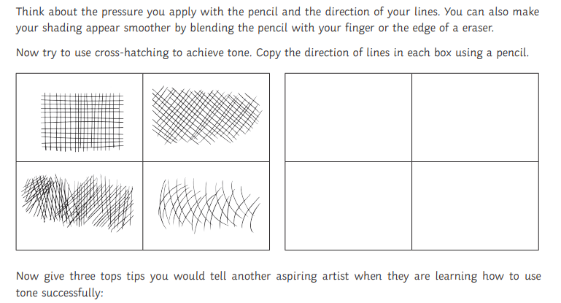

1.___________________________________________________________________________________________
2.____________________________________________________________________________________________
3.____________________________________________________________________________________________

Science
LO – I can explore the role of the flower in the life cycle of flowering plants
Please watch the following videos.
https://www.youtube.com/watch?v=AcSgaUBwIn4
https://www.bbc.co.uk/bitesize/clips/zgqyrdm
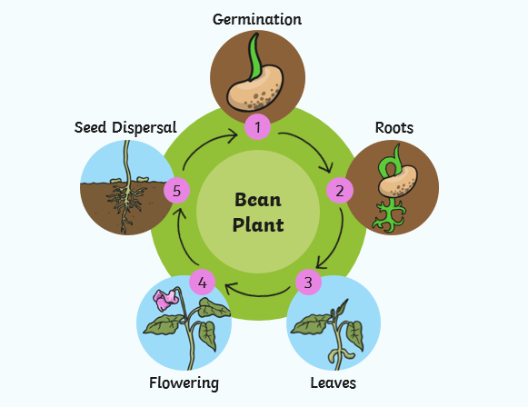

Seed Germination
https://www.youtube.com/watch?v=TE6xptjgNR0&t=246s

Photosynthesis
https://www.youtube.com/watch?v=D1Ymc311XS8

Pollination
https://www.youtube.com/watch?v=j-S5ui9Us7U
https://www.edenproject.com/learn/for-everyone/what-is-pollination-a-diagram-for-kids

Seed dispersal
https://www.bbc.co.uk/bitesize/clips/znvfb9q

Using the videos to help create a comic strip to explain the lifecycle of a flowering plant. Remember to include the key vocabulary.

Friday 15th January 2021
Spelling: Find and fix the spelling mistakes.
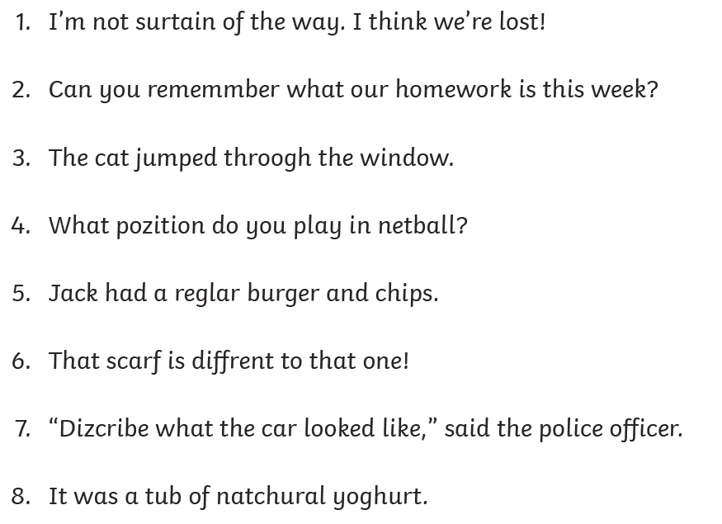

1.
2.
3.
4.
5.
6.
7.
8.

I can use adverbs and verbs to write sentences.
Go to https://www.literacyshed.com/the-other-cultures-shed.html and revisit the story called ‘The Catch’.
You are going to pretend to be the little boy and write about the story of your day. Start from the beginning and use sentences to write about what happened to you. Use sentences that include adverbs and verbs. Here is a checklist of other skills to try and include.
Skill | Examples
Contractions | didn’t, hadn’t, shouldn’t
Emotive vocabulary | devastated furious anxious delighted
Expanded noun phrases | the little, orange fish  my lovely, green hat
Conjunctions | if, since, as, when, after, while, although, because, until, before, and, but, yet, so, or

Maths
TTRS: Soundcheck
My Mini Maths: Complete the following questions
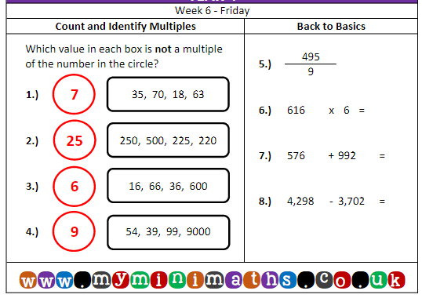

I can complete Arithmetic Test 2
- 39 + 100 =
- 581 – 100 =
- 208 + 300 =
- 418 – 40 =
- 73 x 4 =
- 69 ÷ 3
- 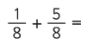
- 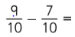
- 6721 + 1000 =
- 4037 – 1000 =
- 4037 – 1000 =
- 7124 – 583 =
- 12 x 6 =
- 56 x 1 =
- 681 x 4 =
- 593 x 8 =
- 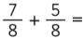
- 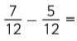
- 2.9 + 0.2 =
- 4.93 – 0.04 =
- 82 ÷ 10
- 31 ÷ 100
- 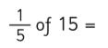
- 3.4 – 2.56
Computing
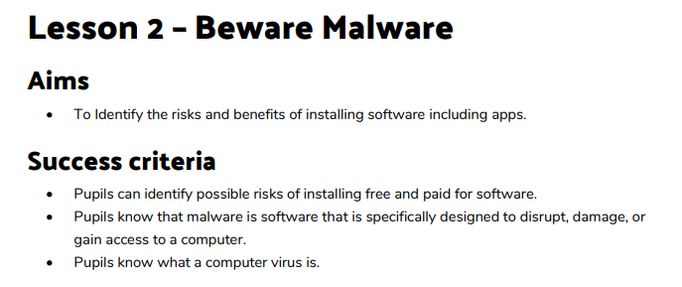
For this lesson we are going to learn all the possible risks of installing software into your computer.

Log into Purple mash and go to your 2do’s
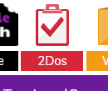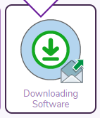
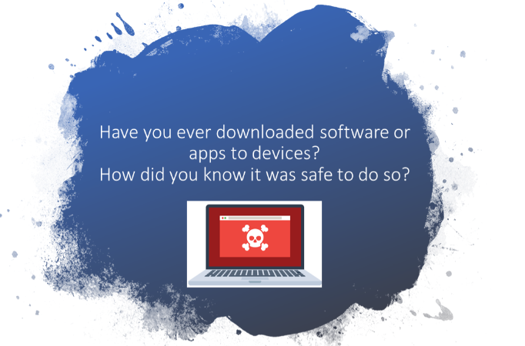
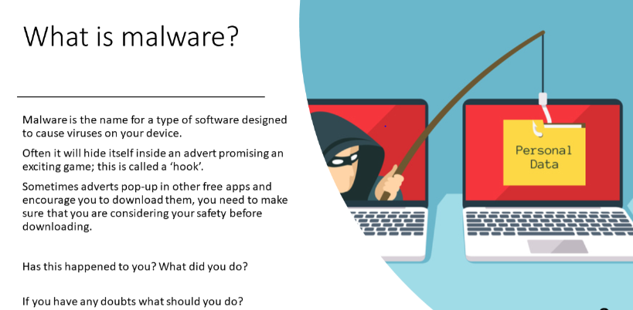

Click on the Downloading Software icon to start the work.

In your inbox you will see there is an email from Jamie.
Open it and have a look.
Reply to his emails what do you think he should do? He should email you back instantly.
Discuss with an adult.
What do you has happened?
What should he have done?
----------------------------------------------------------------------------------------------------------------------------------------------------------------------------------------------------------------------------------------------------------------------------------------------------------------------
Discuss the following questions with an adult.
