

***Wibsey Primary School***

***North Road***

***Wibsey***

***Bradford***

***BD6 1RL***

***Tel: 01274 678016/775545***

***Headteacher: Mr N M Cooper***

**Update from Mr Cooper - Thursday 14th January 2021**

**Dear Parent/Carer**

Well after another snowy and exciting day at Wibsey (one of only a few schools who managed to have staff in to open until 2.00pm) I write to fill you in on where we are and what I know up to press.

Straight out of the way this week is the Government’s food fiasco. I don’t think the press helped, or daft social media speculation. Meal providers were only ever given the money to provide **5** lunches **for a child.** Anyone talking about feeding whole families, meals other than lunches or £30 per week were talking nonsense.

Providers were given **£1.90 per day –** the price of a school meal, to put a day’s lunch together. I asked our provider to make up sample plates from the ingredients handed out and have included the picture below.

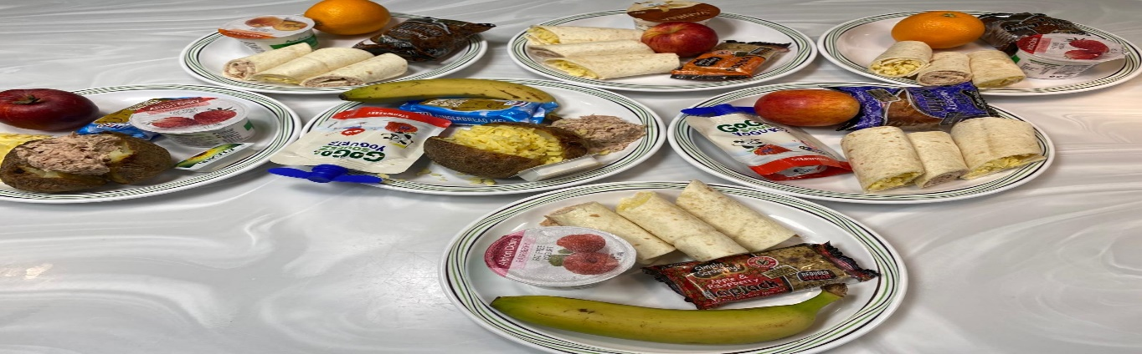

Thankfully the Government have seen sense, and to make things easier have restarted the voucher scheme. Mrs Smith has been in contact about ordering these as was done during the last lockdown. You will then be issued with the codes – look out for the message.

**Weekend food –** is a completely separate grant. The fair formula Wibsey are working on is this:

**Funding received = £7312** to be shared between **208** children in receipt of FSM. This provides total funding of £35.16 per entitled pupil. This is to cover weekends for the next 11 weeks. **The grant of £7312 is from the Government – if we receive any more we will follow the same formula.** Families will be issued with separate vouchers by school during next week for this. The £33.00 left over – for those of you doing the calculations (some rounding) – will go to the first family to come onto the Free School Meals register after distribution.

All affected families have already had this information from Mrs Smith. The above information is so **every Wibsey Primary Family** knows what we are doing and has the accurate, non-Facebook information.

**Online Registration –** The staff have been delighted to see children early in the day, up and ready to learn. It has also been an early catch up for children at the start of online learning. I can see the work and support from yourselves and the staff going from strength to strength over the last two weeks. Just a reminder for children to have their school jumpers on at home on so that we are all getting our learning heads on as well – and so that we all come together as the Wibsey Family, with our badges proudly showing. Thank you for your continued and thoughtful support and comments. Today in school we have been making the most of the snow – building snowmen double our height!



**For children in school: - the menu w/c Monday 18th January**

**Usual daily choices –** Jacket Potatoes, Paninis and Sandwiches, home-made confectionary and fruit.

**Hot Options**

**Monday –** Cheese Pasta

**Tuesday –** Burger in a bun with wedges

**Wednesday –** Shepherd’s Pie

**Thursday –** Pizza

**Friday –** Fish and Wedges

**Message for Wibsey children** **from George and Mildred**



*Our Dad said he wanted a nice picture of us for you this week. Here we are making ourselves comfortable on our Grandad’s knee (He’s Mr Cooper’s dad). We all refused to smile though ☺ ☺ ☺ ☺ Remember we have said before that kindness to each other at home is super important at the moment. We wish we were seeing you in school. See you soon though and stay super safe. G&M.*