Can you label these shapes?

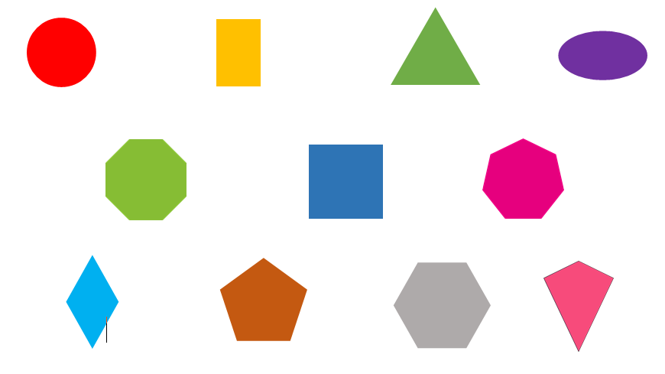

Extension

Choose 3 shapes and write sentences to describe their properties.

