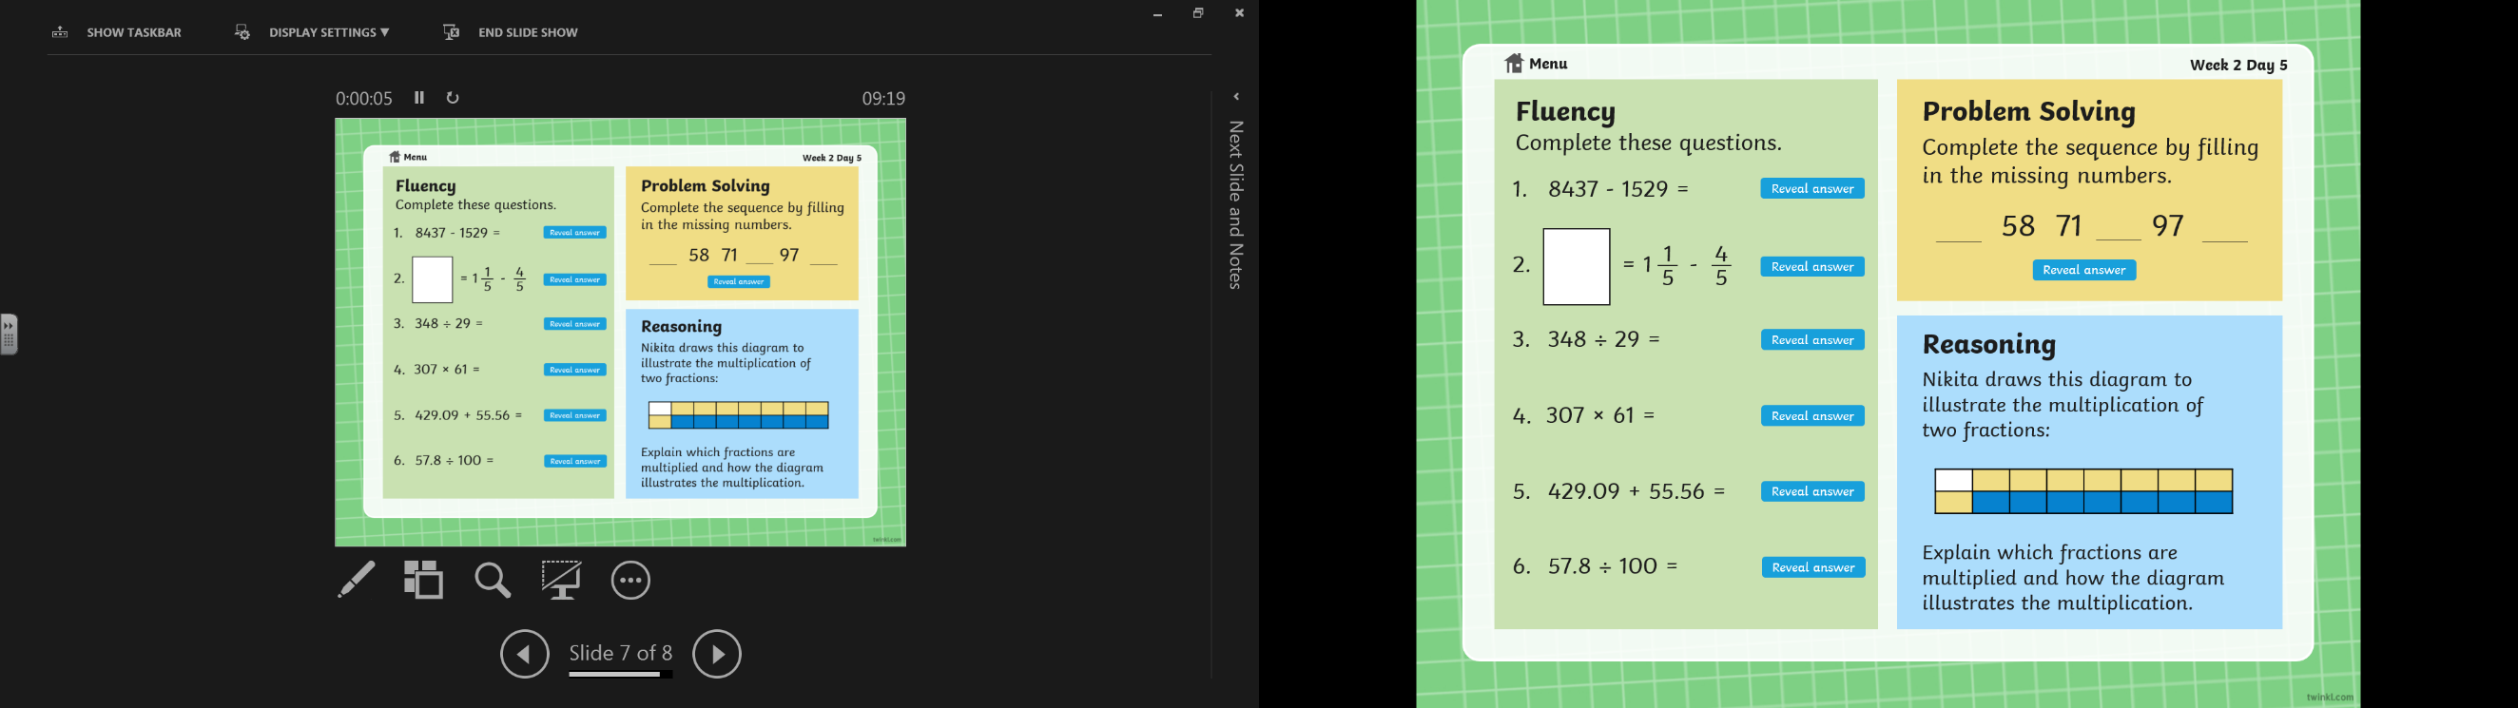

**Thursday 7th January 2021**

**Maths warm-up**