 | Handwriting | Maths | Topic/ English | 50 Things Challenge!
Monday | Practice writing your name.  Remember to use your whooshes for each letter.  Practice writing the letter sound you have learnt in phonics.  EXT: Can you write a word with that sound in? | Ask your child to count forwards to 20 in different voices. E.g. silly voice, deep voice, whisper voice, scary voice.  Introduce the number of the week which is 12.  Go through the power point with your child  (they will be familiar with this) discuss 12. Can they find 12 objects in your house? | Recap the story of Little Red Riding Hood  Can you describe the characters to your grown up?  What happens at the beginning of the story?  What happens in the middle of the story?  What happens at the end of the story?  What was your favourite part of the story?  Please remind your child to speak in full sentences.  Challenge: Can you draw your answer to one of the questions? | Download the app ‘50 things to do before you’re five’ (in Bradford)  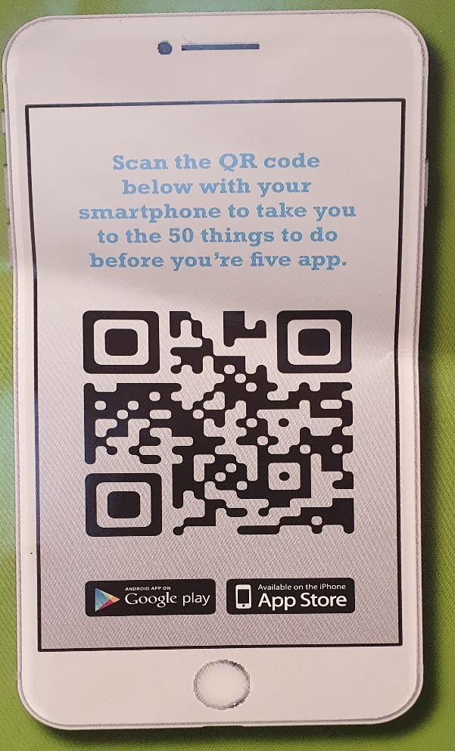  The Reception and Nursery children are going to be participating in ‘50 things to do before you’re five’.  When your child completes a challenge send us a photo to our class email.  reception1@wibsey.bradford.sch.uk  reception2@wibsey.bradford.sch.uk  reception3@wibsey.bradford.sch.uk  Once we have received a photo, your child’s name will go into a prize draw to win some fantastic prizes!  The more tasks your child completes the more chances they have at winning a prize!  This week’s Challenge is:  Challenge #35 – Trip Trap, Trip Trap, Who’s that walking over my bridge?  Now you may not be able to go and visit a real bridge at the moment, but you can always make one!  Have a look around your house, what could you use to build a bridge?  Once you have made your bridge, test it out.. Place a bowl of water under your bridge and carefully put something on top of your bridge e.g. a Lego character. Let’s see if your bridge is strong enough to hold your object or whether your object will fall into the water with the troll!
Tuesday | Practice writing your name.  Remember to use your whooshes for each letter.  Practice writing the letter sound you have learnt in phonics.  EXT: Can you write a word with that sound in? | This week we are continuing to look at addition.  For today’s activity  You will need:  A piece of paper  A pen  10 of the same objects (e.g. pieces of pasta, counters, tea bags etc).  Adult-please can you hold your piece of paper Landscape and draw a line down the middle. Like this  +  Now ask your child to hold their 10 objects and drop them over the piece of paper. Look at where the objects fall. How many objects are on the left of the line? How many objects are on the right of the line? Can your child add the numbers together?  EXT: Can you say the number sentence? | Watch the video of Mrs Davies’ creating the beginning to her story map of the Little Red Riding Hood story.  Using a piece of paper and pencil can your child create their own beginning of the story map like Mrs Davies’  Please make sure you stop once Little Red Riding Hood gets to Grandma’s house.  Although your child will need support with this task please encourage them to draw their pictures independently.
Wednesday | Practice writing your name.  Remember to use your whooshes for each letter.  Practice writing the letter sound you have learnt in phonics.  EXT: Can you write a word with that sound in? | Show me- ask your child to show you a number (10 or below) on their fingers.  Using your piece of paper and objects from yesterday play the game again.  Does your sum equal 10?  Can you say the number sentence?  Can you write the number sentence?  How many ways can your child make 10.  Ask your child to write down a list of the numbers that when added together equal 10.  EXT: Our number of the week is 12. Complete the activity again but with 12 objects. How many different ways can you make the number 12? | Watch the video of Mrs Davies’ creating the middle to her story map of the Little Red Riding Hood story.  Using your child’s story map from yesterday can your child add the middle part to their story like Mrs Davies’  Please make sure you stop once you have described Grandma/the wolf.  Although your child will need support with this task please encourage them to draw their pictures independently.
Thursday | Practice writing your name.  Remember to use your whooshes for each letter.  Practice writing the letter sound you have learnt in phonics.  EXT: Can you write a word with that sound in? | Claps- say a number to your child can they clap that number. E.g. number 7- 7 claps.  Today’s challenge is for your child to have a go at making a number line to 10.  Adult, please can you draw 5 number lines like this:  E.g.  Ask your child to fill in each of the number lines with the numbers 0-10.  Now can your child answer the following 5 addition questions using one number line for each question. Please model to your child how to use a number line for adding.  E.g.  5 + 2 =  Draw a circle around the number 5. Count on 2. What number do you land on? 5 + 2 =  0 1 2 3 4 5 6 7 8 9 10  Now try these:  - 6+1=  - 5+3=  - 2+1=  - 8+2=  - 6+3= | Watch the video of Mrs Davies’ creating the end to her story map of the Little Red Riding Hood story.  Using your child’s story map from yesterday can your child add the end part to their story like Mrs Davies’  Although your child will need support with this task please encourage them to draw their pictures independently.
Friday | Practice writing your name.  Remember to use your whooshes for each letter.  Practice writing the letter sound you have learnt in phonics.  EXT: Can you write a word with that sound in? | Count forwards to 20 in different voices. E.g. silly voice, deep voice, whisper voice, scary voice.  Click on the link and play the addition game.  https://www.topmarks.co.uk/addition/addition-to-10 | Watch the video of Mrs Davies retell her story using her story map and actions.  Now can your child try to retell their story using their own story map. Please remind them to use actions!  We would love to see your child’s story so please send us a video of them retelling their story. Videos can be uploaded to Google Classroom or to our class email address.

