- Open Google Classroom and login with your username and password

- Click on the Class Link (You must only click on this link when the lesson is about to begin, not before)

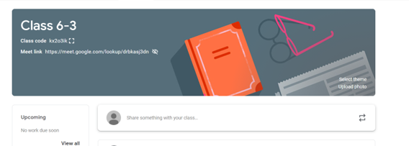

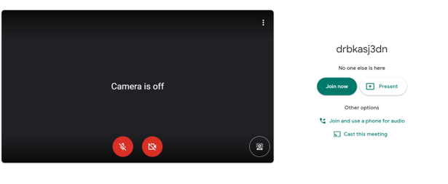
- Turn off your microphone

- Make sure that your camera is turned on

- Click ‘Join Now’

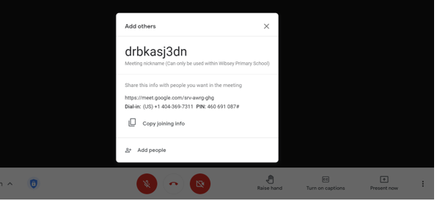

- Click on the X

- Use the ‘Raise hand’ icon if you would like to ask your teacher a question

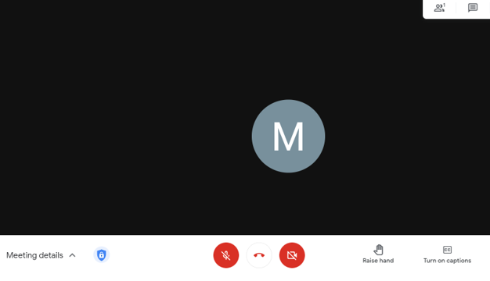

- Remember to turn your microphone on when asked by your class teacher

- Don’t forget to turn it off once you have finished speaking

- Once the live lesson has finished, click on the hang up button

