Reading Continuum – Step 1 Prediction task
LO: I can identify implicit and explicit information and points of view.
BLP: Distilling 1, Imagining 3.

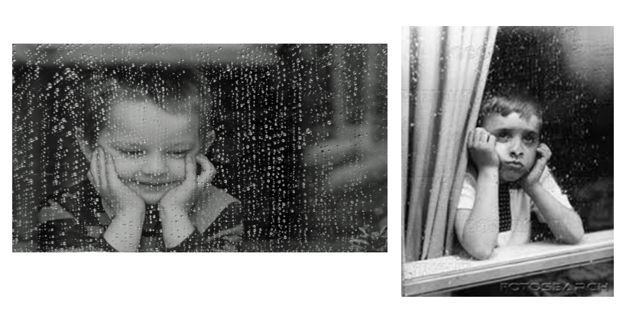
Task 1 - Look at these pictures below and explain what you can retrieve (see) and what you can infer (and this means)? Write you answers in full sentences please.

Task 2 – Write a few sentences explaining what similar about images and what is different.
For example- I think they similar as both have their hands under their chin. I think they are different as both characters are showing different emotions.

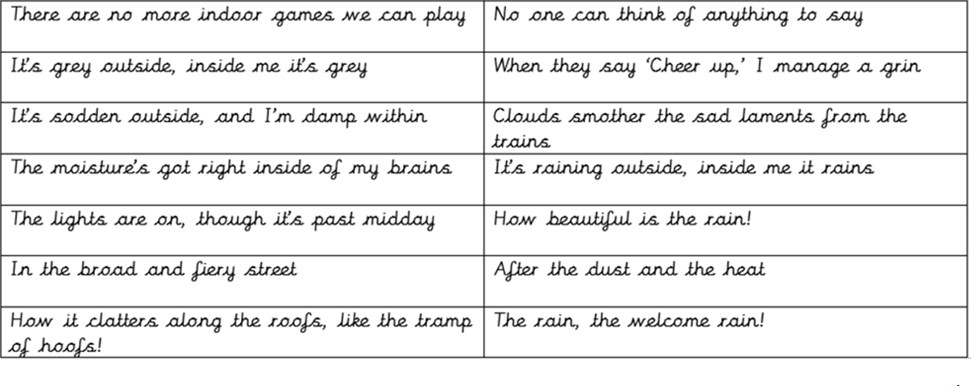
Task 3 - Which phrases below match with Image 1 and which match with image 2?

