Reading Continuum – Step 2 Orientation
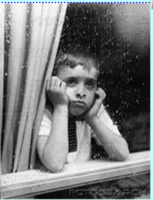
Text 1 and Text 2 - Rain and Rain in the Summer
Read the poems in the ‘Rain and Shine’ booklet called ‘Rain’ and ‘Rain in the Summer’. Once you have read it answer the following questions. Each poem has its own orientation questions to answer.

Orientation 'Rain'
1. What are paragraphs of a poem called?
2. Who is the poet?
3. What time of day is 'past midday'?
4. What is drawn on the glass?
5. What pours into the drains?
6. What is the effect of rain on the writer?
Reasoning challenge
In each verse, all the lines end with the same rhyme. How does this add to the meaning of the poem?
My questions
Create your own question for adults tomorrow

Orientation 'Rain in the Summer'
1. How many verses are in this poem?
2. Who is the poet?
3. List 3 pairs of rhyming words.
4. Compare this poem to yesterday's poem (what is the same and what is different - do a table)
5. What is the effect of rain on the writer?
Reasoning challenge
Why do you think the poet ends the poem with 'The rain, the welcome rain!'
My questions
Create your own question for adults tomorrow

