Reading Continuum – Step 3 Vocabulary
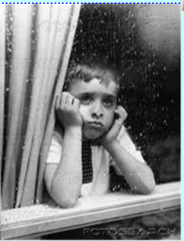
Text 1 and Text 2 - Rain and Rain in the Summer
Re-Read the poems in the ‘Rain and Shine’ booklet called ‘Rain’ and ‘Rain in the Summer’. Once you have read it answer the following questions about the vocabulary. Each poem has its own vocabulary questions to answer.

Vocabulary 'Rain'
Find and write the definitions of the words below and write a sentence explaining what the phrases mean?

1. Sodden
2. Smother
3. Laments
4. Grin
5. 'Stare out of the window, fist under my chin,' What does this phrase mean?
6. 'inside me it rains.' What does this phrase mean?

Vocabulary 'Rain in the Summer'
Find and write the definitions of the words below and write a sentence explaining what the phrases mean?

1. 'broad and fiery street,'
2. 'it clatters along the roofs, like the tramp of hoofs!'?
CLUE (https://www.youtube.com/watch?v=XScUf12tgg4)
3. 'it gushes and struggles out from the throat of the overflowing spout!'
4. 'The rain, the welcome rain!

'

