LO: I can locate the key rivers of the world and state where the mouth and source are.
BLP: Noticing and Revising.
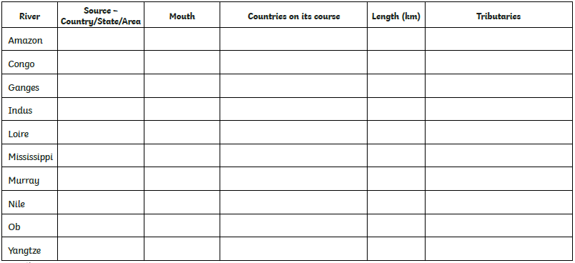
Research these rivers and find out the relevant information to fill in the table below.

