Simplifying Fractions 2
LO: To use the highest common factor to simplify fractions.
To cancel a fraction divide both the numerator and the denominator by the highest common factor (HCF). Example 1: 8/12 = 2/3 (HFC is 4) and Example 2: 9/15 = 3/5 (HCF is 3)
Task 3:

Task 2:

Task 1:

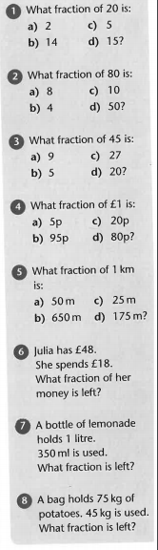
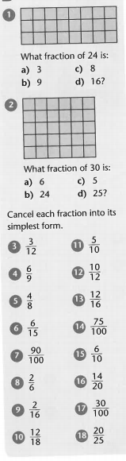
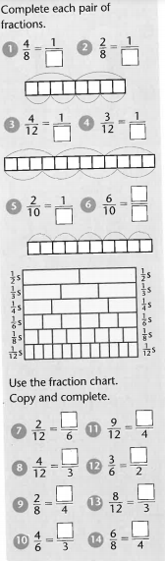
Have a go at the question starting with Task 1 and see if you can challenge yourself and get onto Task 3.

