Simplifying Fractions
LO: To use common factors to simplify fractions.
To simplify a fraction to its lowest terms, divide both the numerator and the denominator by the highest common factor. Example: 12/20 = 3/5, 12 divide by 4 = 3 and 20 divide by 4 = 5
Task 3:

Task 2:

Task 1:

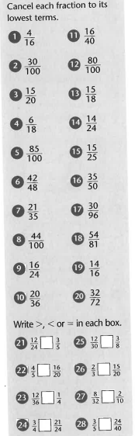
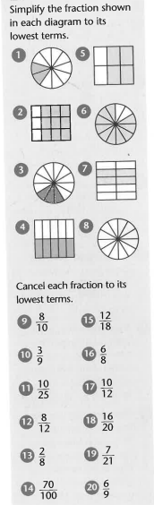
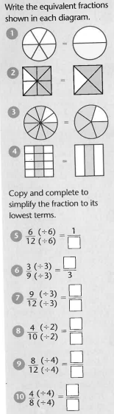
Have a go at the question starting with Task 1 and see if you can challenge yourself and get onto Task 3.

