YEAR 1 w/c 18.1.21

Phonics  Follow links sent out daily via school APP. | English  READING:  1. Read a book every day for 10-15 minutes. Choose a different book from your house or library to read.  2. Reading journal comprehension activity – task 9  WRITING:  This week we are going to be focusing on adjectives.  Monday:  Match the adjectives to complete the sentences.  Tuesday:  Read the sentences and circle the adjective in each of them.  Wednesday:  Write as many adjectives as you can to describe the illustrations. Remember, adjectives are used to describe nouns.  Thursday:  Look at the character profile for Duck. Can you identify the adjectives?  Write them down.  Friday:  Choose one of the characters, Write a list of adjectives about your chosen character. Select a few adjectives from your list and write sentences describing your character. | Maths  Maths 18th January  This week we would like the children to practise counting in fives. Below are a selection of songs they might like to listen to.  https://www.youtube.com/watch?v=_awKlEMyleA  https://www.youtube.com/watch?v=amxVL9KUmq8  https://www.youtube.com/watch?v=56eWo7QbLT4  https://www.youtube.com/watch?v=EemjeA2Djjw  https://www.youtube.com/watch?v=r176jXYwct8  Pick a song each day and let us know which one they liked the best.  Monday  Look at Powerpoint and investigate number of the week.  Tuesday  Investigate coins.  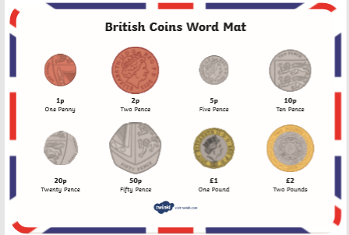  Wednesday  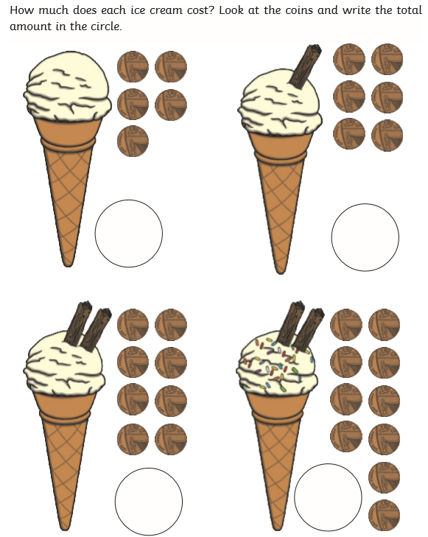  Thursday  https://www.topmarks.co.uk/money/coins-game  Do the ordering activity  1p to 20p  1p to 50p  Any 6 coins  Friday  Complete assigned task on Mathletics. | Topic  Monday  WSFL: Today is International Winnie the Pooh Day.  Watch the powerpoint to find out about it. Or do your own research on Winnie the Pooh and A.A. Milne.  Tuesday  History: Watch the powerpoints to find out about teddy bears and old and new toys.  Then see if you can sort the toys on the worksheet.  Wednesday  Science: You may want to have some objects made of different materials handy so that you can use them for an activity on the powerpoint. Once you have watched that, have a go at the worksheet activities.  Thursday  Computing: Watch the powerpoint and complete the 2Dos on Purple Mash.  Friday  Music: Here are some music activities to help you get that ‘Friday Feeling’!  These are all things you will have done in your music lessons with Mrs White.  Clap 4 different rhythms to your family- can they clap  them back?  Create new rhythms using different parts of your body.  Clap, Tap, Stamp to make sounds.  Play “Don’t clap this one back” with your family!  Listen to different sounds in your garden or out of thewindow- what can you hear? Make a list of all the sounds.

