YEAR 1 Week 5

Phonics  1. Practise set 1, and 2 sounds. (See lists in reading journal.)  2. Practise reading set 1 and 2 words. (See lists in reading journal.)  3. Sound of the day:  Can you write 5 words containing this sound? How many more words can you think of? Can you use each of these words in a sentence?  Monday: oi sound  Tuesday: ai sound  Wednesday: oa sound  Thursday: ew sound  Friday: ire sound | English  READING:  1. Read your reading book every day for 10-15 minutes. Choose a different book from your house or library to read.  2. Reading journal comprehension activity – task 5.  WRITING:  Complete this noun activity.  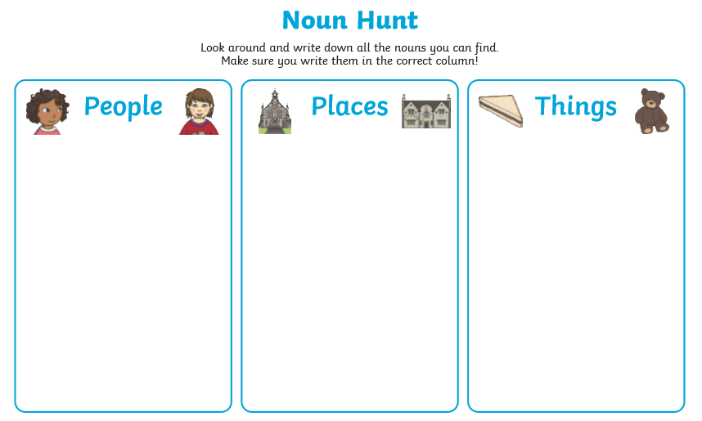 | Maths  Monday: Go on a 2D shape hunt around your house. Write down all the different shapes you find.  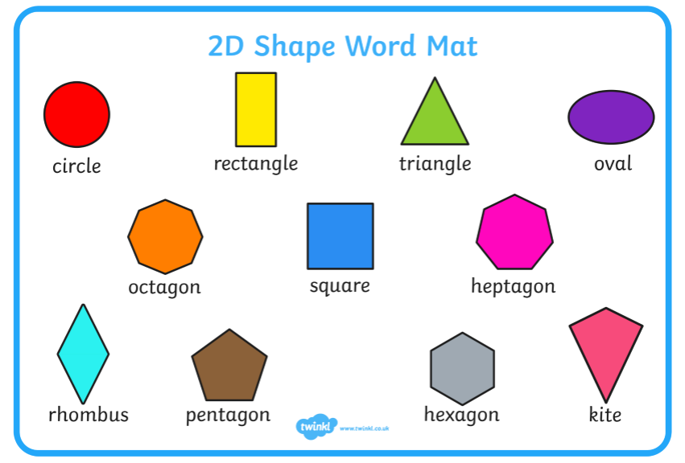  Tuesday: Look at the list from yesterday and group the objects according to their properties e.g. shapes with 4 sides/ shapes without 4 sides.  Wednesday: Can you choose some of the shapes you have found and write a description e.g the triangle has 3 sides and 3 corners.  Thursday:  Play Top Marks 2D shapes Carroll Diagrams  https://www.topmarks.co.uk/carroll-diagrams/2d-shapes  Friday:  Can you create a shape picture? | Topic- Materials  - Look around your home and think of the materials various objects are made from. Complete this table.  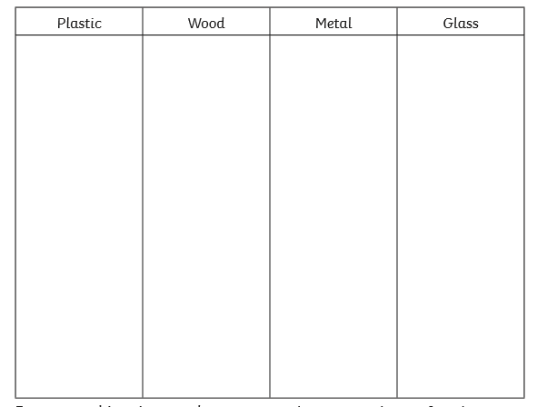  2.  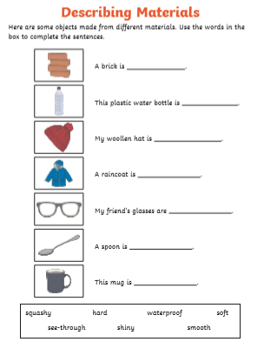  3.Investigate the items below and complete the information.  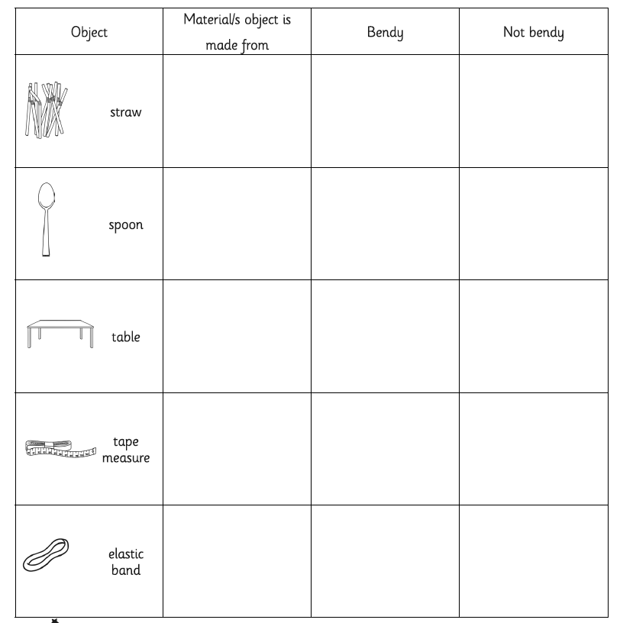

YEAR 1 Week 6

Phonics  1. Practise set 1, and 2 sounds. (See lists in reading journal.)  2. Practise reading set 1 and 2 words. (See lists in reading journal.)  3. Sound of the day:  Can you write 5 words containing this sound? How many more words can you think of? Can you use each of these words in a sentence?  Monday: ear sound  Tuesday: ure sound Wednesday: tion sound  Thursday and Friday: tious / cious sound | English  READING:  1. Read your reading book every day for 10-15 minutes. Choose a different book from your house or library to read.  2. Reading journal comprehension activity – task 6.  WRITING:  Complete this adjective activity.  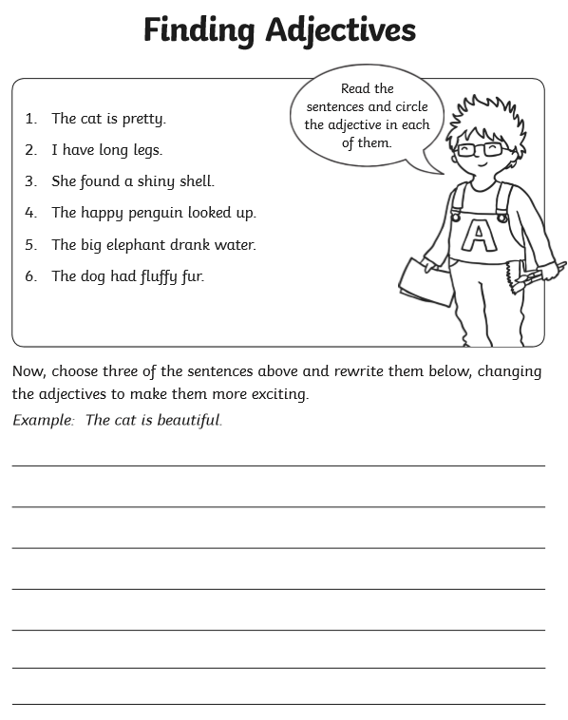 | Maths  Monday: Go on a 3D shape hunt around your house.  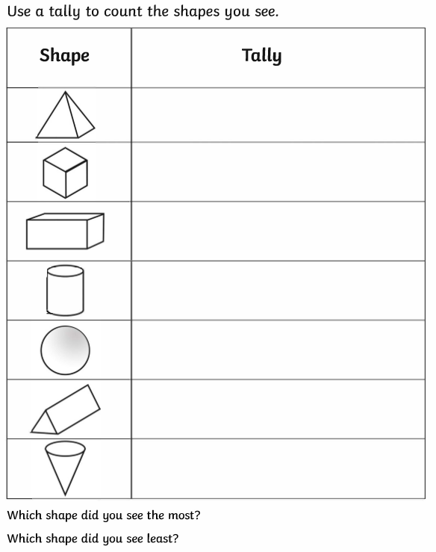  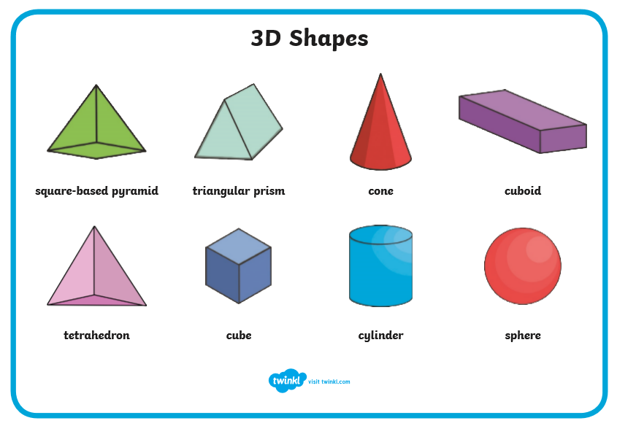  Tuesday: Look at the list from yesterday and group the objects according to their properties e.g. shapes that can roll/ shapes that do not roll.  Wednesday: Top Marks 3D shape games.  Thursday:  Play “I Spy”. Make a tally of the different shapes you can find.  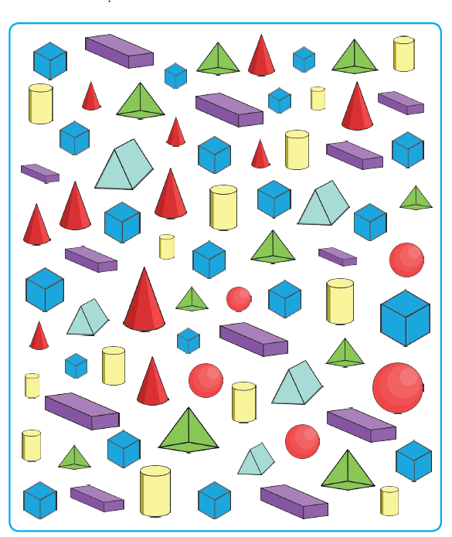  Friday:  Play Shifting Shapes  https://www.topmarks.co.uk/Flash.aspx?a=activity20 | Topic – Toys  - Make a list of your favourite toys.  - Ask a grown up what type of toys they liked to play with.  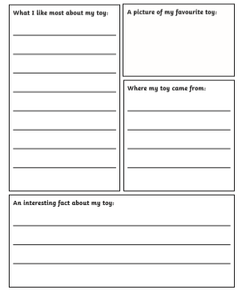  - Design a new toy and label it. What is it made from? What can it do?  If you feel energetic, do one of Joe Wicks’ workouts on youtube, or try Cosmic Yoga:  https://www.youtube.com/results?search_query=cosmic+yoga

