Friday 22nd  January Home Learning  Year 6 | Maths:  1. TTRS/Mathletics 9:00am – 9.30am  Before the start of each lesson get yourself onto times tables rockstars or matheletics and practise some timestables or maths skills.  We have new battles starting this term and to keep things simple the new battle is 6.1 v 6.2 v 6.3.  Let us see who are the year group champions!  2. Warm-up 9:30am - 9:45am  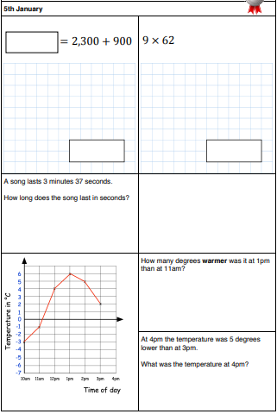  Answer the maths ‘Maths Warm-up’ questions below. A large copy of the questions is attached on Google Classroom.  3. Main Task- Arithmetic 9.45am – 10:30am  Complete Arithmetic Test 3. Remember you can check your work using the answers on the last sheet once you have completed the test. If you want to time yourself 30 minutes and see how much you get right that will be great.  Give yourself a 15 min break now until 10:45am | 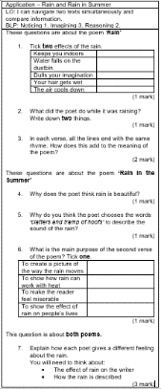  Reading: 10:45am – 11.15am  Open your work from yesterday from your drive. Check over the answers from yesterday and make sure you are happy with them. Watch the video where you can check your work and go through the answers.The video is on Google Classroom.  The question sheet looks like this!  Writing Paragraph P2 11:15am - 12:15pm  Read over the WAGOLL again, it is saved in Google Classroom as well the summary so you are familiar with the first few chapters of Percy Jackson again.  You are going to write paragraph two of your own Diary as Percy.  Watch the video posted by Mrs Choudhery talking you through what you will need to write and doing a shared example. Open the ppt ‘Shared Write Examples’ and you will have shared write example in front of you to refer too.  Think about the writing features you need to include.  - Punctuation  - Relative Clause  - Subjunctive  - Formal and Informal Language  - Modal verbs  - Subordinate and coordinate Clause  - Expanded noun phrases  - Parenthesis  - Question and exclamation mark  - Apostrophes for possessions and contractions  Give yourself a hour lunch break now until 1:15pm | Science: 1:15pm – 2:15pm  Hope you enjoyed learning about the heart. This week in Science you will be learning about the Lungs and why they vital to Human living.  Open the ‘The Lungs in the Human Body’ PowerPoint on Google Classroom and have a read through it carefully. There are some difficult scientific words so search them up and if you do not know what they mean then ask.  At the end of the PPT there is a video link which will also give more information.  https://www.youtube.com/watch?v=p4zOXOM6wgE  Once you have read through the PPT and watched the video open the ‘The Lungs Diagram and Questions sheet’ and work through Hard, Harder and Hardest. | PE: 2:15pm – 3:15pm  This you your time to have some active time at home.  If the weather is good, then take yourself outside in the garden or down your local park (remember to keep a safe distance) and do some exercise.  This could be in any form you like for example: football, gymnastics, going on the trampoline, running, cycling etc.  Take a picture of what you do and post it onto Google Classroom.  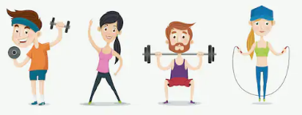  UNFORTUNATELY PLAYING ON THE PLAYSTATION, XBOX OR PHONE IS NOT A F ORM OF EXERCISE.

