Monday 11th  January Home Learning  Year 6 | Maths:  1. Warm-up  Answer the maths ‘Warm-up’ questions below. A large copy of the questions is attached on Google Classroom.  2. Short division Continued  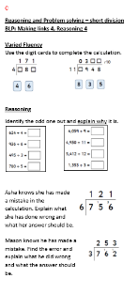  Record the answers to the division questions on a Google doc. The question sheet is attached on Google Classroom.  The question sheet looks like this!  Use the Steps to Success to help you. A large version is on Google Classroom. | 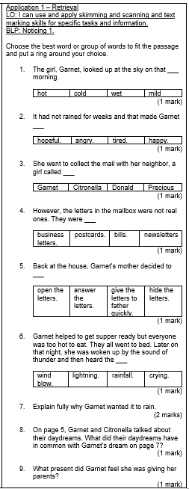  Reading:  Use the text rain and Shine. Re-read the The Hottest Day pages 3-7, Answer the Application 1 Retrieval questions. See the ‘large version’ in Google Classroom – it is called Retrieval Application Questions.  The question sheet looks like this!  English  Percy Jackson:  1. Read the summary of chapters 2,3,4 and 5. It is saved in Google Classroom.  2. Read the diary WAGOLL in Google Classroom.  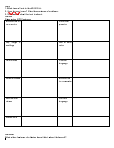  Look at the WAGOLL task sheet in Google classroom and identify the features of the WAGOLL. Record your work on a Google doc.  You can just write each feature as a subheading and then record at least 2 examples underneath the subheading.  The WAGOLL task sheet looks like this! | Computing:  Internet safety  You will need your Purple Mash log-in. This will be inside your reading journal.  Access the Computing section and scroll down to Online Safety.  1.Complete the following activities:  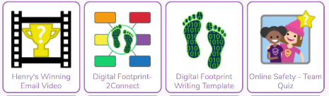  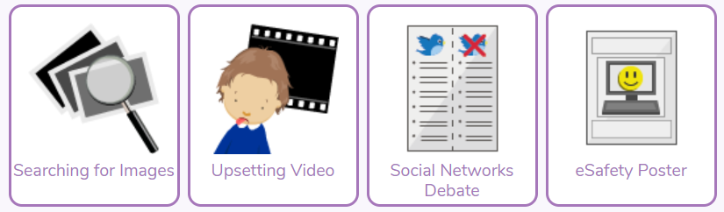  2. Now complete a poster/fact file to record what you have learnt from completing these activities. You may wish to complete this activity on paper and take a photo and email it to your teacher using the email address that we sent on the APP. Or you could just add it to a google slide or doc.

