Monday 18th  January Home Learning  Year 6 | Maths:  1. TTRS/Mathletics 9:00am – 9.30am  Before the start of each lesson get yourself onto times tables rockstars or matheletics and practise some timestables or maths skills.  We have new battles starting this term and to keep things simple the new battle is 6.1 v 6.2 v 6.3.  Let us see who are the year group champions!  2. Warm-up 9:30am - 9:45am  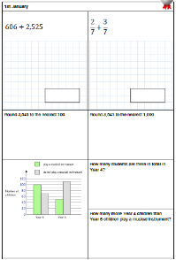  Answer the maths ‘Maths Warm-up’ questions below. A large copy of the questions is attached on Google Classroom.  3. Main Task- HCF and LCM 9.45am – 10:30am  Once you have finished the task watch the series of these videos below and then complete the ‘Maths HCF and LCM Task’ sheet which can be found on Google Classroom. You may not need to know all the information which will be given in the videos to answer the questions but it is good to know for your knowledge.  Skill 1,2 and 3 - https://www.youtube.com/watch?v=ckm89S7sz3s&feature=emb_logo  Skill 4 - https://www.youtube.com/watch?v=s90QqvUM094m  Overview - https://www.youtube.com/watch?v=4x3iAplVX_Q&feature=emb_logo  Give yourself a 15 min break now until 10:45am | 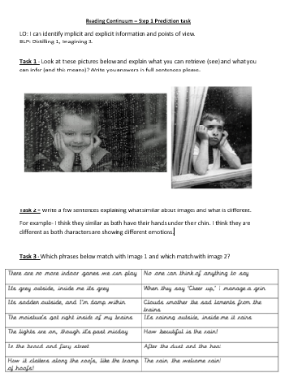  Reading: 10:45am – 11.15am  See the ‘large version’ in Google Classroom – it is called Reading Continuum step 1 task. Read the instructions of each task and answer the questions carefully.  The question sheet looks like this!  Subjunctive Form: 11:15am - 12:15pm  Open both PowerPoints on the Subjunctive Form in Google Classroom. Read through them and understand what the Subjunctive Form is.  Then open the worksheet and complete the Subjunctive Form Task. At the bottom of this sheet there is are 3 SATs Style questions to test your knowledge.  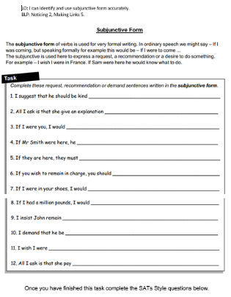  The worksheet looks like this!  Give yourself an hour lunch break now until 1:15pm | Computing: From 1:15pm - 2.15pm  How would you lay out your web page?  Click on the link below and it will take you to your computing lesson for today. You will be learning how to and will create your own webpage.  Remember this could be about anything so make it as creative and innovative as you can. Make it unique displaying who you are.  https://classroom.thenational.academy/lessons/how-would-you-lay-out-your-web-pa ge-6djp2t | PE: From 2:15pm - 3.15pm  Dance  Watch the 2 clips below showing you 2 different styles of Dance.  https://www.bbc.co.uk/bitesize/clips/zq83cdm  https://www.bbc.co.uk/bitesize/clips/zstw2hv  Task 1  Pick and Research one style of dance from anywhere around the world and create a poster about it either on paper or on Google Classroom.  Task 2  Once you have completed it can you choreograph your own dance and record it.

