Thursday 22st  January Home Learning  Year 6 | Maths:  1. TTRS/Mathletics 9:00am – 9.30am  Before the start of each lesson get yourself onto times tables rockstars or matheletics and practise some timestables or maths skills.  We have new battles starting this term and to keep things simple the new battle is 6.1 v 6.2 v 6.3.  Let us see who are the year group champions!  2. Warm-up 9:30am - 9:45am  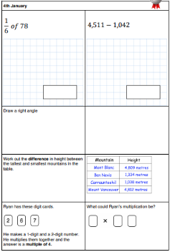  Answer the maths ‘Maths Warm-up’ questions below. A large copy of the questions is attached on Google Classroom.  3. Main Task- Equivalent 9.45am – 10:30am  Once you have finished the warm up open the sheet which says ‘Equivalent Fractions Maths task’ and have a go at Task 1, 2 and 3. The Tasks get harder but do progress so give each a go and see how far you get.  Click on the link below and watch the following videos:  - Equivalent Fractions  - Simplify Fractions  These should help you understand and answer some of the questions.  https://whiterosemaths.com/homelearning/year-6/week-8-number-fractions/  Click on these links to find interactive fraction walls to help you find equivalent fractions.  https://mathsbot.com/manipulatives/fractionWall  https://www.visnos.com/demos/fraction-wall  EXTENSION: Complete the Extension questions Equivalent Questions. You can check your work using the answer sheet attached.  Give yourself a 15 min break now until 10:45am | 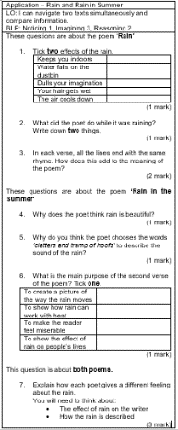  Reading: 10:45am – 11:15am  Use the text rain and Shine. Re-read the Rain and Rain in the Summer poems pages 8-9. Answer the Application questions. See the ‘large version’ in Google Classroom – it is called Poem Application Questions.  The question sheet looks like this!  Writing Paragraph Intro and P1 11:15am - 12:15pm  Read over the WAGOLL again, it is saved in Google Classroom as well the summary so you are familiar with the first few chapters of Percy Jackson again.  You are going to write the introduction and paragraph one of your own Diary as Percy.  Watch the video posted by Mrs Choudhery talking you through what you will need to write and doing a shared example. Open the ppt ‘Shared Write Example’ and you will have shared write example in front of you to refer too.  Think about the writing features you need to include.  - Punctuation  - Relative Clause  - Subjunctive  - Formal and Informal Language  - Modal verbs  - Subordinate and coordinate Clause  - Expanded noun phrases  - Parenthesis  - Question and exclamation mark  - Apostrophes for possessions and contractions  Give yourself a hour lunch break now until 1:15pm | Geography: 1:15pm – 2:15pm  Rivers of the World  Last lesson you researched some of the world’s famous rivers.  In today’s lesson you will look into some of them in detail and finding some specific information.  Research or look at the PowerPoint to help you find the answers to these questions. Answer them on a Google Doc. Your find or draw illustrations.  - What is the source of a river?  - What is the mouth of a river?  - What is the course that rivers take?  - What are tributaries?  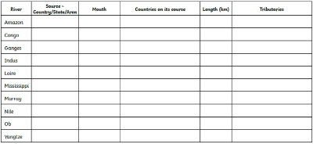  Once you have answered the questions open the ‘Rivers of the World Task Sheet’. Research each of the different rivers and fill in as many of the gaps as possible. The answers will go up later. | RE: 1:15pm – 2:15pm  Heaven  The word heaven figures significantly in some religions especially the Abrahamic religions, with each having their own views.  1. We would like you to research the definition of the word heaven and find some synonyms for example: after-life, paradise etc.  Record your work on a Google doc. You can add illustrations too.  2. Research the idea of Heaven for the following 3 Abrahamic religions:  Islam  Christianity  Judaism  Record your work using Google Slides (which is the same as PowerPoint). Use the info sheet to help you.  What is the view of Heaven in other religions?

